**Sepsis and Septic Shock**

**1. Introduction to Sepsis**

**Definition and Clinical Significance**

**Sepsis** represents one of the most critical medical emergencies, with mortality rates ranging from moderate (10%) to substantial (>40%) depending on various pathogen and host factors. The condition affects millions of patients worldwide annually and remains a leading cause of death in hospitalized patients.

**Current Sepsis-3 Definition** [1]

The most recent consensus defines **sepsis** as a life-threatening organ dysfunction caused by a dysregulated host response to infection. This definition, established in 2016, represents a fundamental shift from previous classifications by focusing on organ dysfunction rather than inflammatory response criteria. [1]

**Septic shock** is defined as a subset of sepsis with profound circulatory and cellular-metabolic abnormalities that substantially increase mortality. Operationally, septic shock requires: [2]

* Vasopressor therapy to maintain mean arterial pressure ≥65 mmHg [2]
* Serum lactate level >2 mmol/L (18 mg/dL) despite adequate volume resuscitation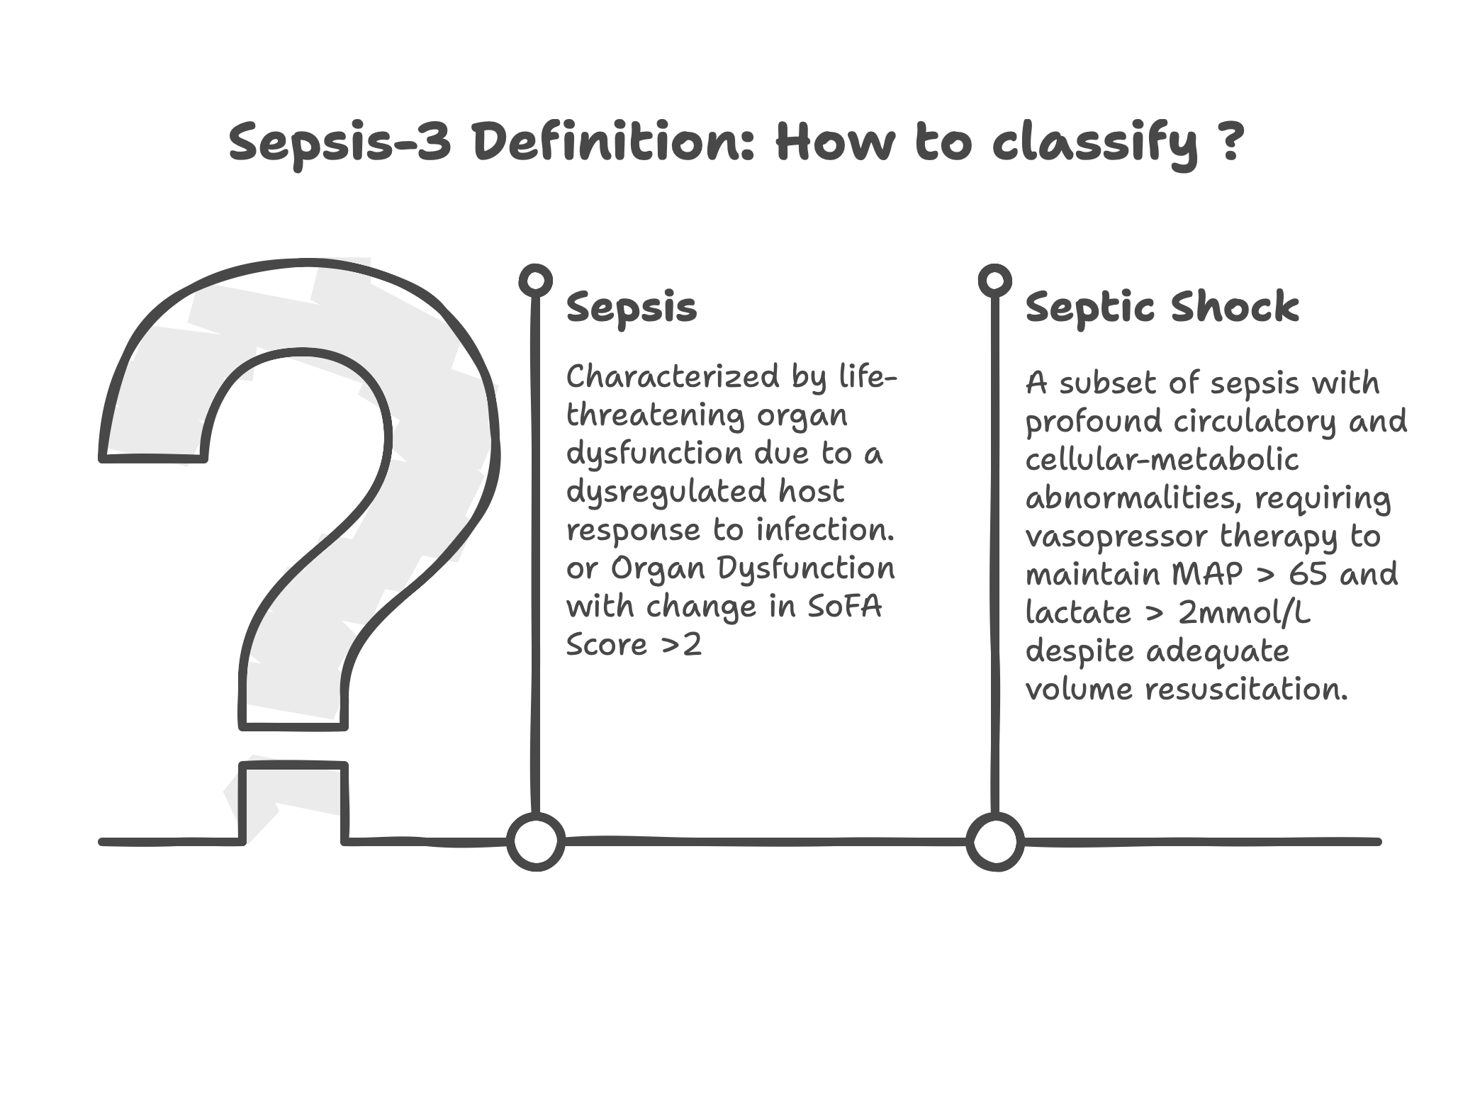 [2]

**Evolution of Definitions (Sepsis-1** → **Sepsis-2** → **Sepsis-3)**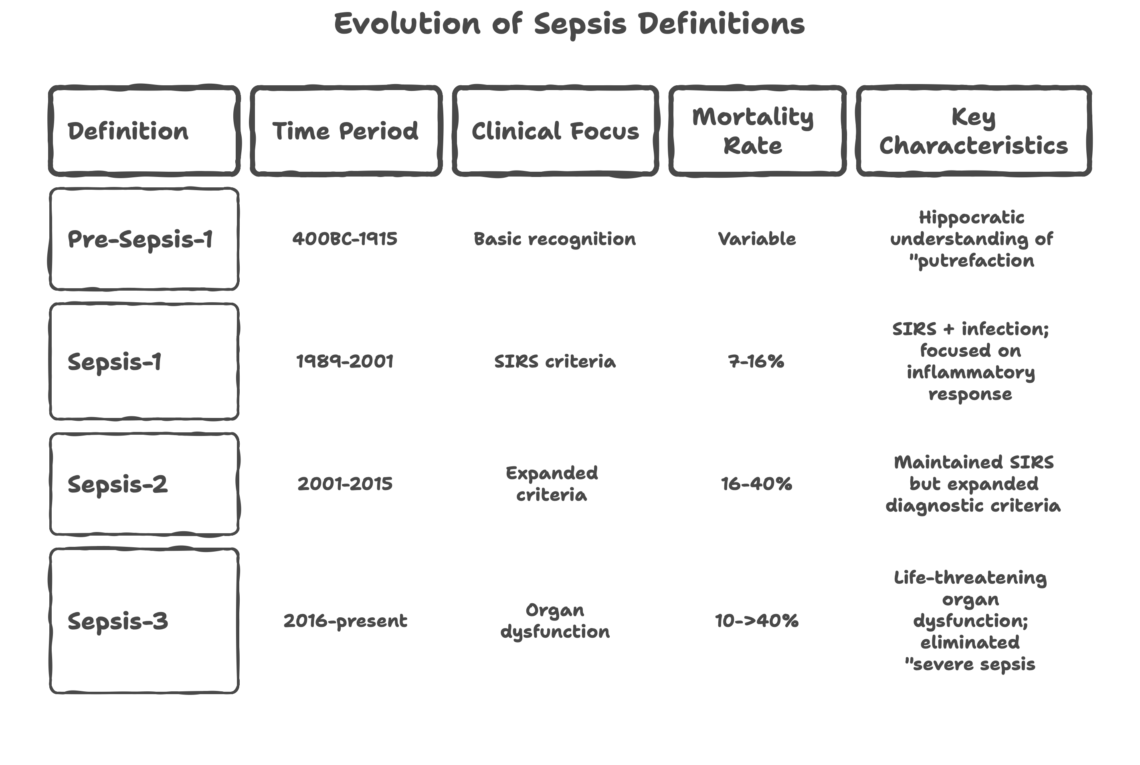 [1]

The Sepsis-3 definition eliminated the term "severe sepsis" and emphasizes that sepsis inherently represents organ dysfunction. [1]

**2. Pathophysiology**

The pathophysiology of sepsis involves a complex cascade of immunological, inflammatory, and metabolic responses that can become maladaptive.

**Initial Recognition and Activation**

Sepsis begins with the recognition of pathogen-associated molecular patterns (PAMPs) such as endotoxins, exotoxins, lipids, or DNA sequences, and damage-associated molecular patterns (DAMPs) from host tissue damage. These molecules activate toll-like receptors (TLRs) on antigen-presenting cells and monocytes, initiating signal transduction pathways.

**Inflammatory Cascade**

The binding of PAMPs and DAMPs to TLRs results in nuclear factor-kappa B (NF-κB) translocation into the cell nucleus, leading to expression of early activation genes including:

* Pro-inflammatory interleukins (IL-1, IL-12, IL-18)
* Tumor necrosis factor alpha (TNF-α)
* Interferons (IFNs)

This subsequently activates further cytokines (IFN-γ, IL-6, IL-8), complement cascades, and coagulation pathways.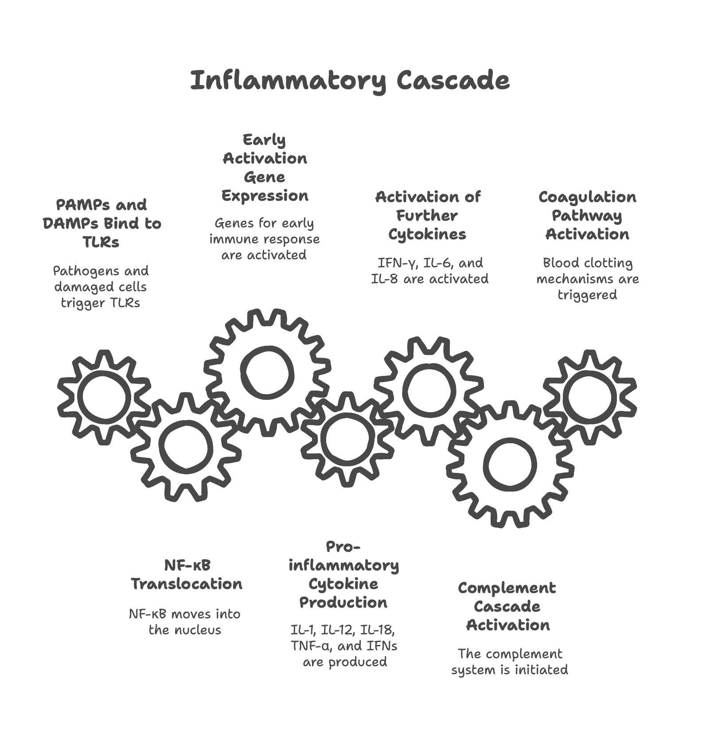

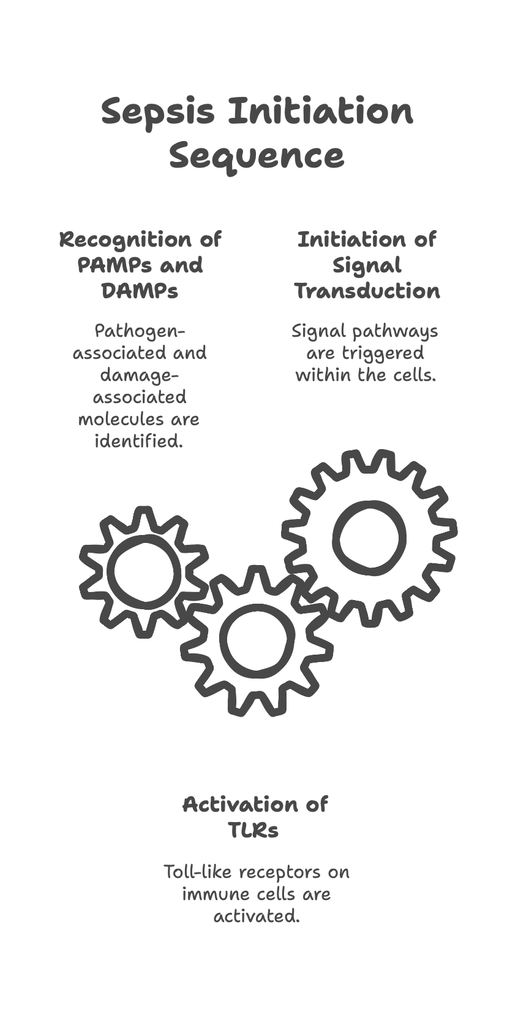

**Mechanisms of Organ Dysfunction**

Multiple mechanisms contribute to multi-organ dysfunction syndrome (MODS):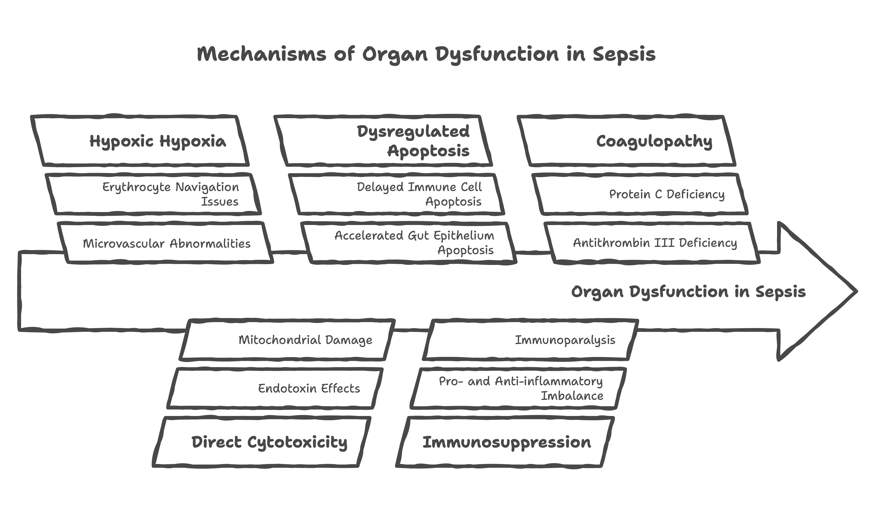

**3. Sepsis Phenotypes and Subtypes**

**Clinical Phenotypes (Machine Learning/Cluster Analyses)**

Recent advances in computational medicine have revealed that sepsis encompasses multiple distinct clinical phenotypes with varying pathophysiology, treatment responses, and outcomes.

**The Four Sepsis Phenotypes**

Large-scale analysis of electronic health records from 63,858 patients using machine learning algorithms identified four distinct sepsis phenotypes: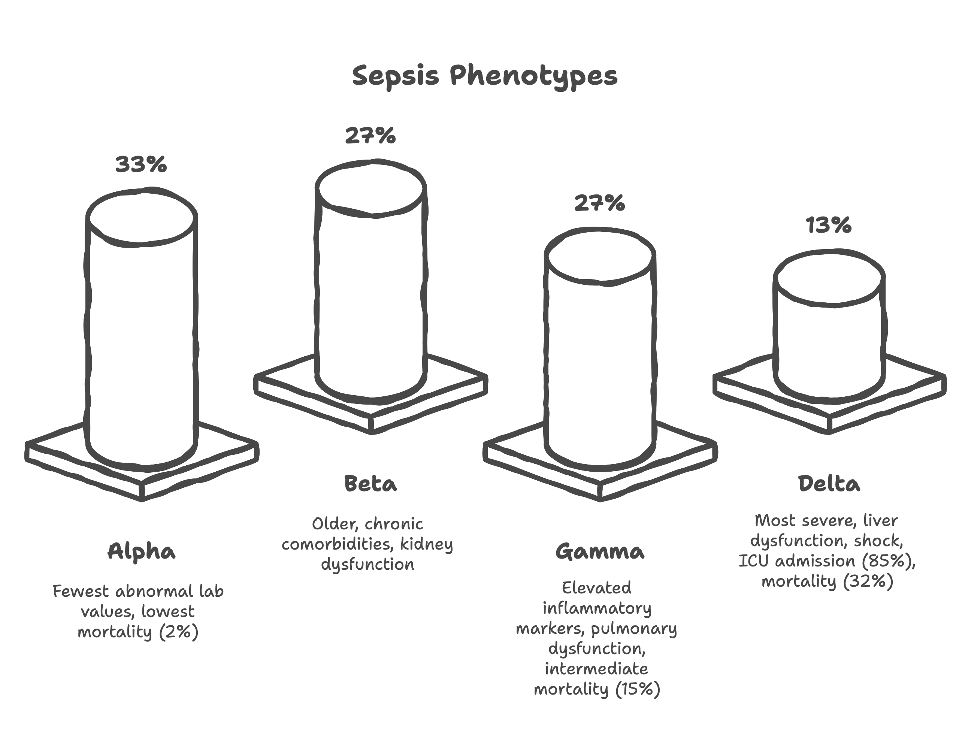 [17]

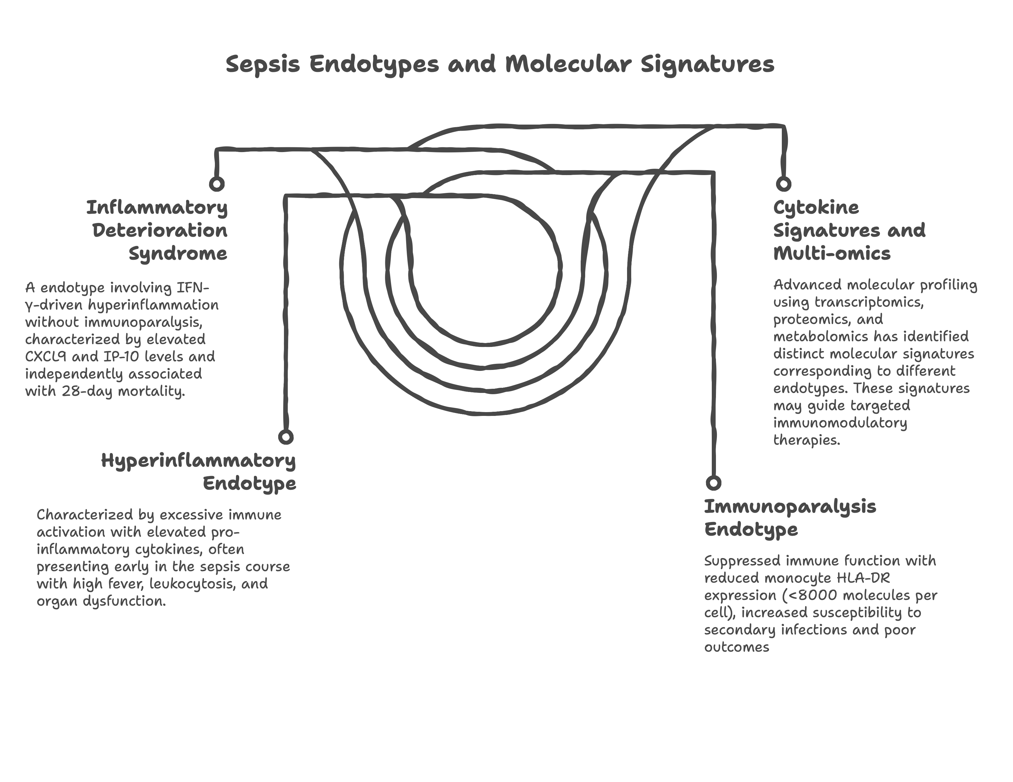

**Dynamic Nature of Phenotypes**

**Temporal Evolution**

Patients may transition between phenotypes during their clinical course, reflecting the dynamic nature of sepsis pathophysiology. Early hyperinflammatory phases may evolve into immunosuppressive states, requiring adaptive therapeutic strategies.

**Clinical Implications**

These phenotypes demonstrate distinct treatment responses and suggest potential for precision medicine approaches. Different phenotypes may respond variably to fluid resuscitation, vasopressor selection, and adjunctive therapies, emphasizing the need for personalized sepsis management.

**Implications for Clinical Trials**

Recognition of sepsis heterogeneity has profound implications for clinical trial design. Future studies may need to stratify patients by phenotype or endotype to identify treatment effects that might be obscured in heterogeneous populations.

**4.Organ Cross-Talk in Sepsis**

**Heart–Kidney–Lung Axis**

Sepsis induces complex interactions between cardiovascular, renal, and pulmonary systems that 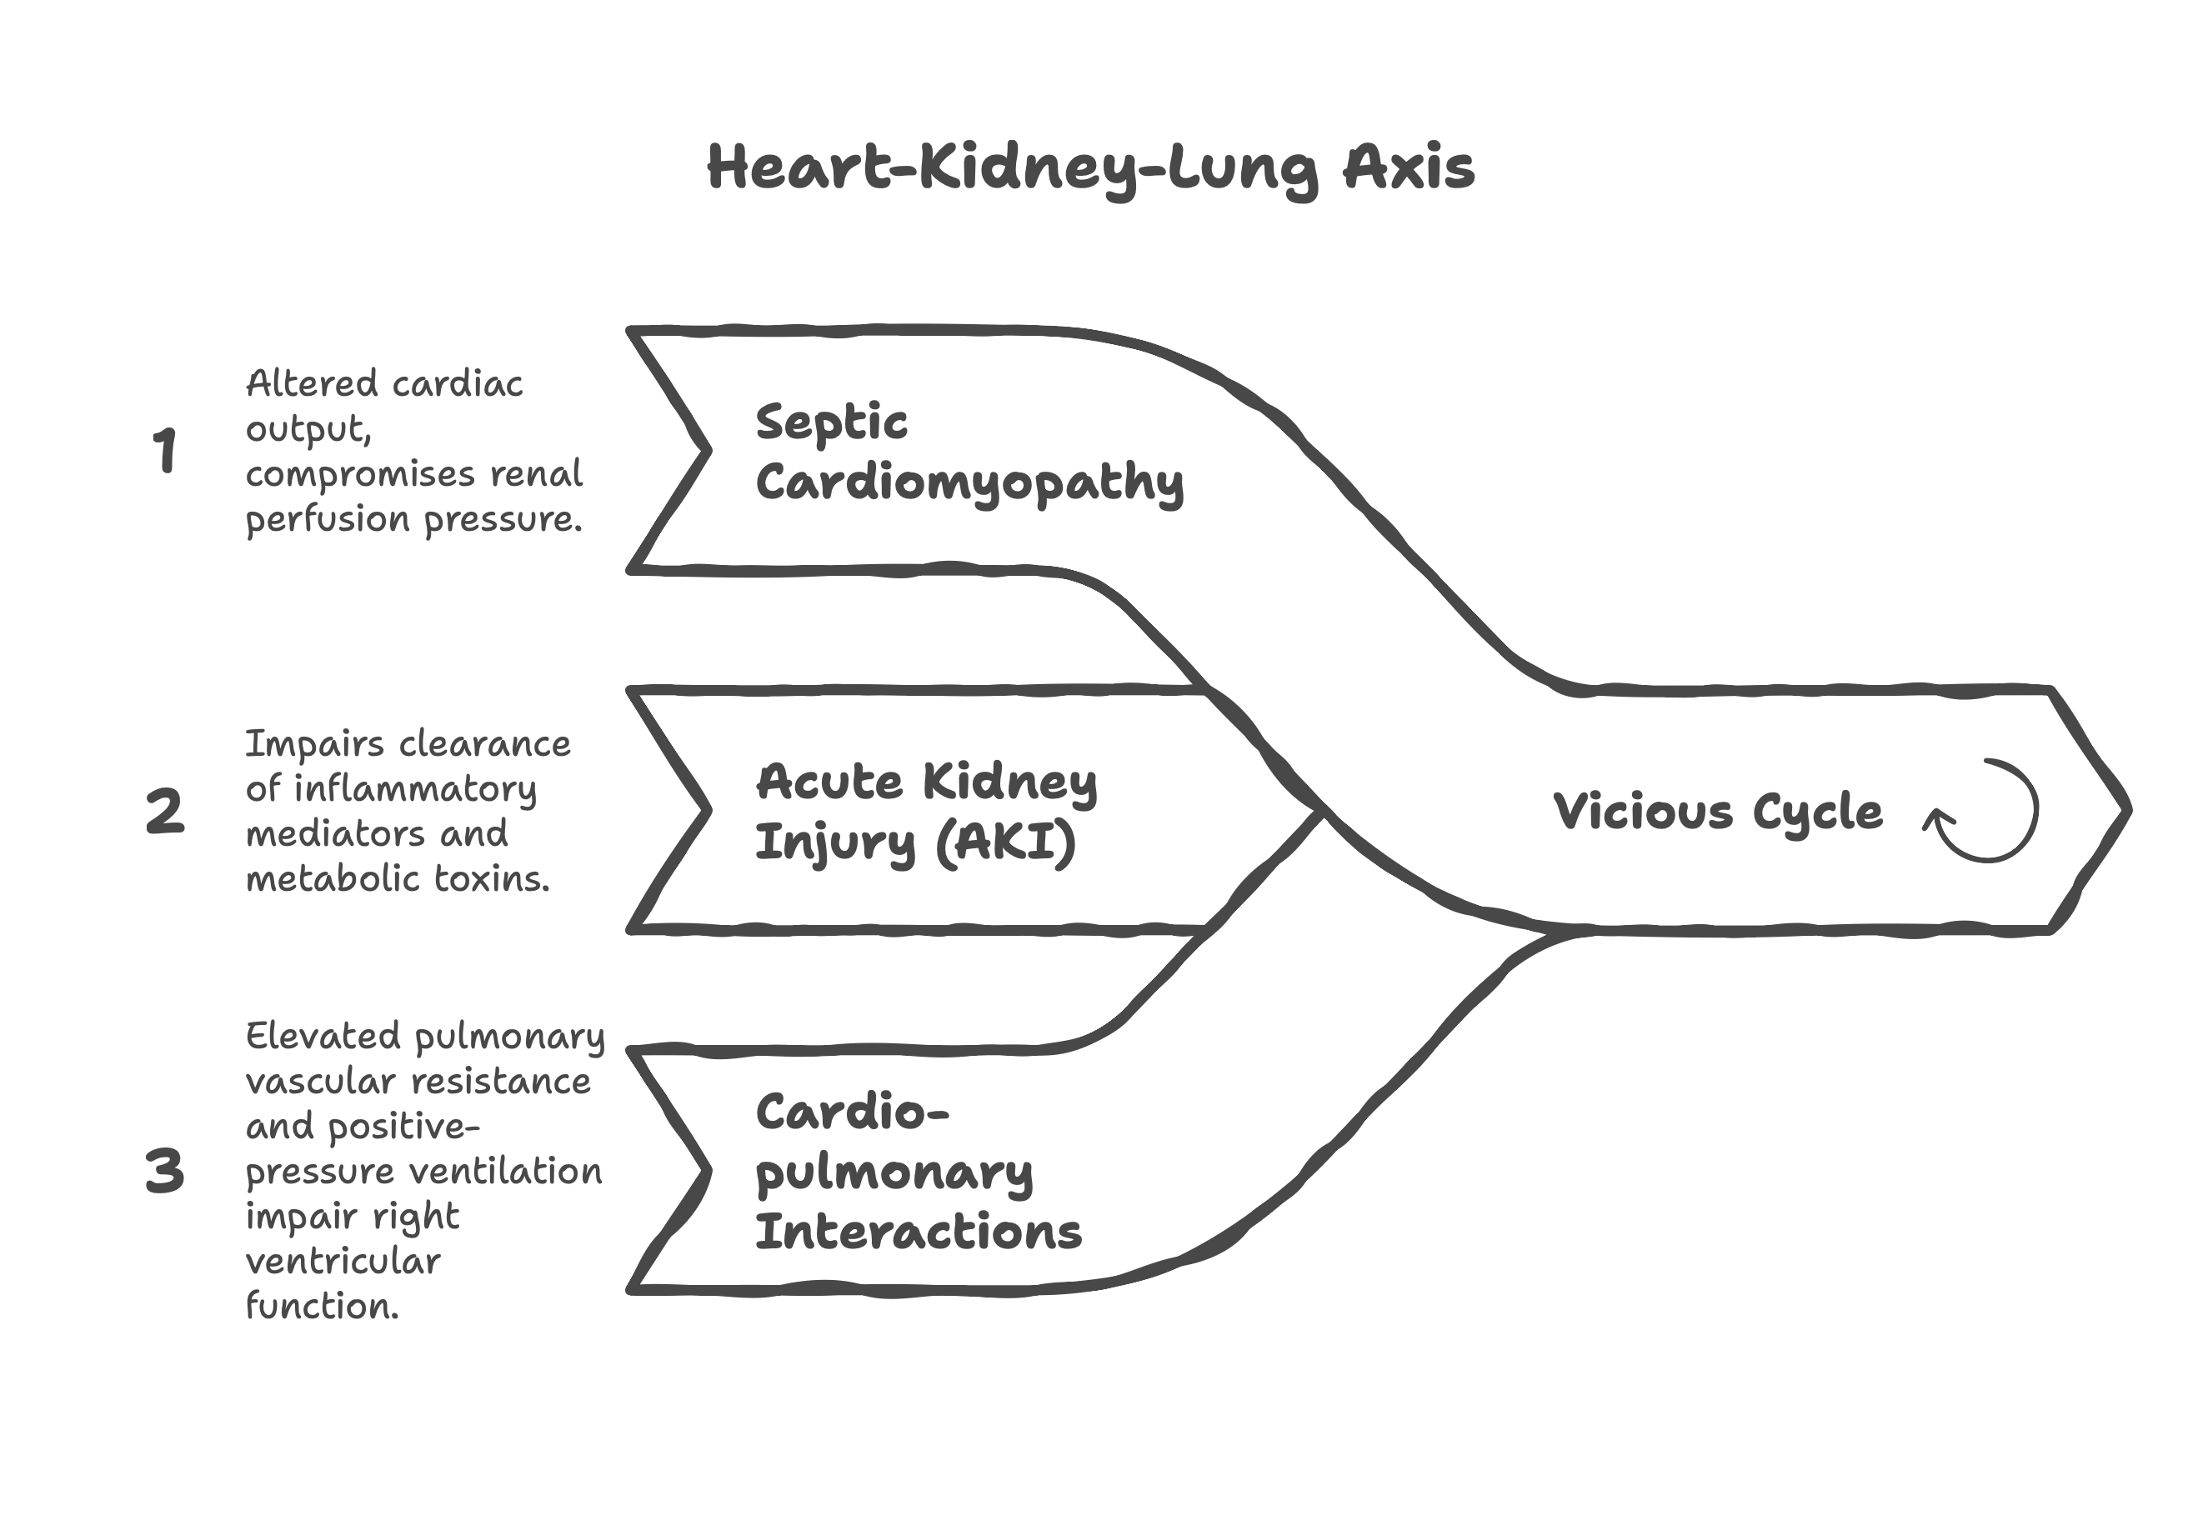amplify organ dysfunction through 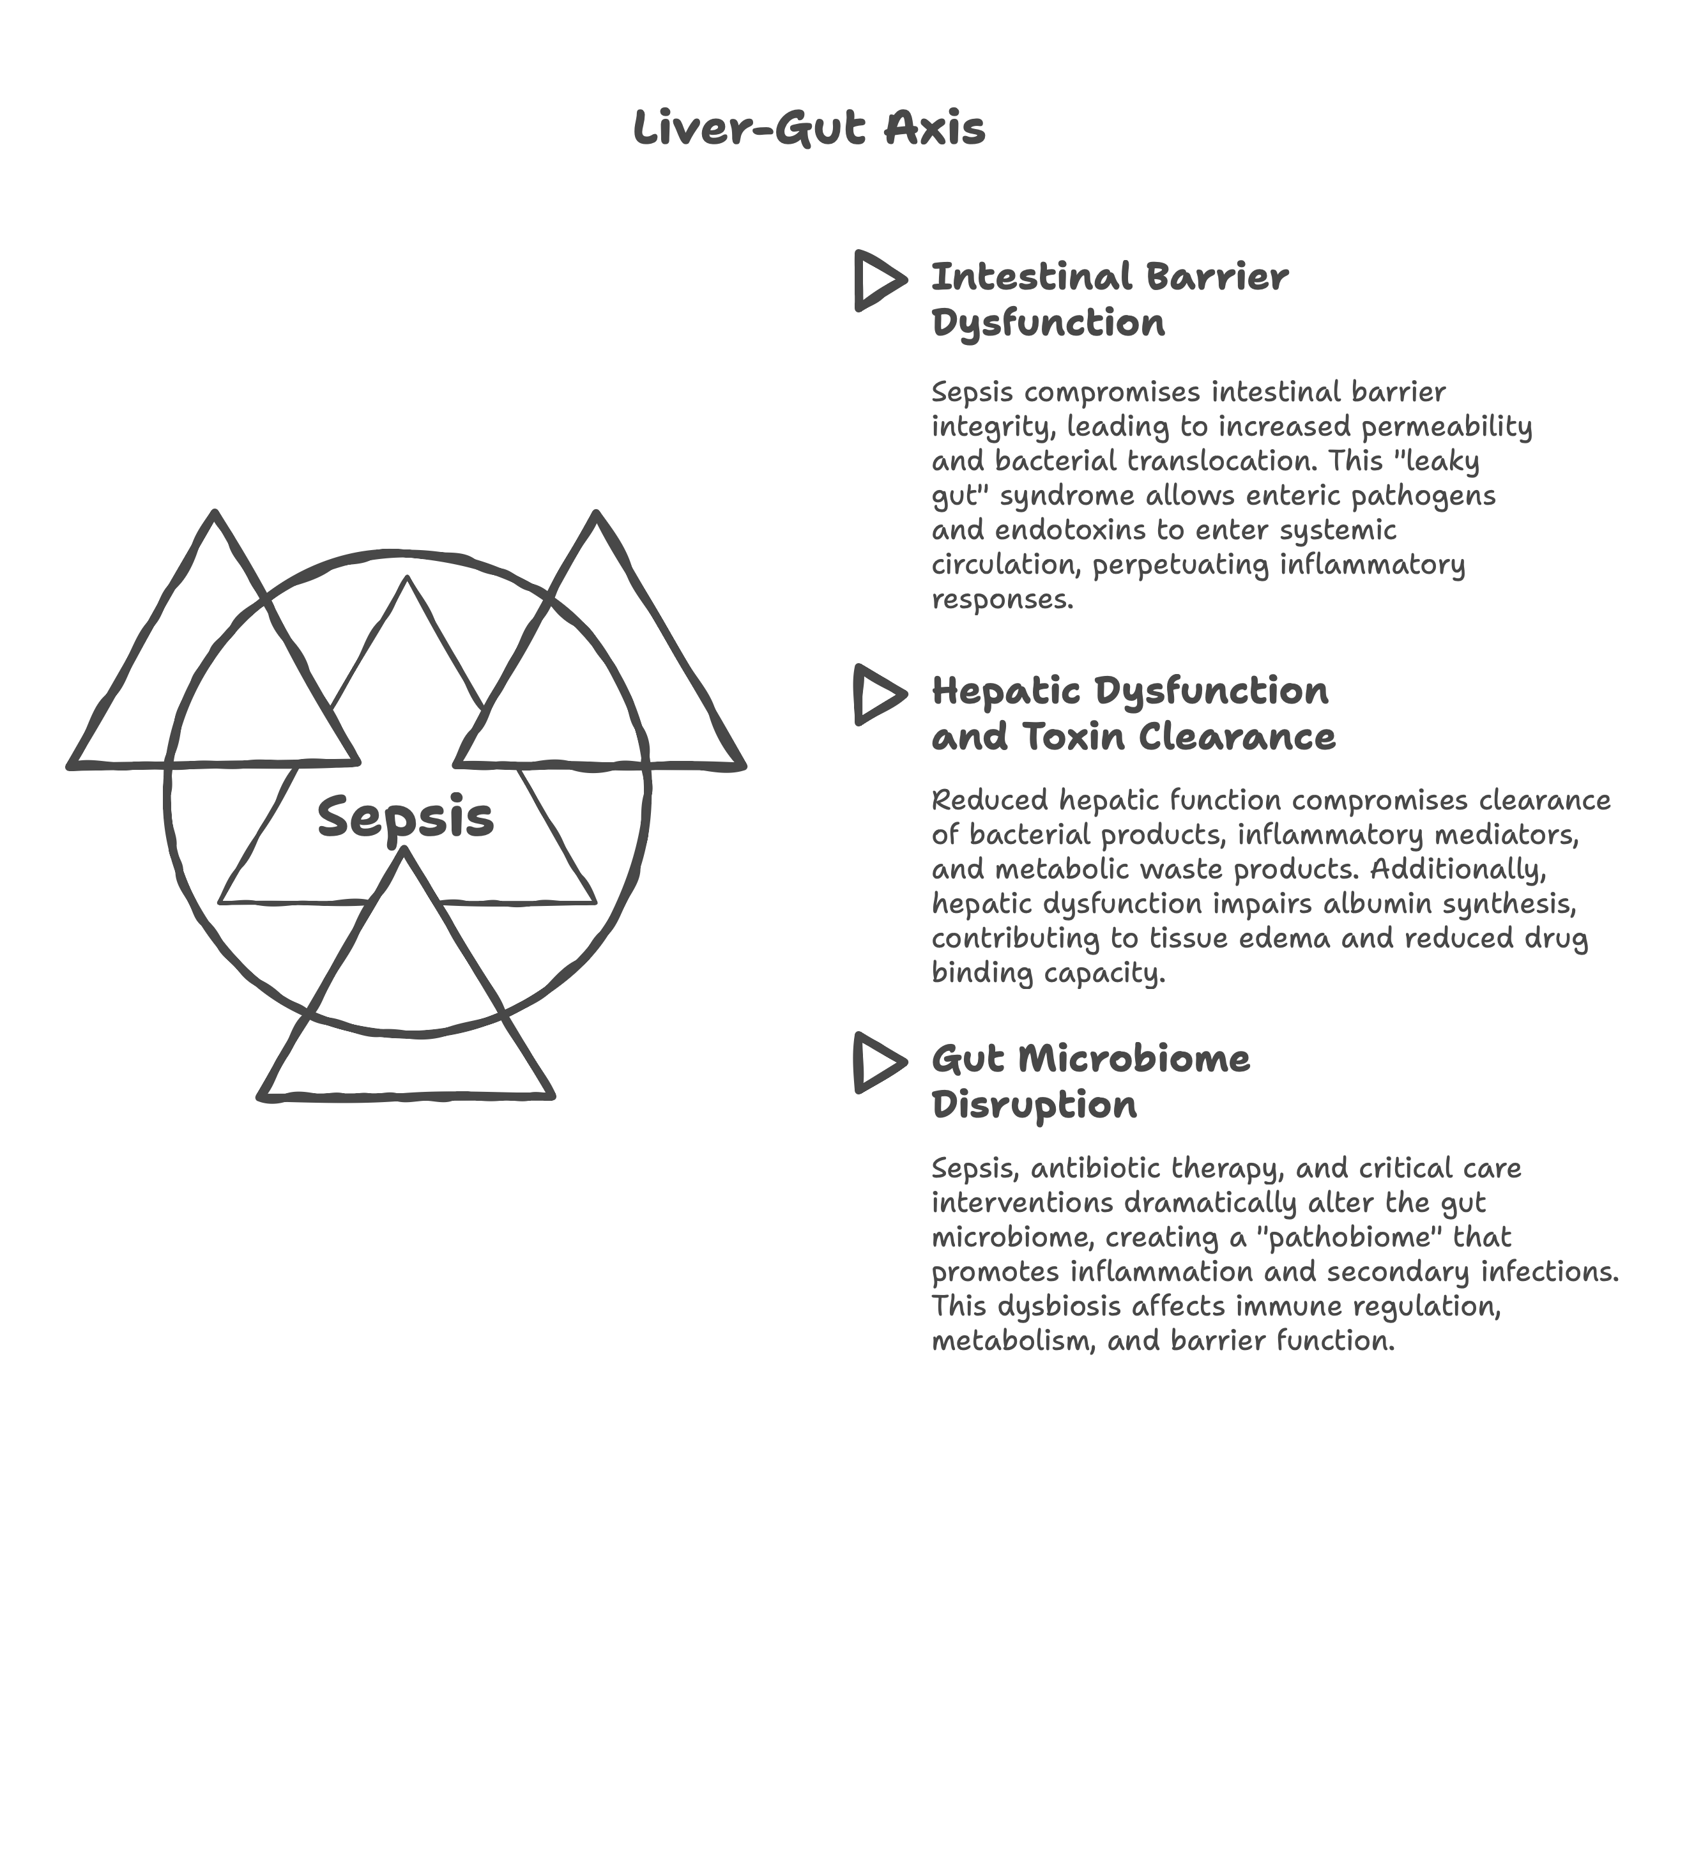bidirectional crosstalk mechanism.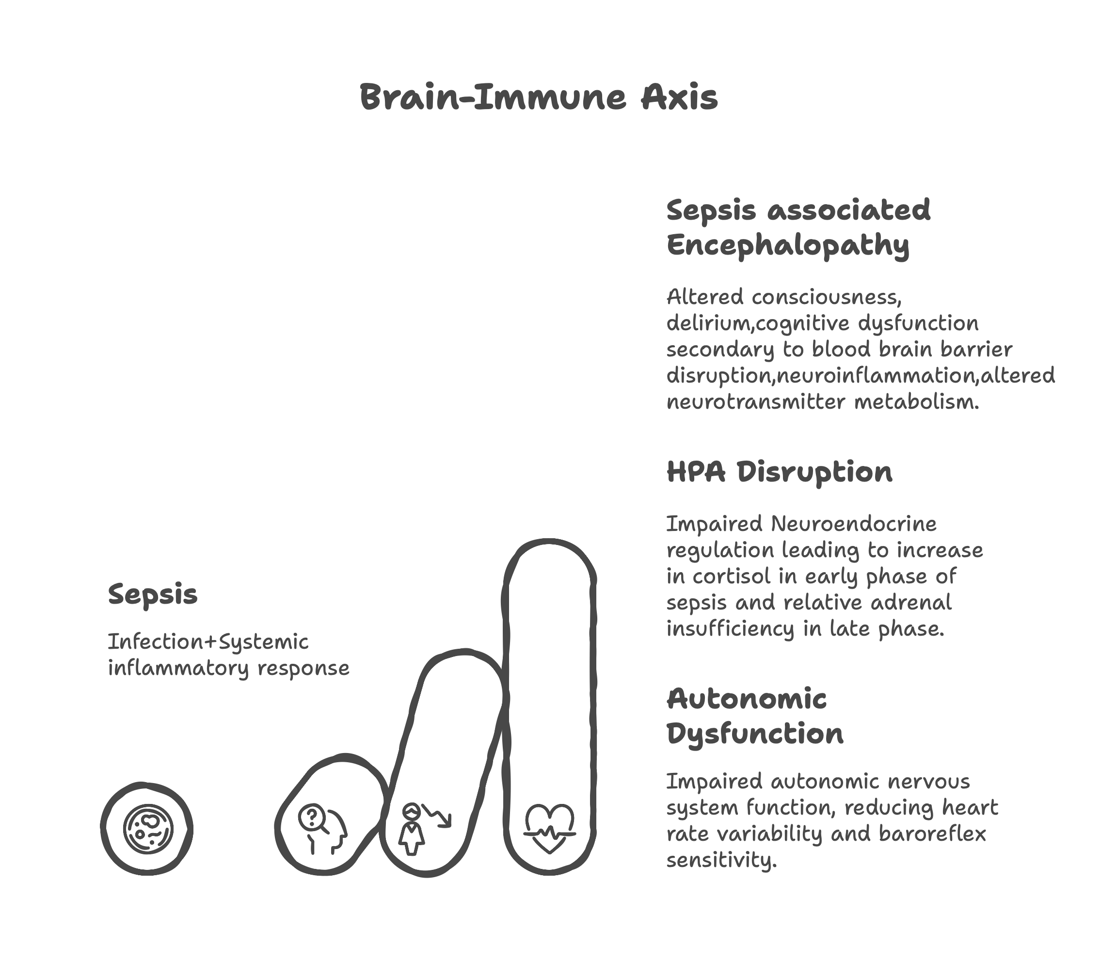

**Implications for Multiple Organ Dysfunction Syndrome (MODS)**

Understanding organ crosstalk is crucial for recognizing that MODS represents network failure rather than simply additive individual organ dysfunction. Therapeutic interventions must consider these interactions to avoid inadvertently worsening function in interconnected organ systems.

**5. Sepsis Mimics**

**Common Mimics**

Several conditions can present with clinical features indistinguishable from sepsis, leading to diagnostic confusion and inappropriate treatment.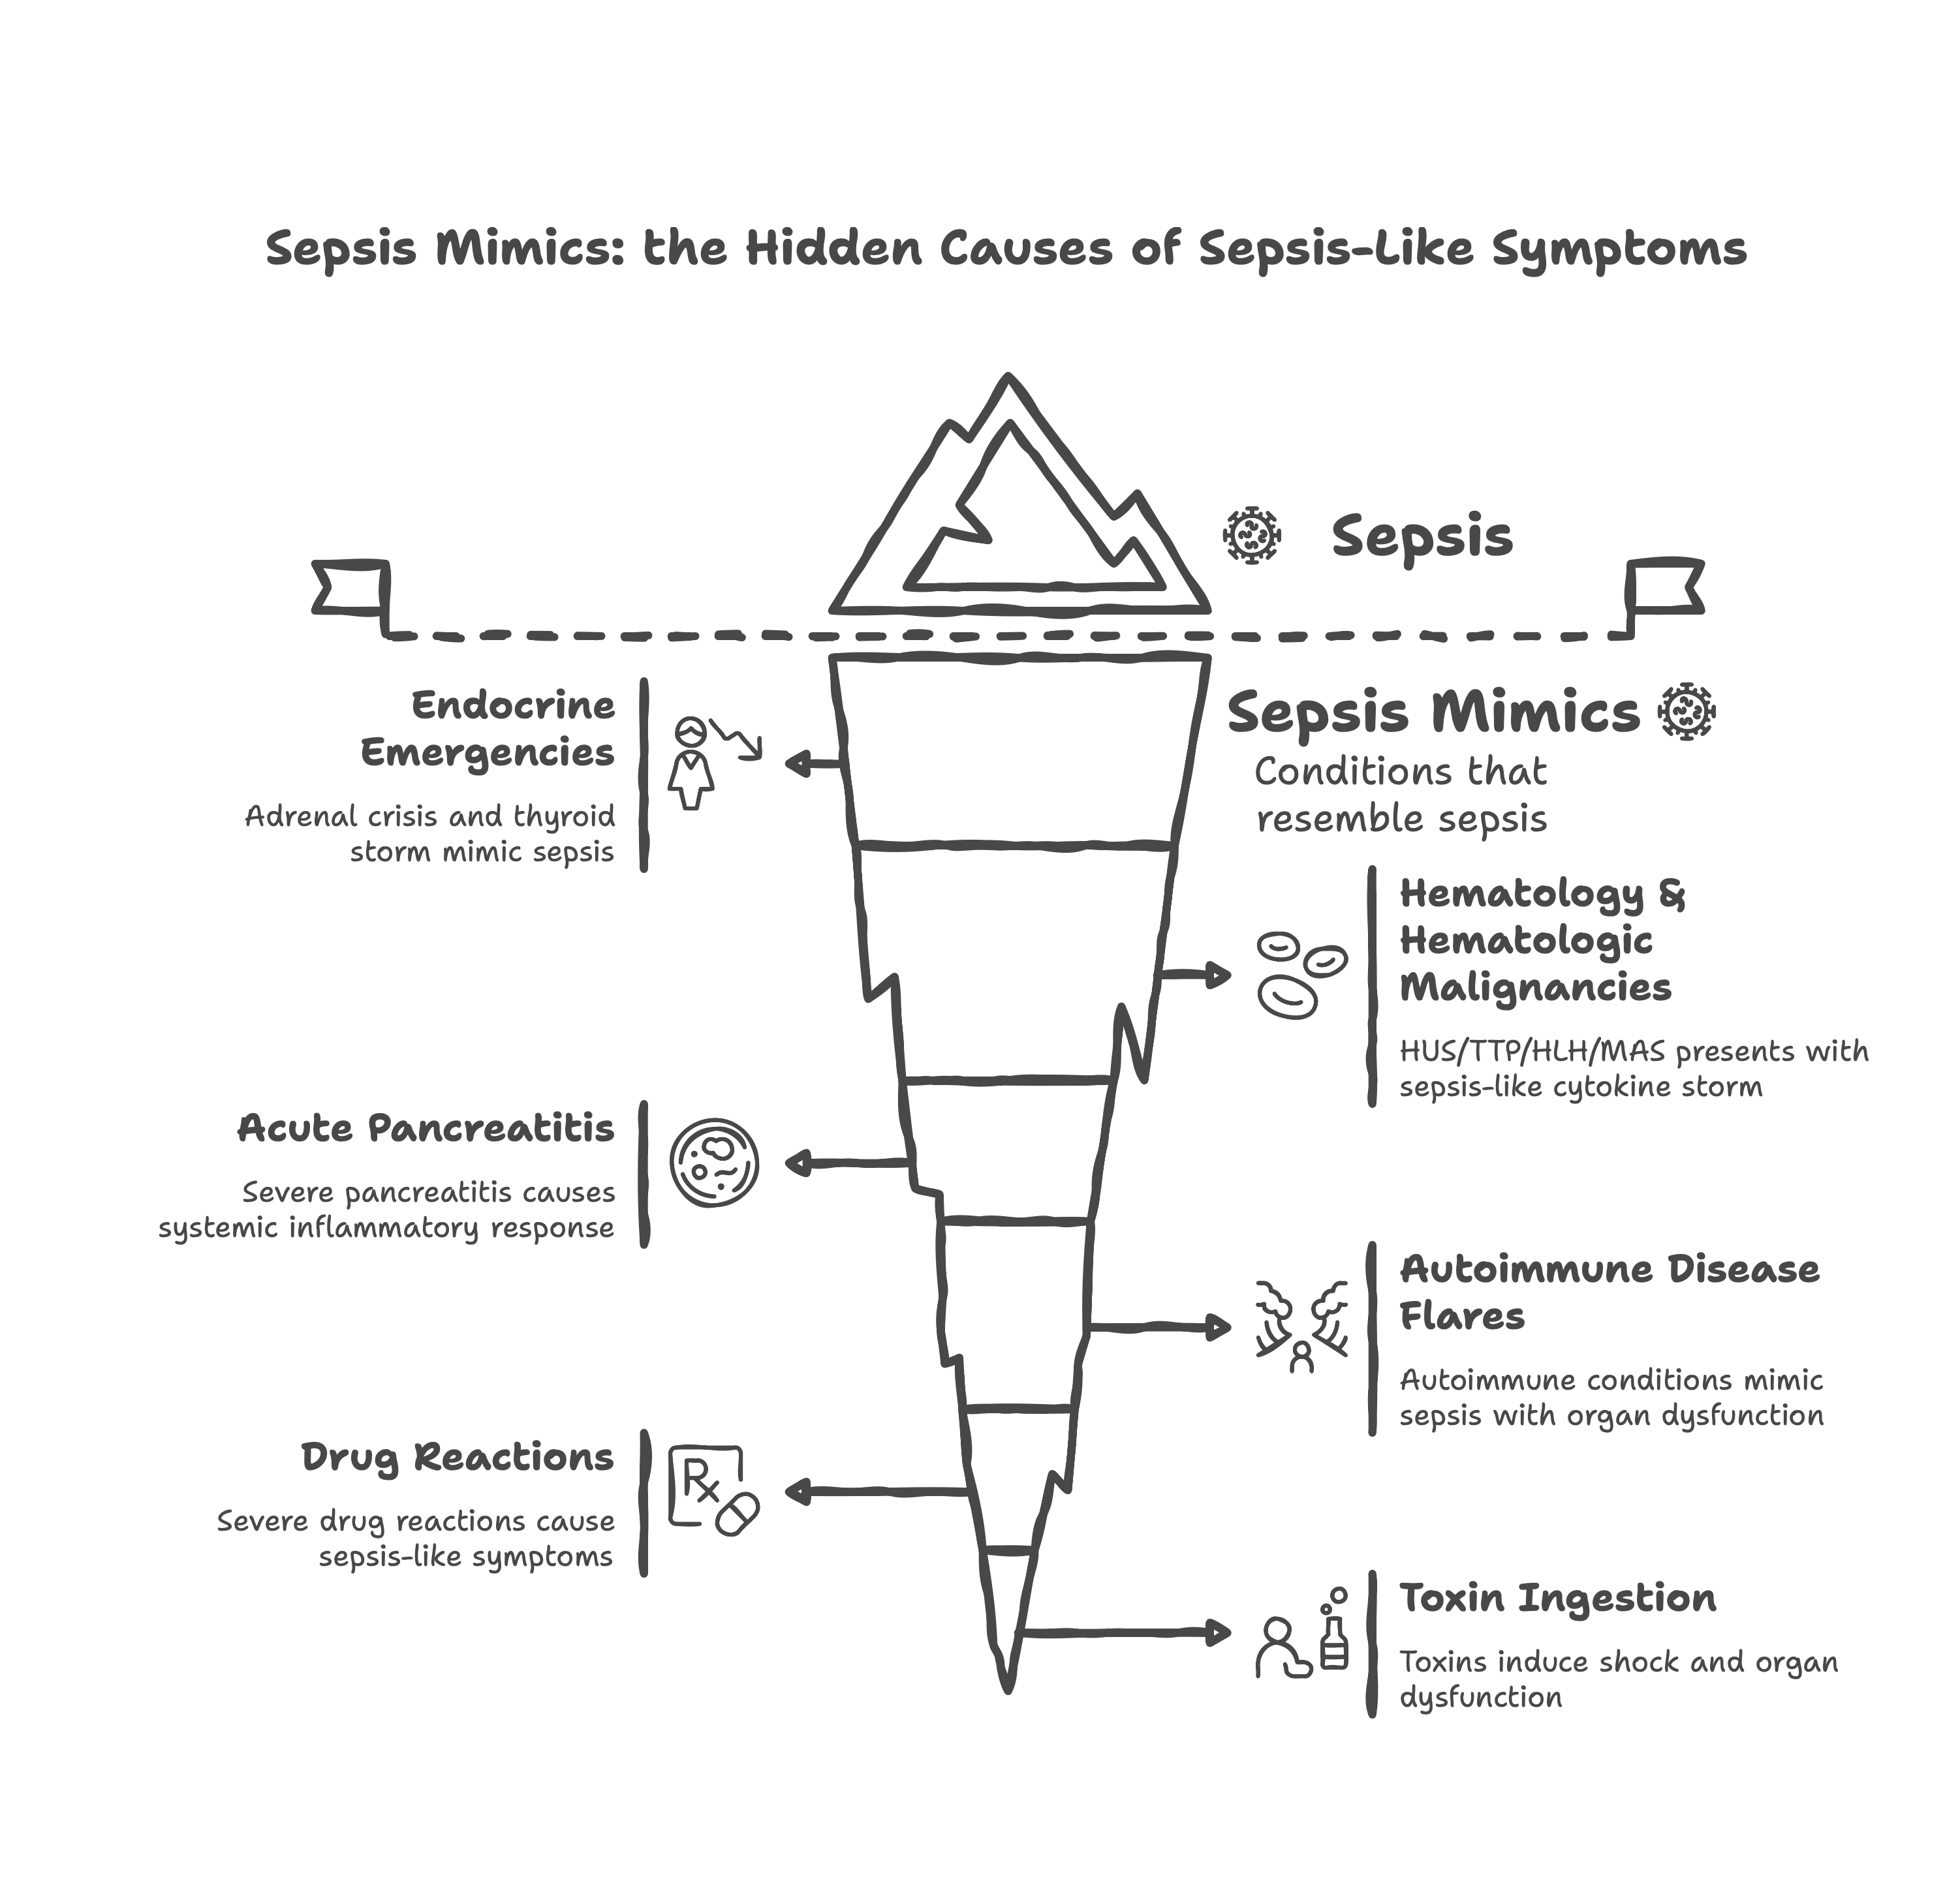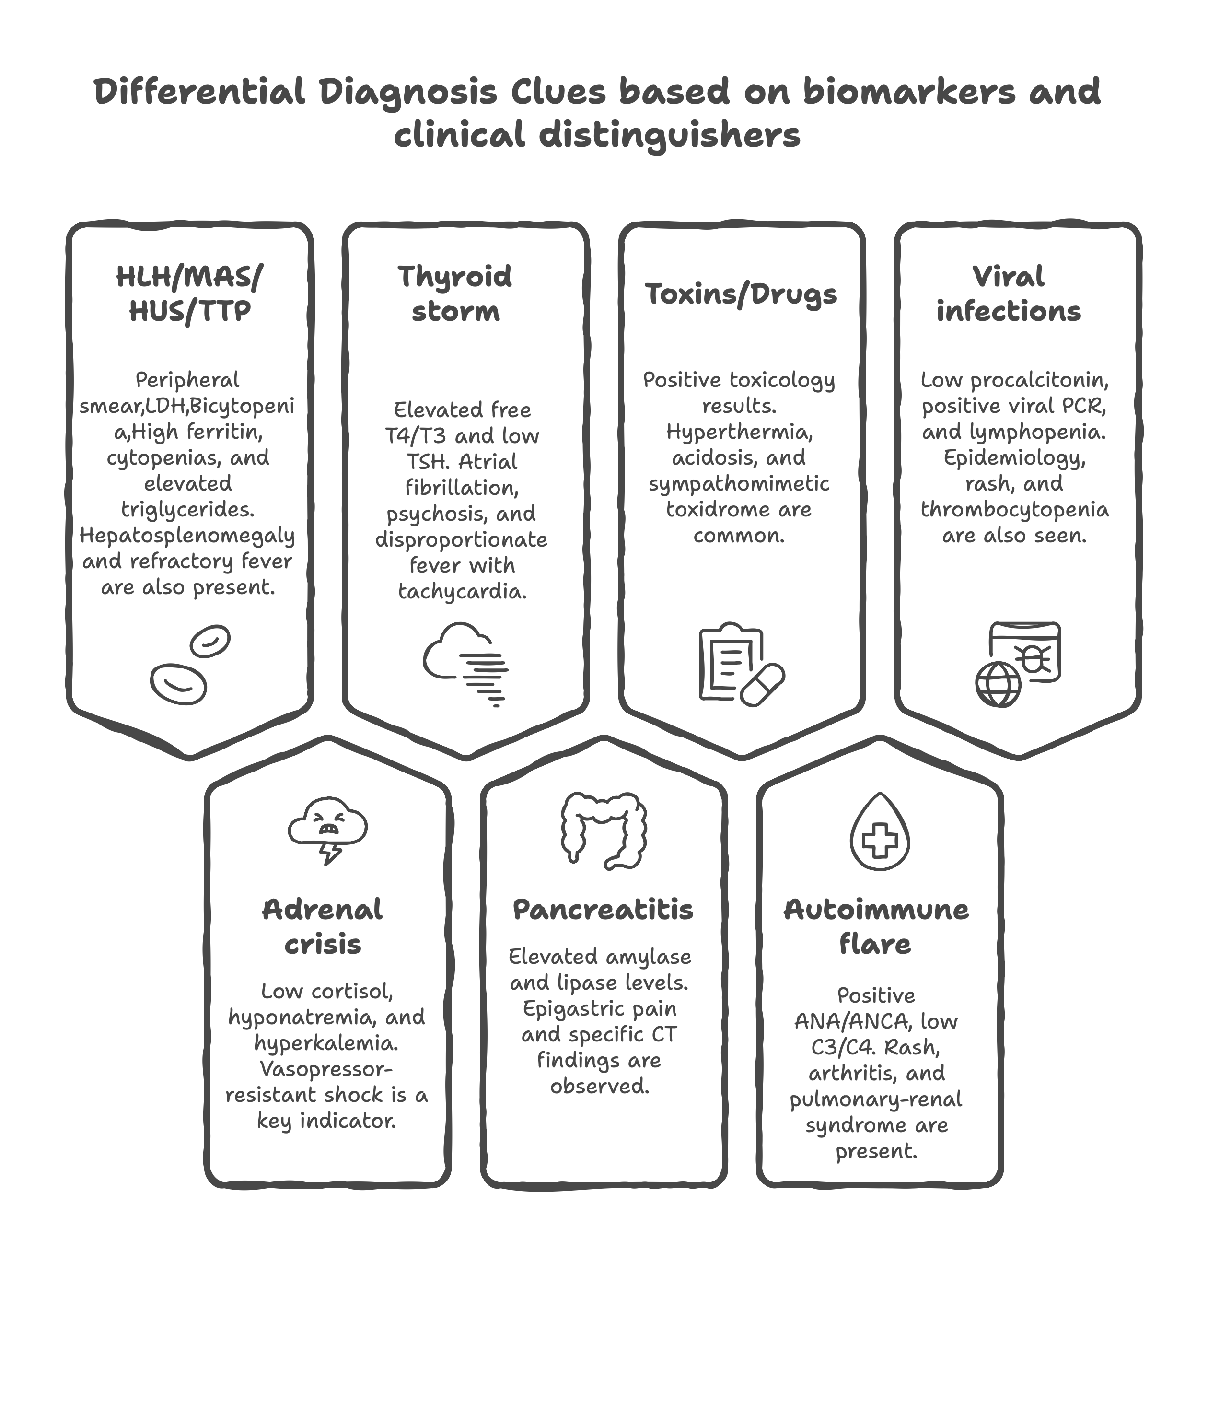

**Clinical Importance**

**Risk of Delayed Specific Therapy**

Misclassification of sepsis mimics as infectious sepsis can lead to inappropriate antibiotic therapy while delaying disease-specific treatments. For example, delayed corticosteroid therapy in adrenal crisis or antithyroid medications in thyroid storm can result in preventable mortality.

**Antimicrobial Stewardship Implications**

Accurate differentiation reduces unnecessary antibiotic exposure, which contributes to antimicrobial resistance, adverse drug reactions, and healthcare costs. The 2021 Surviving Sepsis Campaign guidelines now emphasize careful assessment of infection probability before initiating antimicrobials. [4,5]

**6. Clinical Presentation and Diagnosis**

**Variable Presentation**

Sepsis has a highly variable presentation depending on the infection source and may not be apparent until late in the disease course. The absence of classical signs does not exclude sepsis, particularly in vulnerable populations.

**Clinical Manifestations by Organ System**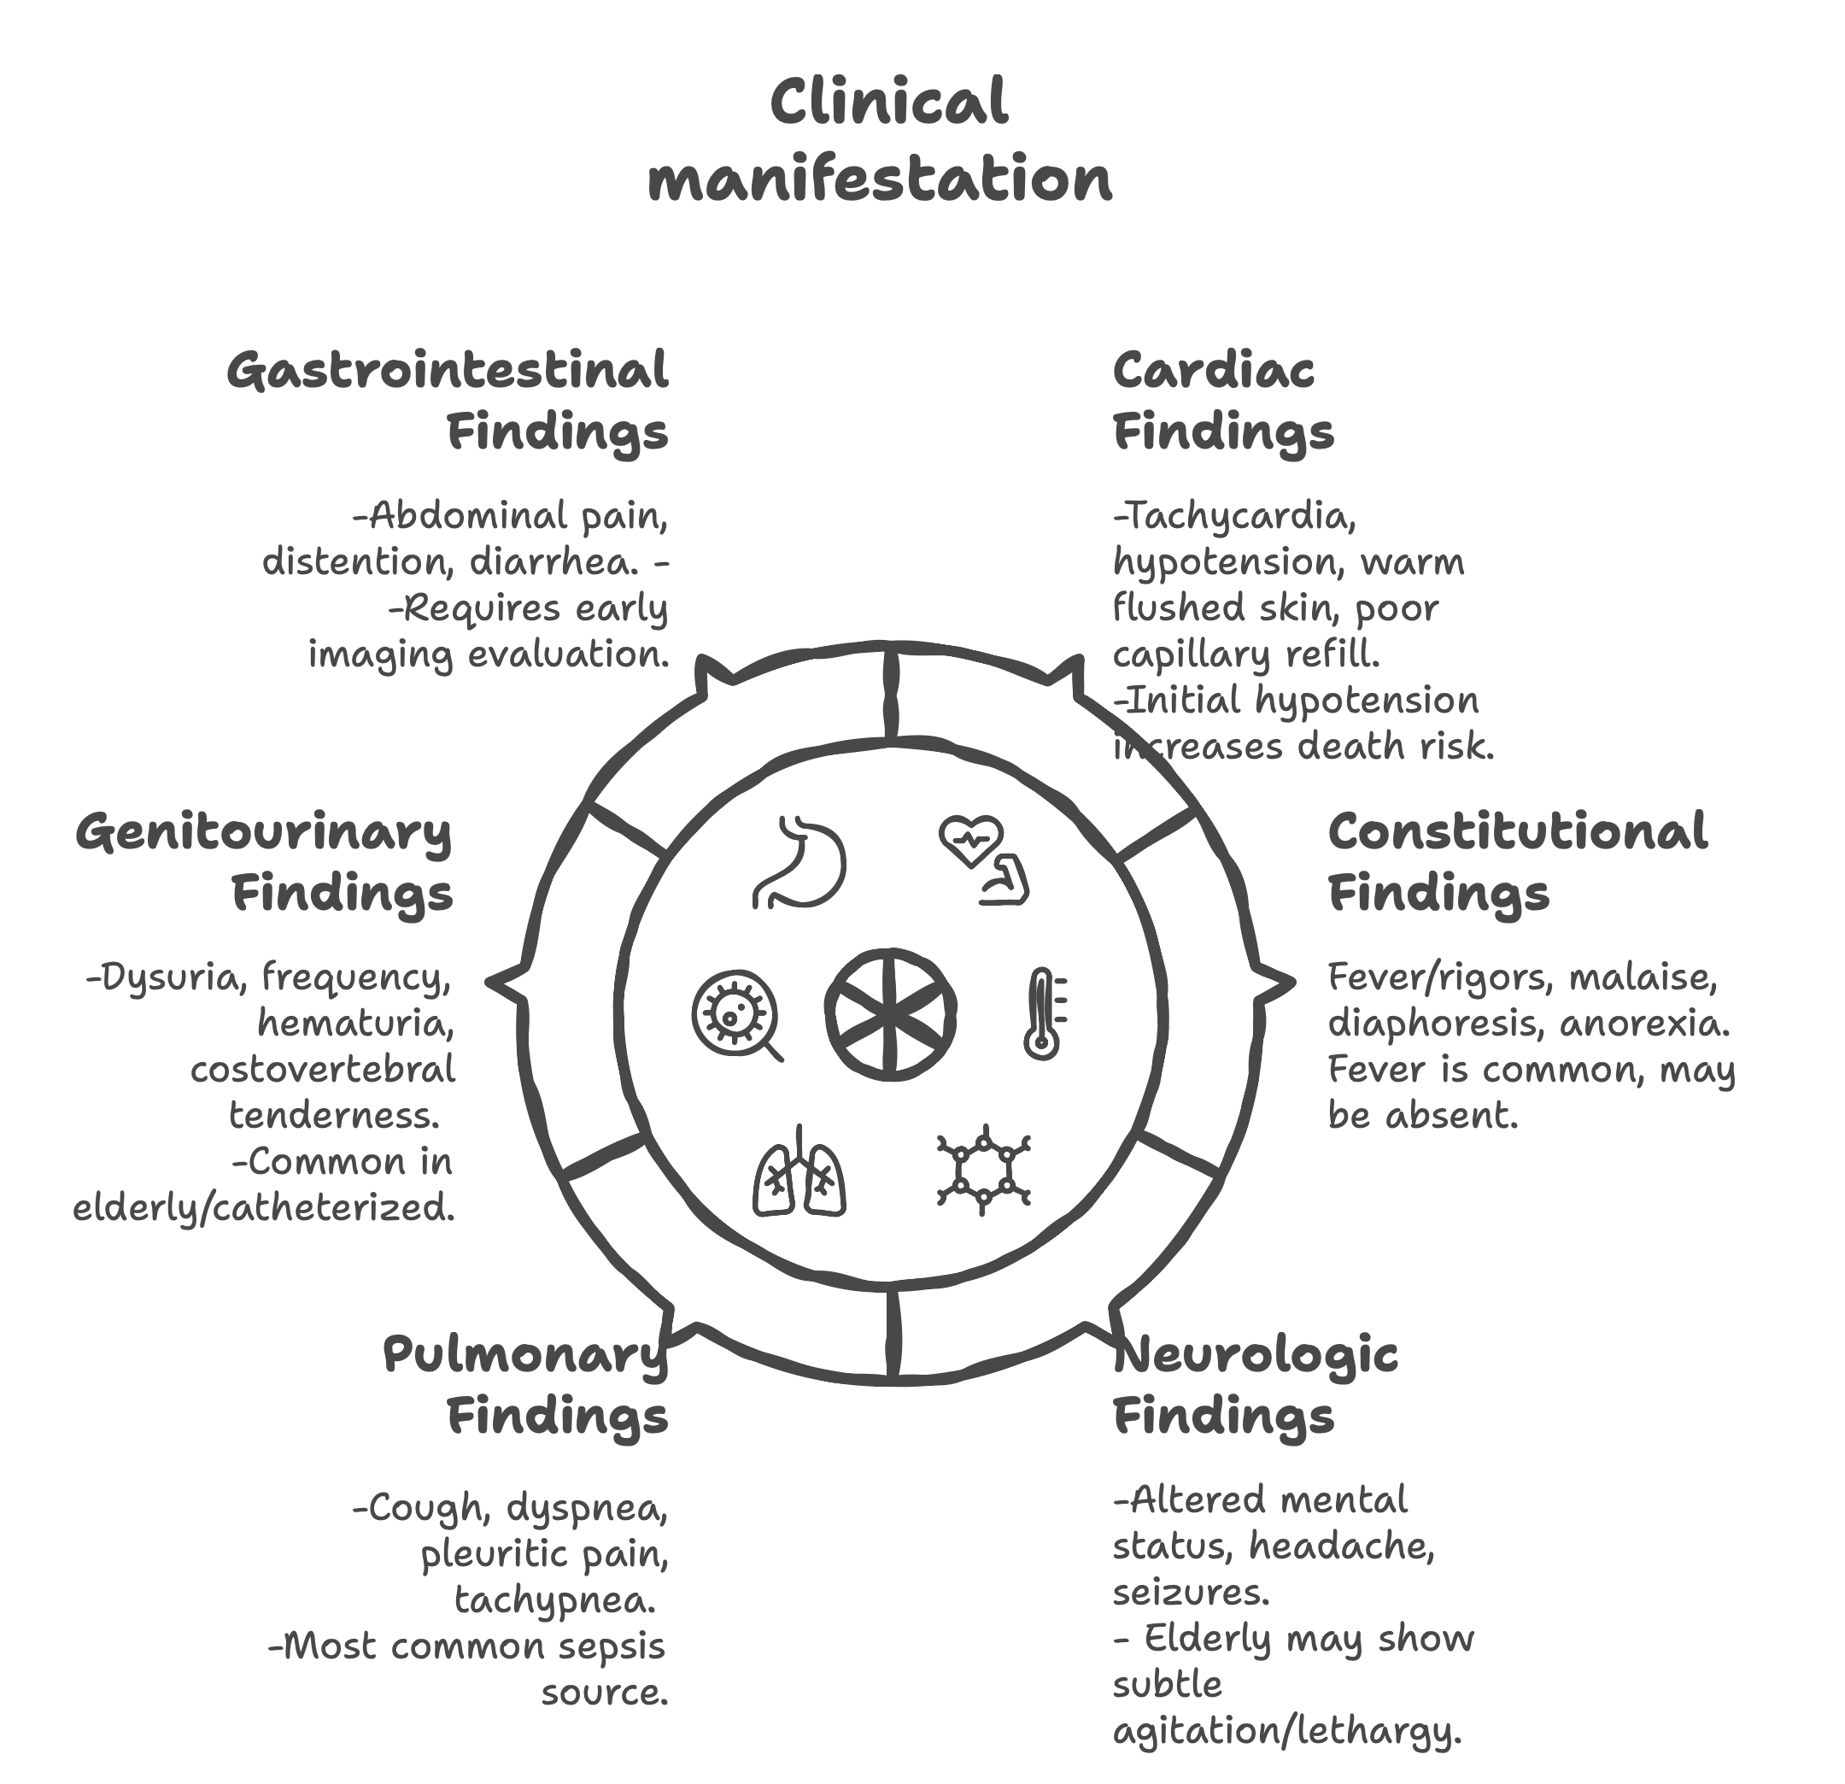

**Screening Tool**

Multiple screening tools have been developed to facilitate early sepsis recognition, each with distinct performance characteristics.

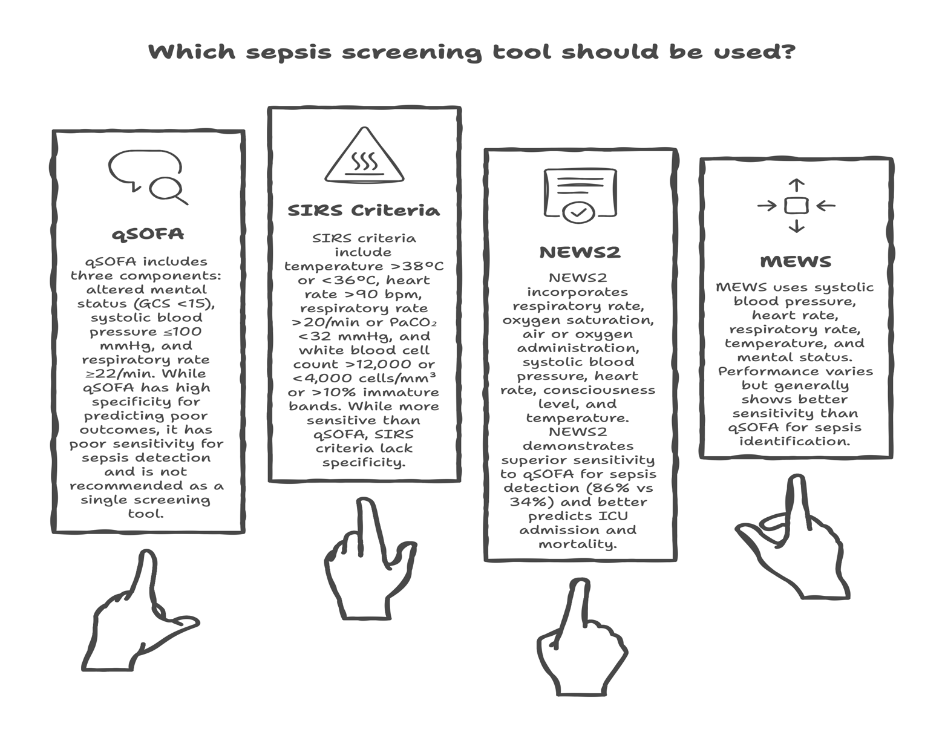

**Diagnostic Approach**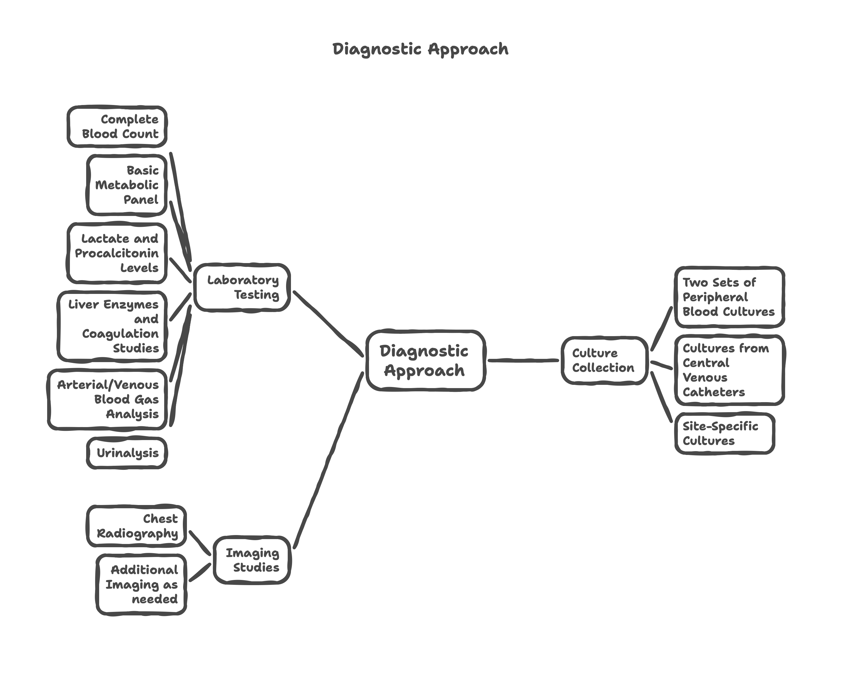

**Sepsis Biomarkers**

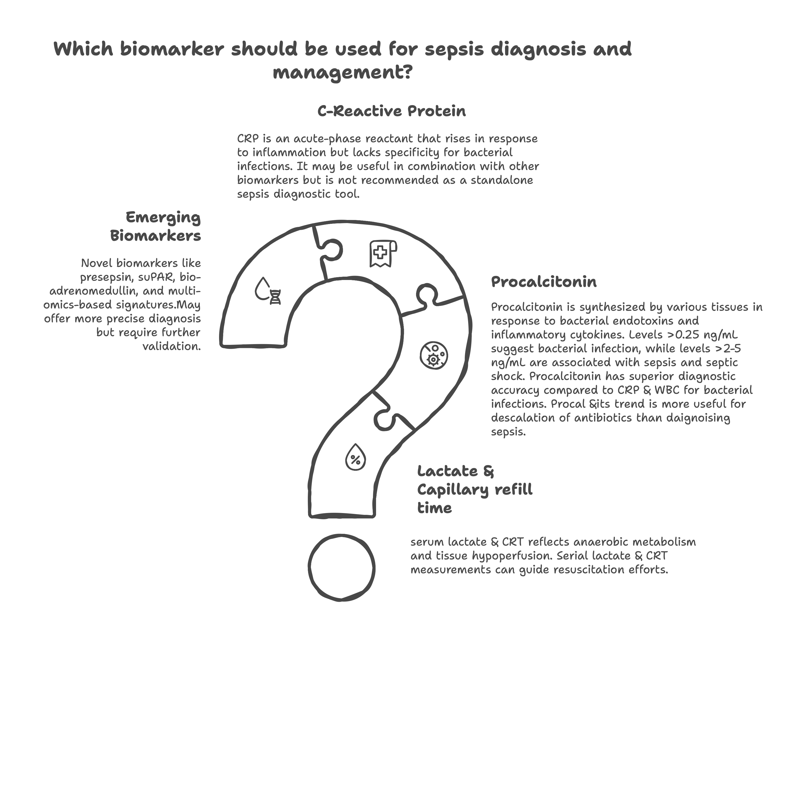

**5. Common Sources and Risk Factors**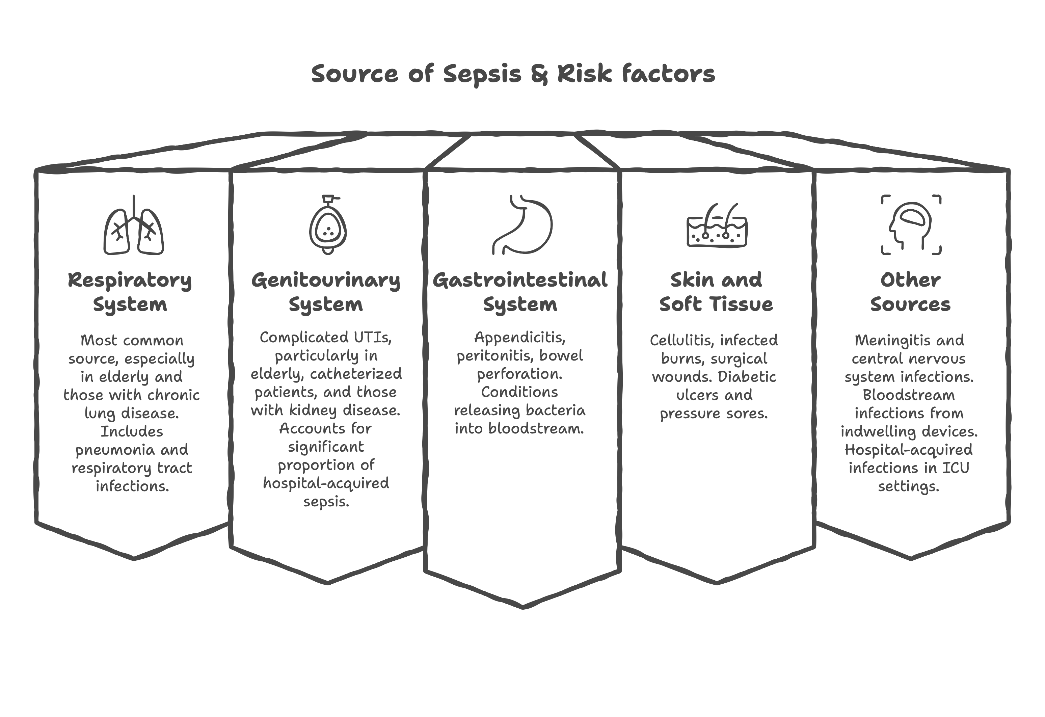

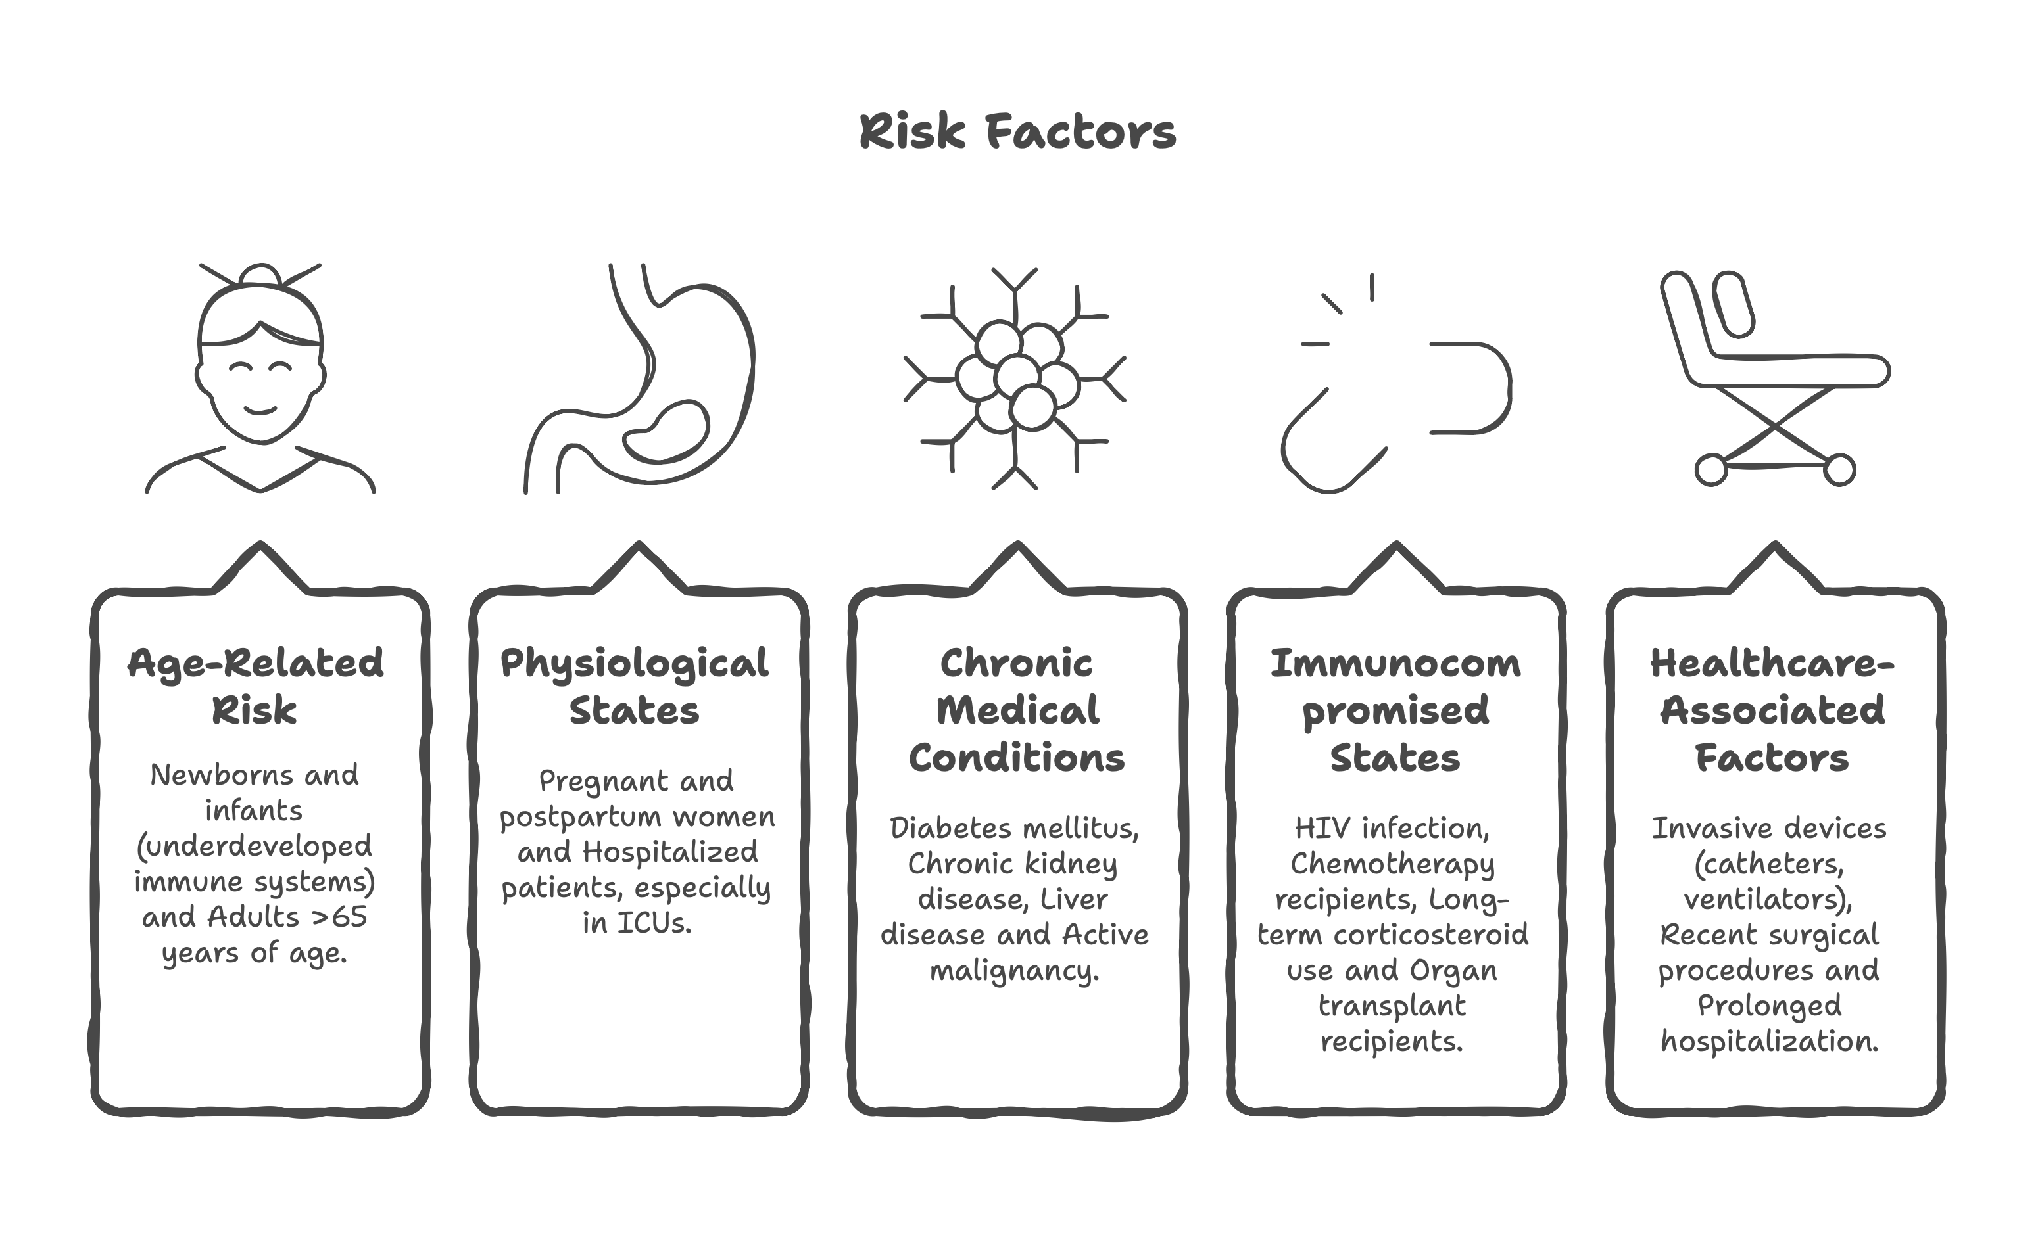**6. Principles of Management**

The management of sepsis requires immediate, aggressive intervention focusing on several key principles that must be implemented simultaneously rather than sequentially.

**Time-Critical Interventions**

**Immediate Assessment and Stabilization**:

* Ensure adequate oxygenation (>95% saturation)
* Establish vascular access for fluid resuscitation
* Obtain cultures before antibiotic administration if possible
* Initiate empiric antimicrobial therapy within 1 hour

**Core Management Principles**

**Bundle Approach**

Modern sepsis management follows bundled care approaches that combine multiple evidence-based interventions delivered within specific timeframes to optimize outcomes. [4,5]

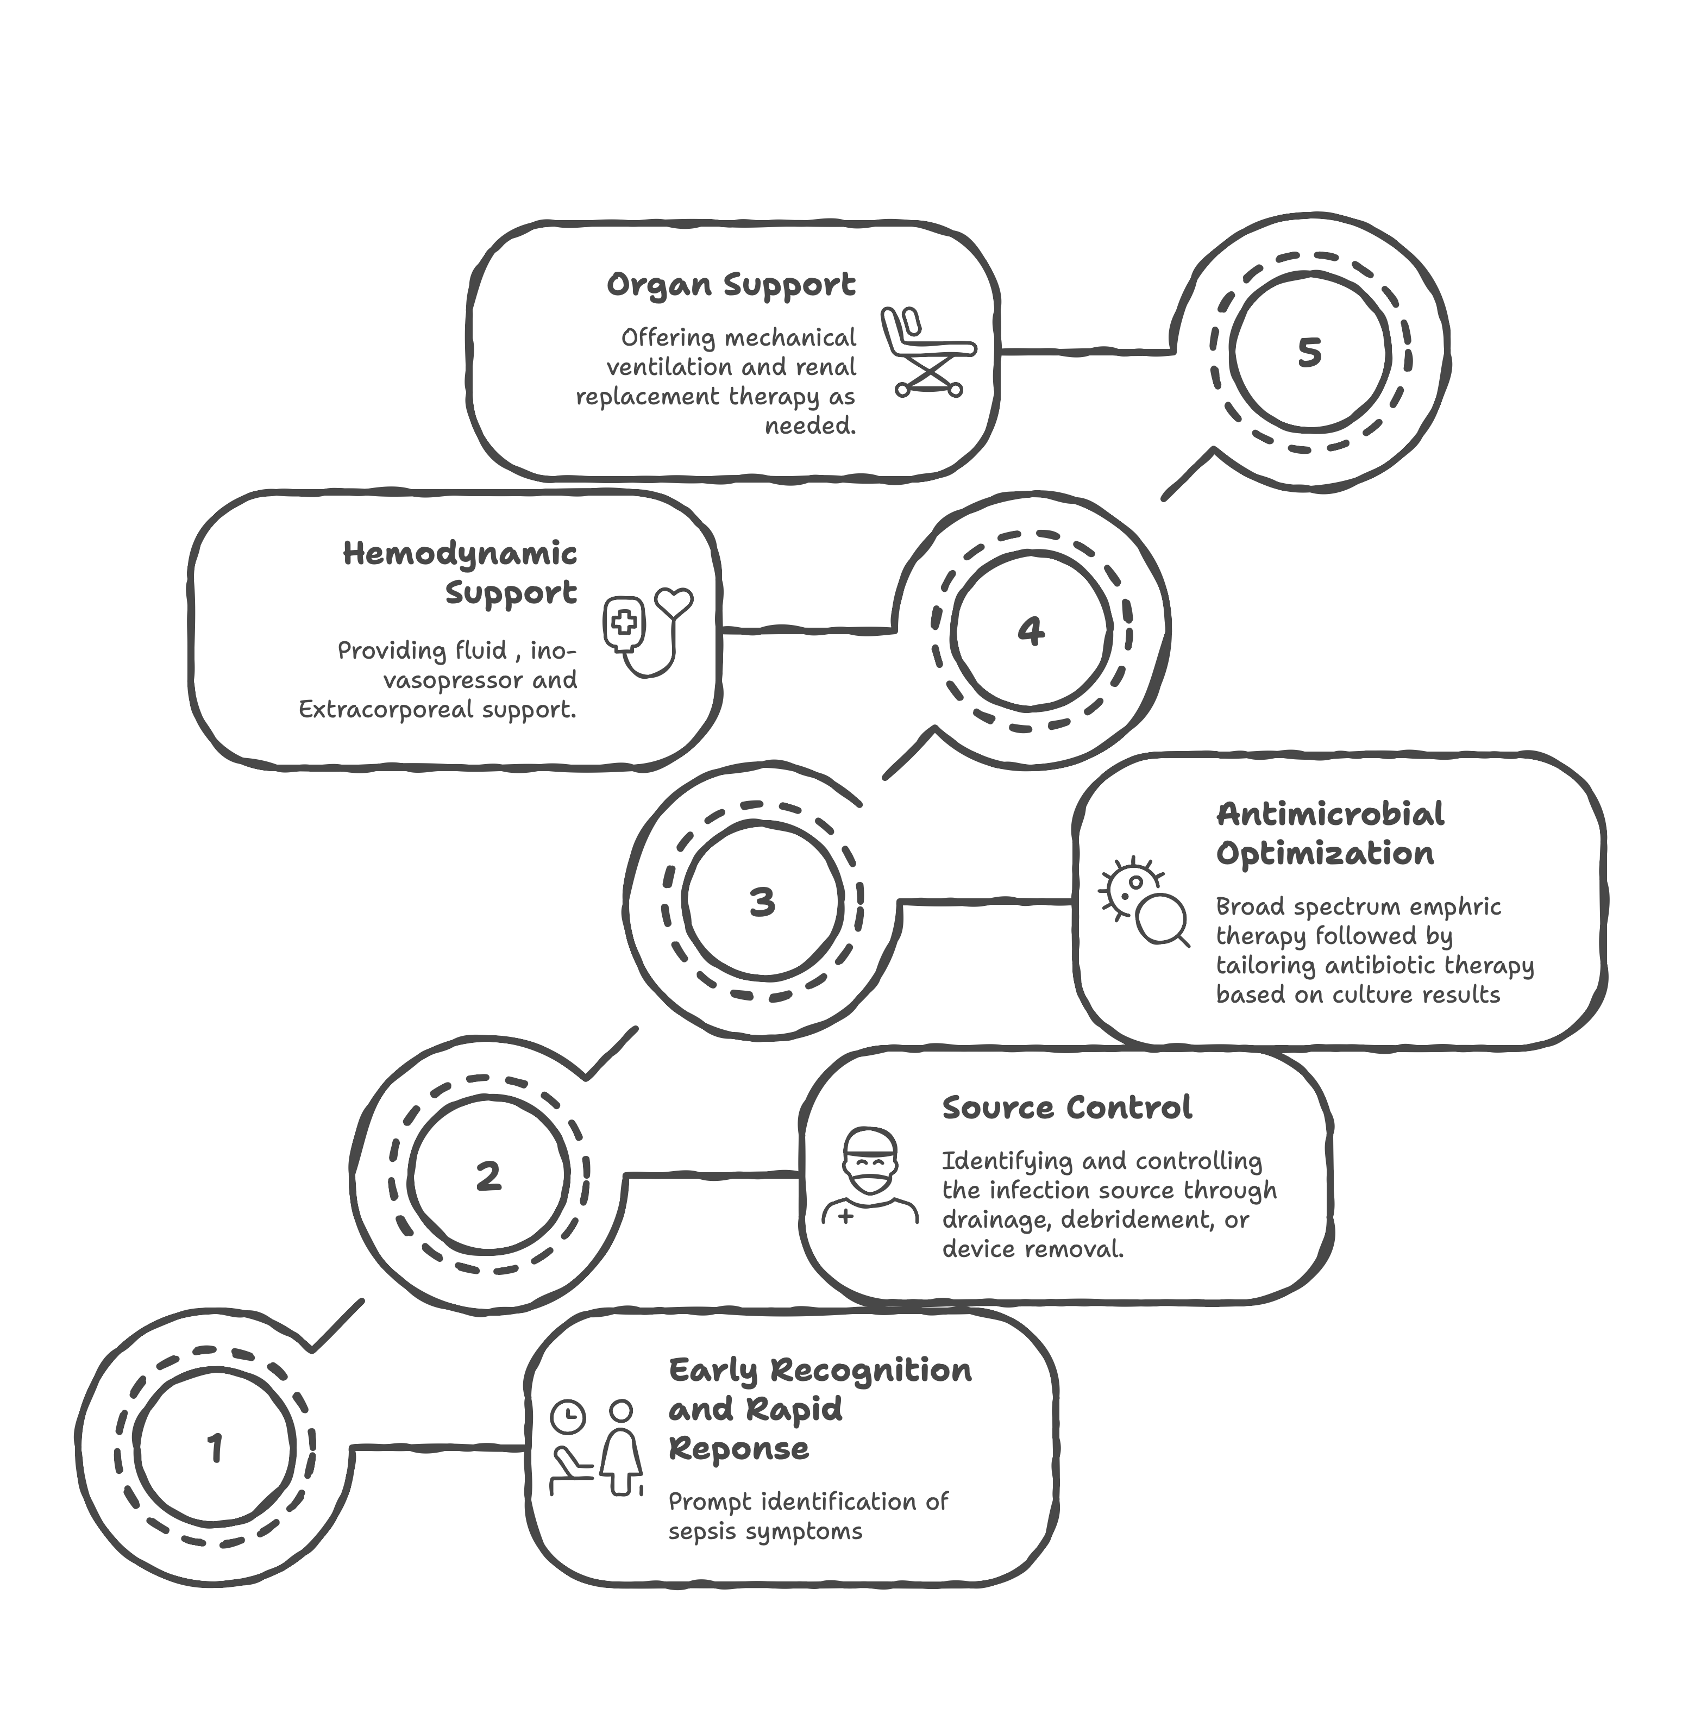**6.Hemodynamic Management**

Hemodynamic management represents a cornerstone of sepsis treatment, as delayed or inadequate management can lead to hypoperfusion, tissue hypoxia, and multiple organ failure.

**Initial Resuscitation**

The primary goal of hemodynamic management in sepsis is to restore adequate tissue perfusion within the "golden hour" of recognition. Early interventions focus on optimizing preload, maintaining adequate perfusion pressure, and ensuring sufficient oxygen delivery to tissues.

**The Golden Hour Concept**

Time to intervention strongly correlates with outcomes in sepsis. Each hour of delay in appropriate antibiotic administration increases mortality risk, emphasizing the critical importance of rapid recognition and treatment initiation. [26,27]

**Fluid Resuscitation Strategies**

**Initial Fluid Bolus**

Current guidelines recommend an initial fluid bolus of 30 mL/kg of crystalloid within the first hours for patients with sepsis-induced hypoperfusion or septic shock. However, this should be individualized based on patient factors. [4]

**Normal Saline versus Balanced Crystalloids**

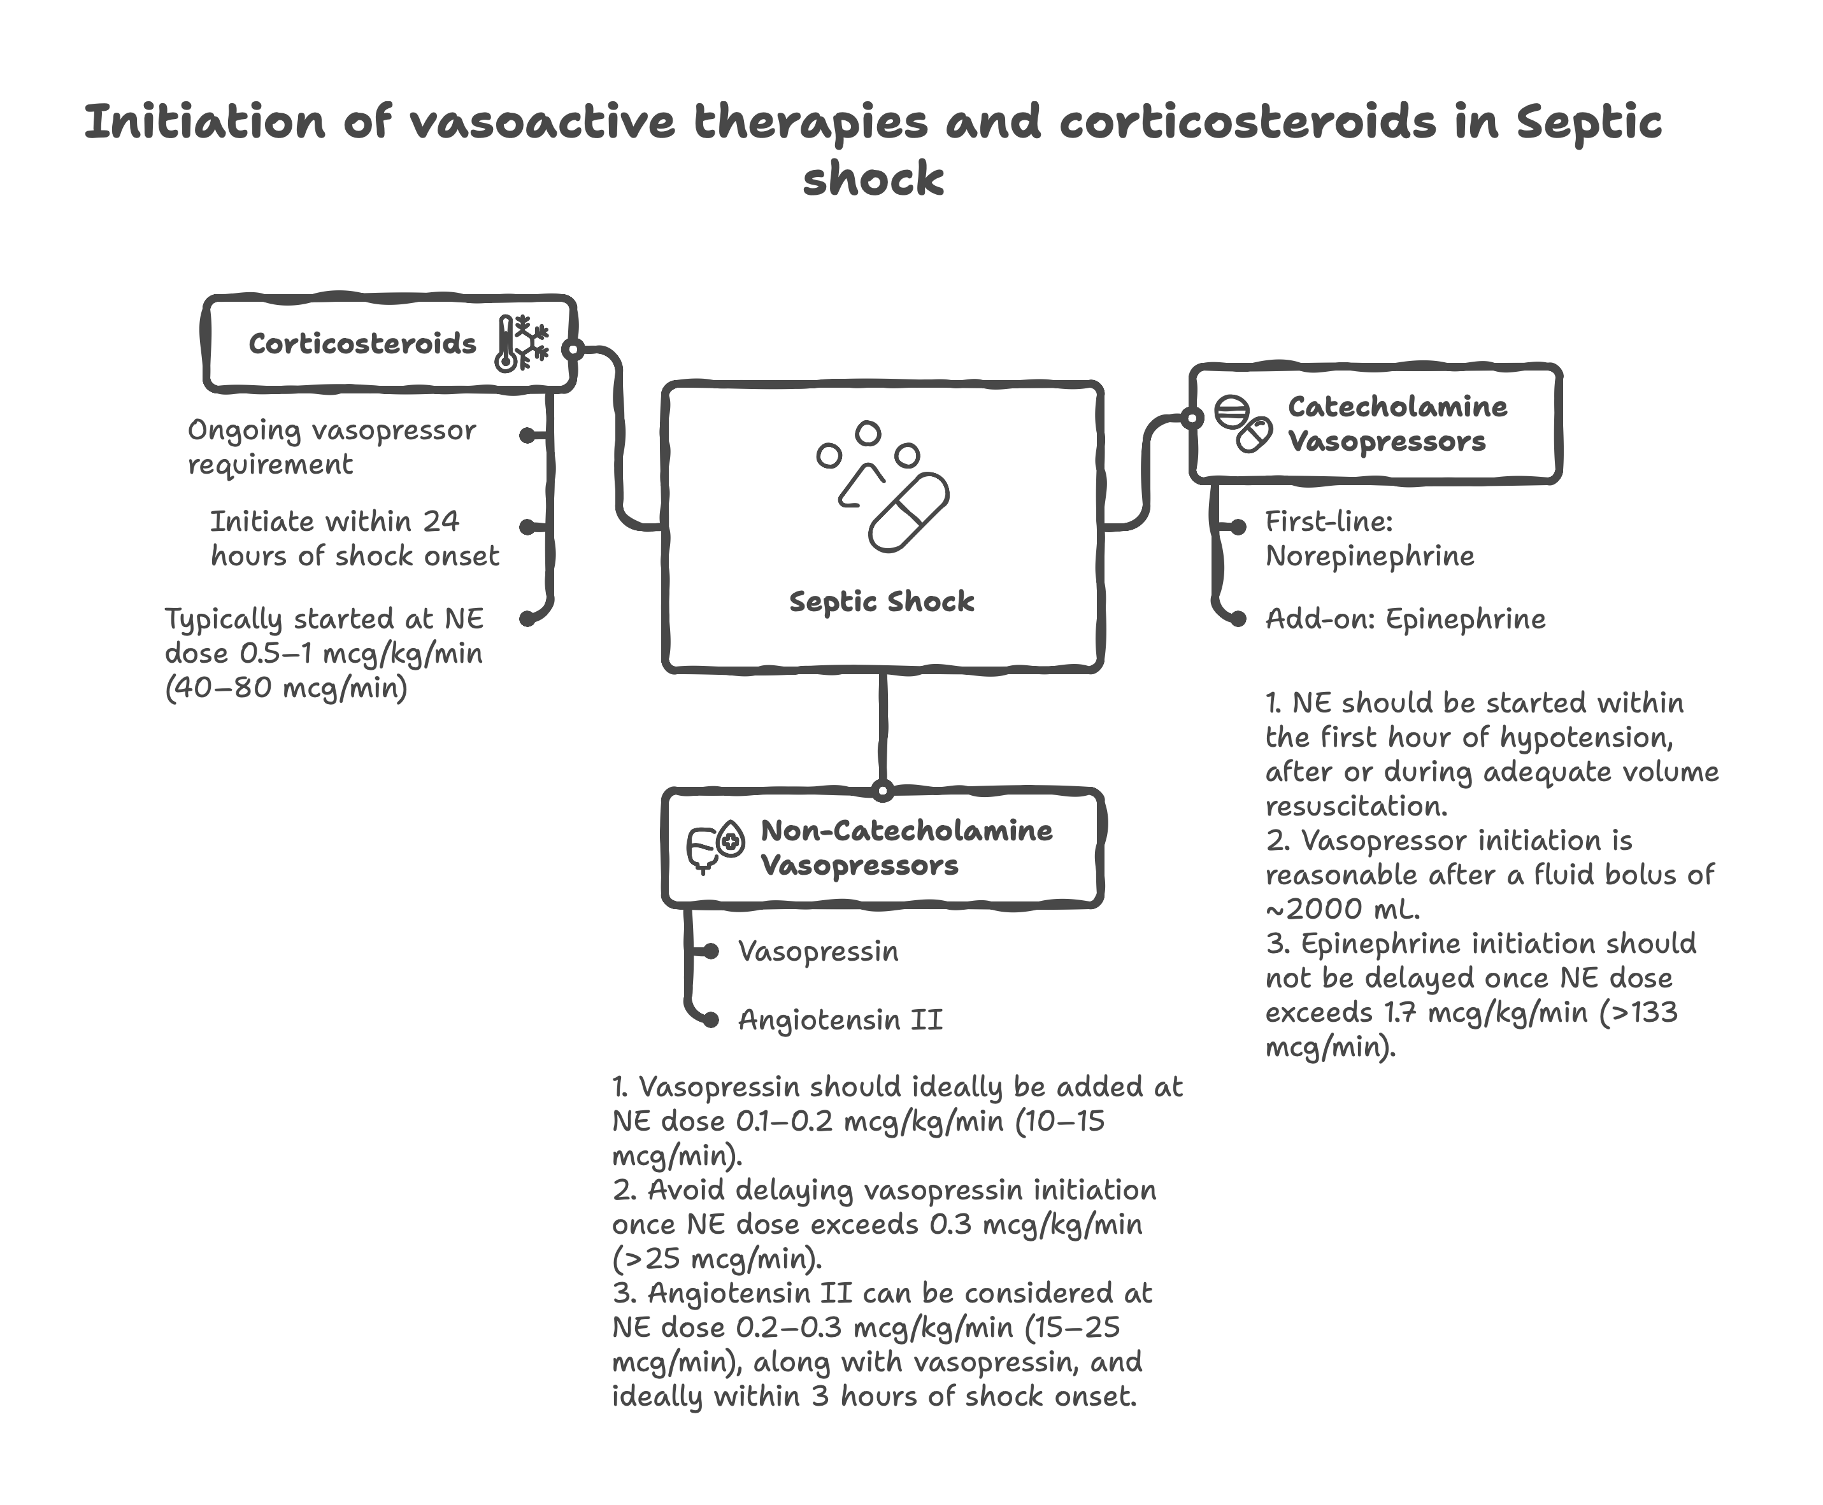**Mechanistic Rationale**: Normal saline contains supraphysiological chloride concentrations (154 mEq/L) that can cause hyperchloremic metabolic acidosis and renal vasoconstriction. Balanced crystalloids more closely approximate plasma electrolyte composition.

**Albumin in Sepsis**

**Current Recommendations**: Albumin may be considered in septic patients with hypoalbuminemia and significant capillary leak, particularly those requiring large volumes of crystalloids.

|  |  |  |  |  |  |  |
| --- | --- | --- | --- | --- | --- | --- |
| Trial Name (Year) | Type of RCT | Sample Size | Eligibility Criteria | Intervention | Primary Outcome | Conclusion |
| Rivers EGDT (Rivers et al.) (2001) | Single-center, randomized, controlled | 263 patients | Inclusion: Severe sepsis/septic shock in ED, SBP <90 mmHg after fluid challenge or lactate ≥4 mmol/L<br>Exclusion: Age <18 yrs, pregnancy, acute cerebrovascular event, acute coronary syndrome, active GI bleeding, seizure, drug overdose | EGDT: Protocolized care targeting CVP 8-12 mmHg, MAP ≥65 mmHg, urine output ≥0.5 mL/kg/hr, ScvO2 ≥70% using fluids, vasopressors, inotropes, transfusion<br>Standard care: Standard resuscitation per physician discretion | Outcome: In-hospital mortality<br>Result: EGDT 30.5% vs Standard care 46.5% (p=0.009; 16% absolute reduction) | EGDT significantly reduces mortality in severe sepsis/septic shock; established foundation for sepsis bundles and protocolized care |
| ProCESS (Yealy et al.) (2014) | Multicenter, randomized, controlled | 1,341 patients | Inclusion: Suspected infection, ≥2 SIRS criteria, SBP <90 mmHg after 1L fluid or lactate ≥4 mmol/L<br>Exclusion: Age <18 yrs, pregnancy, contraindication to central line, comfort care only | Protocol-based EGDT: Rivers protocol with ScvO2 monitoring<br>Protocol-based standard therapy: Structured care without ScvO2 monitoring<br>Usual care: Physician discretion | Outcome: 60-day mortality<br>Result: EGDT 21.0% vs Protocol-based 18.2% vs Usual care 18.9% (p=0.83) | No difference in mortality between EGDT, protocol-based care, or usual care; questions necessity of ScvO2 monitoring |
| ARISE (Peake et al.) (2014) | Multicenter, randomized, controlled | 1,600 patients | Inclusion: Suspected infection, ≥2 SIRS criteria, refractory hypotension or hyperlactatemia ≥4 mmol/L<br>Exclusion: Age <18 yrs, pregnancy, limitation of care, contraindication to central access | EGDT: Modified Rivers protocol targeting CVP, MAP, urine output, ScvO2 ≥70%<br>Usual care: Standard resuscitation per treating clinician | Outcome: 90-day mortality<br>Result: EGDT 18.6% vs Usual care 18.8% (p=0.90) | EGDT does not improve survival vs usual care in early septic shock; no benefit from protocolized ScvO2-guided therapy |
| ProMISe (Mouncey et al.) (2015) | Multicenter, randomized, controlled | 1,260 patients | Inclusion: Adults presenting to ED with septic shock, systolic BP <90 mmHg after fluid challenge or lactate ≥4 mmol/L<br>Exclusion: Pregnancy, severe heart failure, treatment limitation, active bleeding | EGDT: Protocolized resuscitation with ScvO2 monitoring, targeting CVP, MAP, urine output, ScvO2 ≥70%<br>Usual care: Resuscitation per local protocols without mandated ScvO2 monitoring | Outcome: 90-day mortality<br>Result: EGDT 29.5% vs Usual care 29.2% (p=0.90) | EGDT with ScvO2 monitoring does not reduce mortality vs usual care; confirms findings of ProCESS and ARISE |
| Jones et al. Lactate Clearance (2010) | Single-center, randomized, controlled | 300 patients | Inclusion: Severe sepsis/septic shock, lactate ≥4 mmol/L, MAP and CVP optimized<br>Exclusion: Age <18 yrs, pregnancy, comfort care, contraindication to ScvO2 monitoring | Lactate clearance: Target ≥10% lactate clearance every 2 hours<br>ScvO2 monitoring: Target ScvO2 ≥70% | Outcome: In-hospital mortality<br>Result: Lactate clearance 17% vs ScvO2 23% (p=0.31) | Lactate clearance ≥10% is equivalent to ScvO2 ≥70% as resuscitation target; simpler and more accessible endpoint |
| ANDROMEDA-SHOCK (Hernandez et al.) (2019) | Multicenter, randomized, controlled | 424 patients | Inclusion: Septic shock within 4hrs, age ≥18 yrs, requiring norepinephrine ≥0.1 μg/kg/min<br>Exclusion: Pregnancy, cardiogenic shock, acute bleeding, severe liver disease, palliative care | Peripheral perfusion: Target capillary refill time ≤3 seconds<br>Lactate-targeted: Target lactate normalization or ≥20% decrease every 2 hours | Outcome: 28-day mortality<br>Result: Peripheral perfusion 34.9% vs Lactate-targeted 43.4% (p=0.06; HR 0.75) | Peripheral perfusion-guided resuscitation shows trend toward lower mortality vs lactate-targeted approach; challenges biochemical targets |
| CENSER (LACTATE Trial) (2023) | Multicenter, randomized, controlled | 380 patients | Inclusion: Septic shock, initial lactate 2-10 mmol/L, MAP ≥65 mmHg achieved<br>Exclusion: Chronic liver disease, malignancy with poor prognosis, limitation of care | Lactate-guided: Target lactate clearance ≥20% every 2 hours or normalization<br>Clinician-directed: Resuscitation per standard care without mandatory lactate targets | Outcome: 28-day mortality<br>Result: Lactate-guided 25.8% vs Clinician-directed 28.4% (p=0.62) | No mortality benefit from lactate-guided resuscitation vs standard care once hemodynamic stability achieved |

## 

## **Insights**

**EGDT Era (2001-2013):** Rivers' landmark study established EGDT as the gold standard, showing dramatic 16% absolute mortality reduction with protocolized care targeting CVP, MAP, urine output, and ScvO2 ≥70%. This revolutionized sepsis care and formed the foundation for Surviving Sepsis Campaign bundles.   
Historical significance: The study's impact extended beyond the protocol itself to emphasize systematic, time-sensitive care. [18]

**EGDT Debunking (2014-2015):** The ProCESS, ARISE, and ProMISe trials (total n=4,201 patients) consistently showed no mortality benefit from EGDT vs usual care. Key insight: These trials suggested that improved outcomes from the Rivers study reflected systematic care implementation rather than specific ScvO2 targets. Patient-level meta-analysis of these three trials confirmed no mortality benefit (OR 1.01, 95% CI 0.87-1.18). [18]

**Current Evidence-Based Practice:** Focus on systematic care delivery rather than specific physiologic targets. Core elements: Timely antibiotics, adequate fluid resuscitation, vasopressor support for MAP ≥65 mmHg, and source control. Monitoring: Lactate trending more practical than ScvO2; consider clinical perfusion markers (capillary refill, skin mottling, mental status).

**MAP Targets**

**Standard Target: ≥65 mmHg**

The current recommendation for MAP targets in septic shock is ≥65 mmHg based on expert consensus and observational data.

**Individualized MAP Targets**

**Chronic Hypertensive Patients**: The SEPSISPAM trial demonstrated that patients with pre-existing hypertension benefit from higher MAP targets (80-85 mmHg) with reduced acute kidney injury. This likely reflects rightward-shifted autoregulation curves in chronically hypertensive patients. [6]

**Dynamic Assessment**: MAP targets should be individualized based on perfusion markers including lactate clearance, urine output, mental status, and capillary refill time rather than relying solely on arbitrary pressure targets.

|  |  |  |  |  |  |  |
| --- | --- | --- | --- | --- | --- | --- |
| Trial Name (Year) | Type of RCT | Sample Size | Eligibility Criteria | Intervention | Primary Outcome | Conclusion |
| SEPSISPAM (Asfar et al.) (2014) | Multicenter, randomized, open-label, controlled | 776 patients | Inclusion: Septic shock requiring vasopressors for >2hrs, age ≥18 yrs Exclusion: Pregnancy, limitation of life support, moribund state, contraindications to catecholamines | High target: MAP 80-85 mmHg Low target: MAP 65-70 mmHg Both groups used norepinephrine ± epinephrine | Outcome: 28-day mortality Result: High target 36.6% vs Low target 34.0% (p=0.57; HR 1.07) | No mortality difference between MAP targets of 80-85 vs 65-70 mmHg; higher target increased arrhythmias but reduced RRT need in hypertensive patients |
| OVATION (Lamontagne et al.) (2016) | Pilot multicenter, randomized, controlled | 118 patients | Inclusion: Vasodilatory shock requiring vasopressors, age ≥18 yrs, expected to survive >24hrs Exclusion: Pregnancy, acute coronary syndrome, limitation of care, previous enrollment | Higher target: MAP 75-80 mmHg Lower target: MAP 60-65 mmHg Primary vasopressor was norepinephrine | Outcome: Feasibility (protocol adherence, separation of MAP targets) Result: Mean achieved MAP: Higher 75±8 mmHg vs Lower 67±8 mmHg (p<0.001) | Pilot study confirmed feasibility of maintaining different MAP targets; no mortality difference but underpowered for clinical outcomes |
| The 65 Trial (Lamontagne et al.) (2020) | Multicenter, randomized, open-label, controlled | 2,600 patients | Inclusion: Age ≥65 yrs, vasodilatory hypotension, receiving vasopressors in ICU Exclusion: Acute coronary syndrome, acute stroke, active bleeding, life expectancy <90 days | Permissive hypotension: MAP 60-65 mmHg Usual care: MAP per local protocol (typically ≥65 mmHg) Norepinephrine was primary vasopressor | Outcome: 90-day mortality Result: Permissive 41.0% vs Usual care 43.8% (p=0.12; HR 0.91) | Permissive hypotension (MAP 60-65) did not reduce mortality vs usual care in elderly patients; reduced vasopressor exposure without increased adverse events |
| ANDROMEDA-SHOCK (Hernandez et al.) (2019) | Multicenter, randomized, controlled | 424 patients | Inclusion: Septic shock within 4hrs, age ≥18 yrs, requiring norepinephrine ≥0.1 μg/kg/min Exclusion: Pregnancy, cardiogenic shock, acute bleeding, severe liver disease, palliative care | Perfusion-guided: Target capillary refill time ≤3 seconds (MAP adjusted as needed) MAP-guided: Target MAP ≥65 mmHg | Outcome: 28-day mortality Result: Perfusion-guided 34.9% vs MAP-guided 43.4% (p=0.06; HR 0.75) | Perfusion-guided resuscitation targeting capillary refill time showed trend toward lower mortality vs standard MAP targets; challenges traditional MAP-focused approach |
| SEPSISPAM Subgroup (Chronic HTN) (Asfar et al.) (2014) | Post-hoc subgroup analysis | 269 patients with chronic hypertension | Inclusion: Septic shock patients from SEPSISPAM trial with documented chronic hypertension Exclusion: Same as parent SEPSISPAM trial | High target: MAP 80-85 mmHg Low target: MAP 65-70 mmHg Analysis of hypertensive subgroup | Outcome: Need for renal replacement therapy Result: High target 31% vs Low target 42% requiring RRT (p=0.05) | In chronically hypertensive patients with septic shock, higher MAP targets (80-85 mmHg) reduced need for RRT without affecting mortality |

## 

## **Insights**

**Standard Target Establishment (2014):** SEPSISPAM, the largest and most definitive MAP target trial, established that MAP 65-70 mmHg is as effective as MAP 80-85 mmHg for mortality outcomes in septic shock. This landmark trial included 776 patients and definitively showed no mortality benefit from higher targets in the general septic shock population. [6]

**Population-Specific Considerations:** Chronic Hypertension Subgroup: SEPSISPAM's post-hoc analysis revealed that patients with chronic hypertension had significantly less renal dysfunction (31% vs 42% requiring RRT) when targeted to MAP 80-85 mmHg, suggesting these patients may benefit from higher targets due to rightward-shifted autoregulation curves.

**Elderly Population Evidence (2020):** The 65 Trial challenged traditional MAP targets by testing permissive hypotension (MAP 60-65 mmHg) in patients ≥65 years old. Results showed no mortality difference but significantly reduced vasopressor exposure, suggesting elderly patients may tolerate lower MAP targets without harm. [7,8]

**Alternative Targets (2019):** ANDROMEDA-SHOCK introduced perfusion-guided resuscitation targeting capillary refill time ≤3 seconds rather than MAP ≥65 mmHg. This approach showed a trend toward improved mortality (p=0.06), challenging the traditional MAP-centric approach and emphasizing tissue perfusion over pressure.

**Vasopressor Toxicity Considerations:** Higher MAP targets consistently require higher vasopressor doses, leading to increased adverse effects. SEPSISPAM showed increased atrial fibrillation with higher MAP targets (23% vs 15%, p=0.02). The benefit-risk balance favors lower targets in most patients.

**Current Evidence-Based Practice:** Standard recommendation: MAP ≥65 mmHg for most septic shock patients. Individualization: Consider MAP 70-80 mmHg for patients with chronic hypertension to preserve kidney function. Elderly patients: MAP 60-65 mmHg may be acceptable to minimize vasopressor exposure. Monitor perfusion: Consider alternative perfusion markers (capillary refill, lactate clearance, urine output) alongside MAP.

**Personalized Approach**

Recent evidence emphasizes that hemodynamic management should be individualized based on patient characteristics, sepsis phenotype, and response to initial interventions.

**Personalized Approach to Shock Resuscitation Using the Four-Interface Model**

Based on the holistic four-interface conceptual model by Rola et al., there is a systematic **three-step approach** for personalizing shock resuscitation that integrates physiological assessment with dynamic monitoring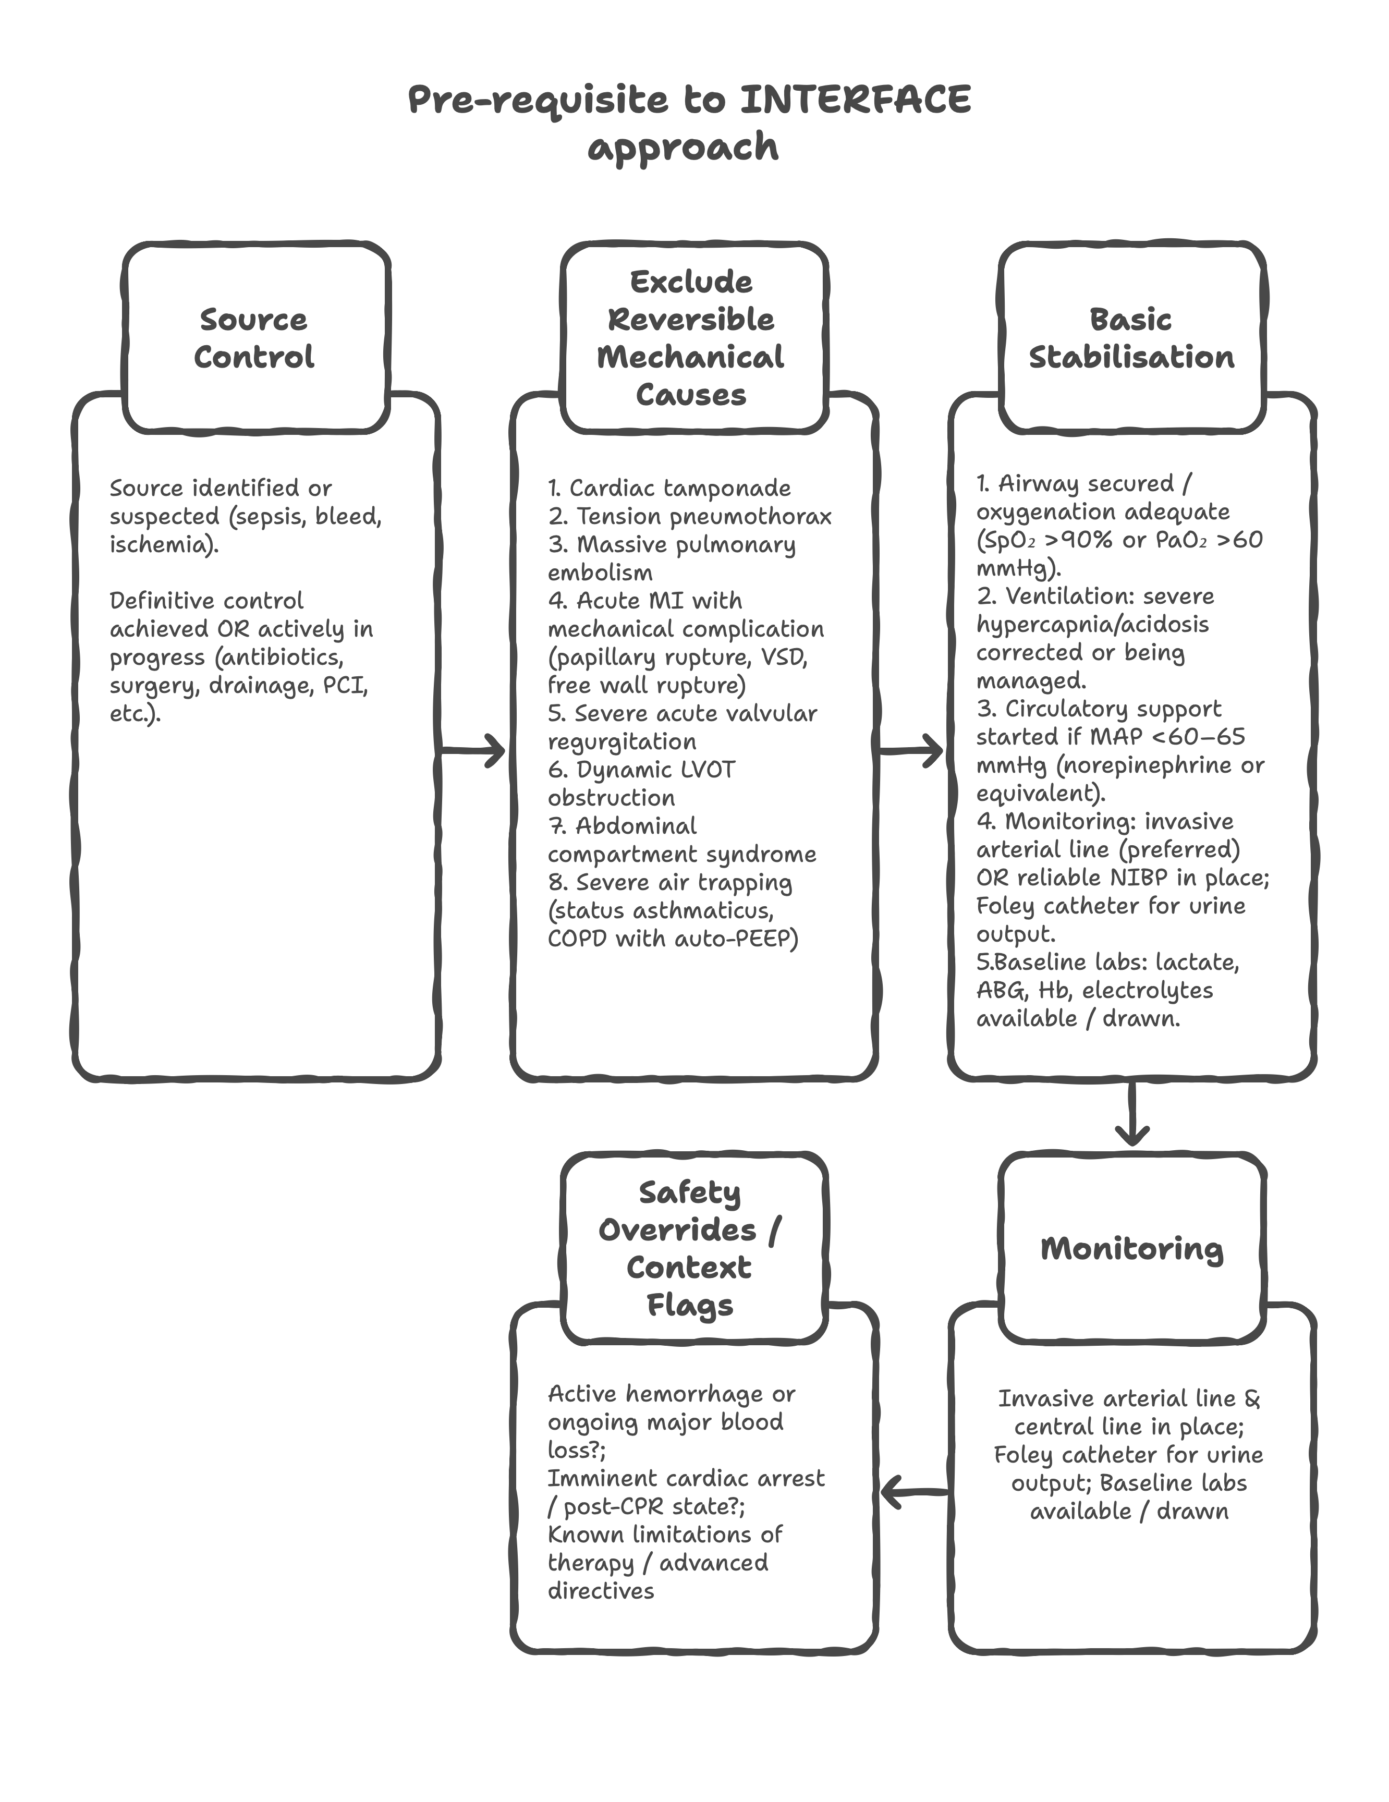 [15]

👉 Proceed to **Step 1 (Place on Forrester–Kenny diagram)** **only if all above are checked/justified**.  
👉 If any box unchecked → fix or escalate *before* applying the 3-step model.

**Step 1: Placing the Patient in the Modified Forrester Kenny Diagram**

**Initial Phenotyping and Quadrant Assignment**

In the first minutes of initial assessment, place the shock patient into one of four quadrants using:

* **Y-axis**: Measure of venous congestion
* **X-axis**: Measure of forward flow or stroke volume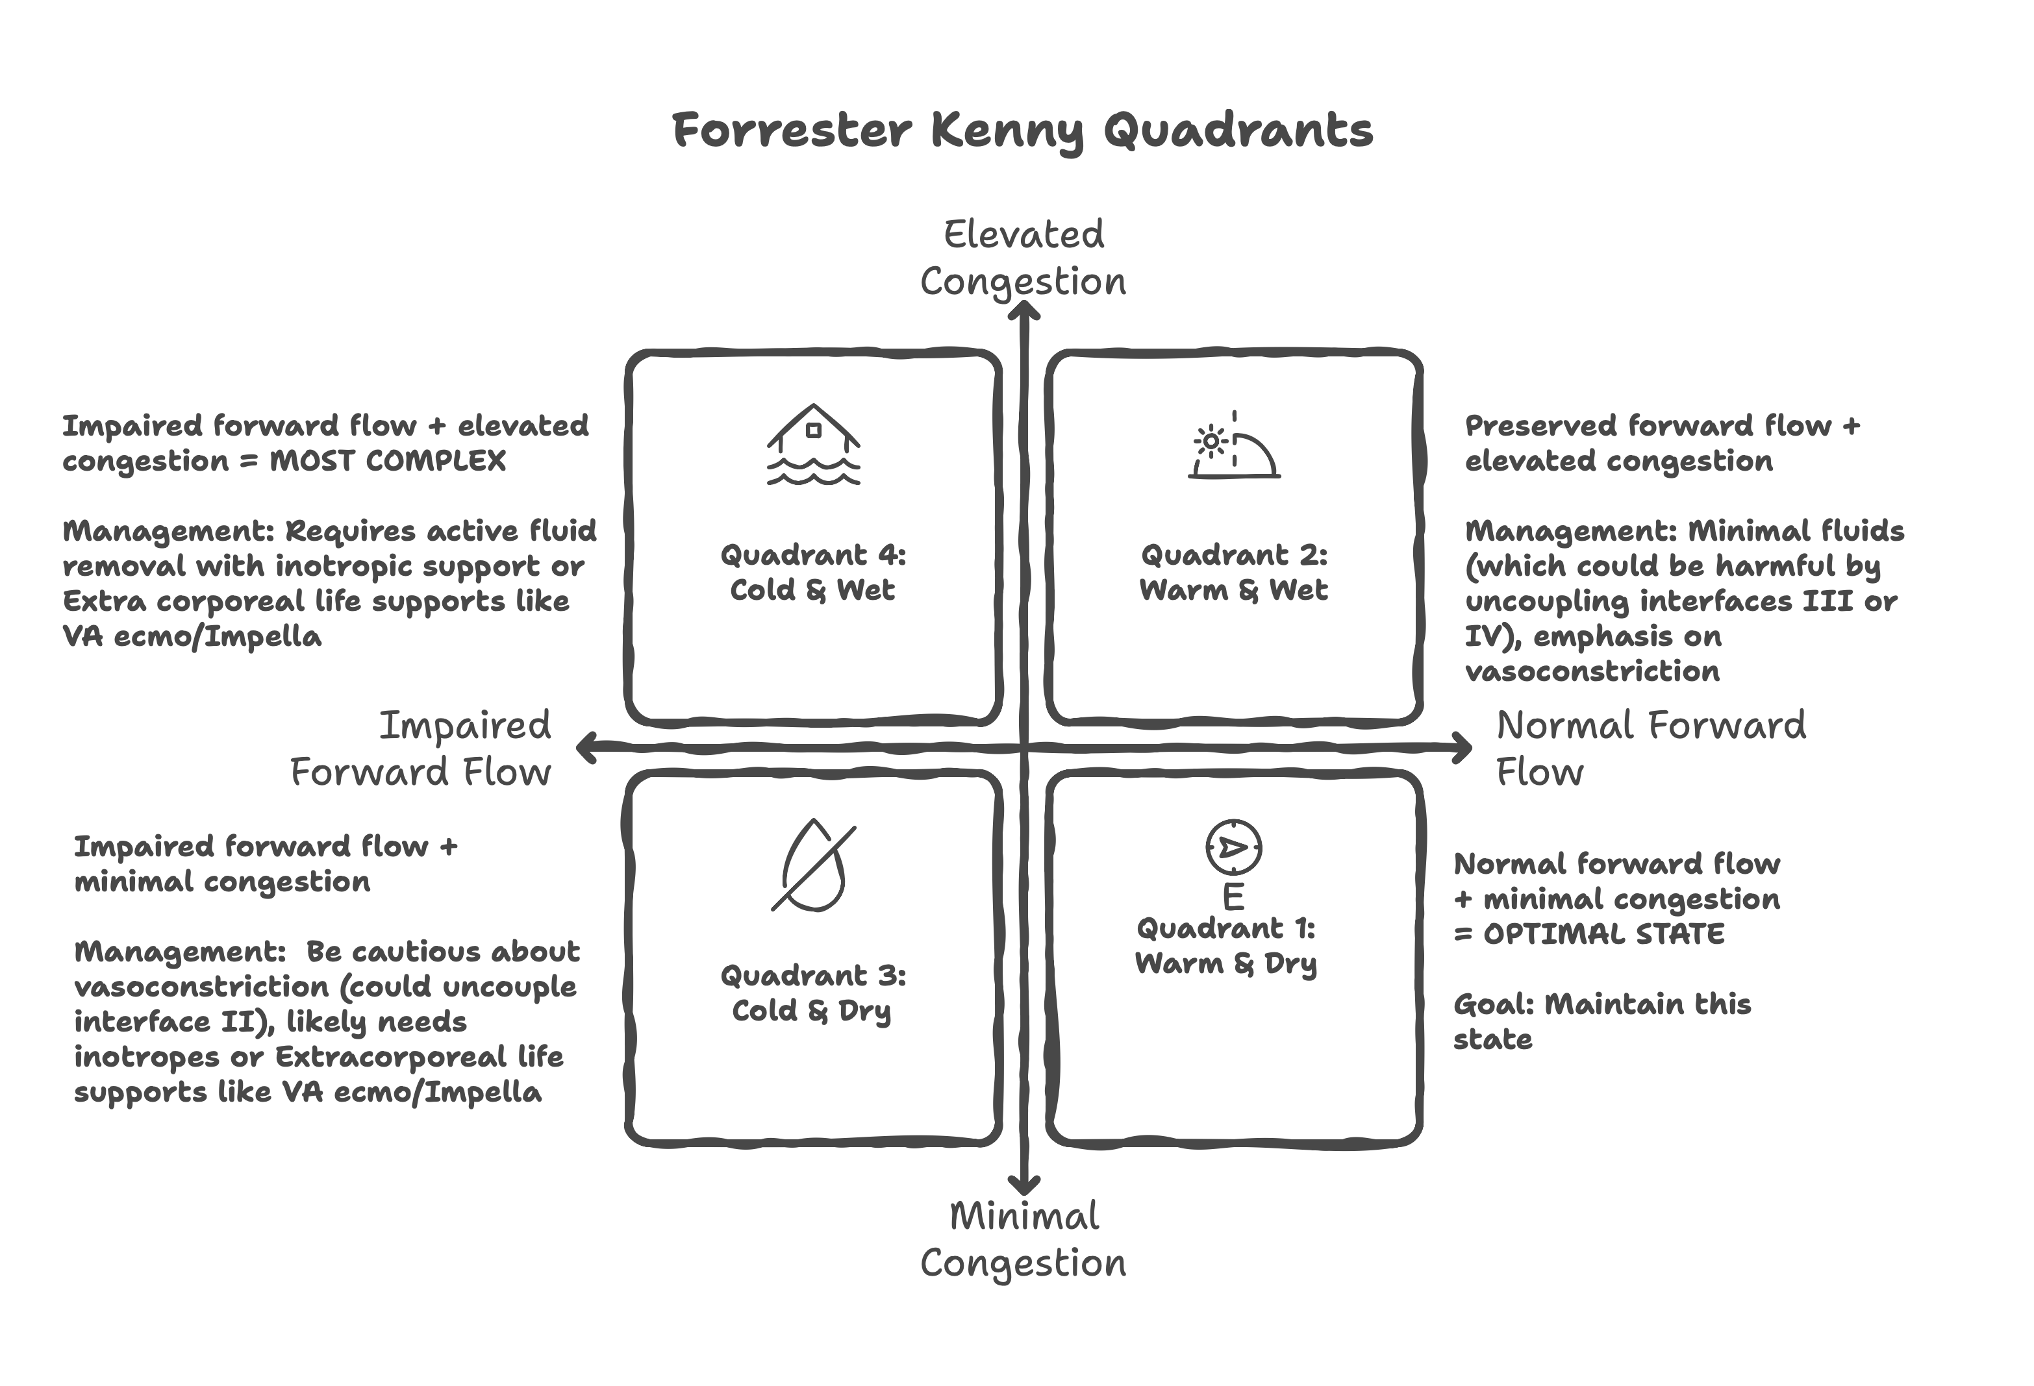

**Assessment Parameters:**

* **Forward Flow Measures**: LVOT-VTI, stroke volume, cardiac output, carotid corrected flow time, pulse pressure
* **Congestion Measures**: JVP, VExUS score, CVP, femoral vein Doppler patterns, clinical signs [15]

**Step 2: Assessing the Four Interfaces**

**Systematic Interface Evaluation to Identify Primary Dysfunction**

After initial quadrant placement, systematically evaluate each interface to identify the most severely affected:

**Interface I: Left Ventricular-Arterial Coupling (Ea/Ees)**

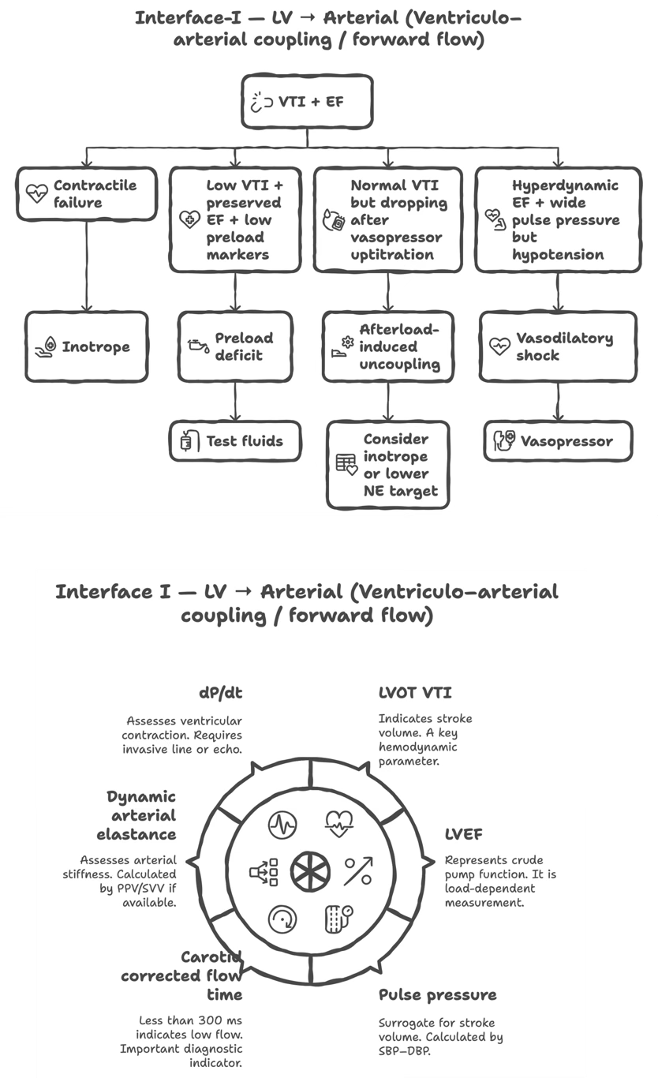

**Interface II: Arteriolar-Capillary (Macro-to-Microcirculation)**

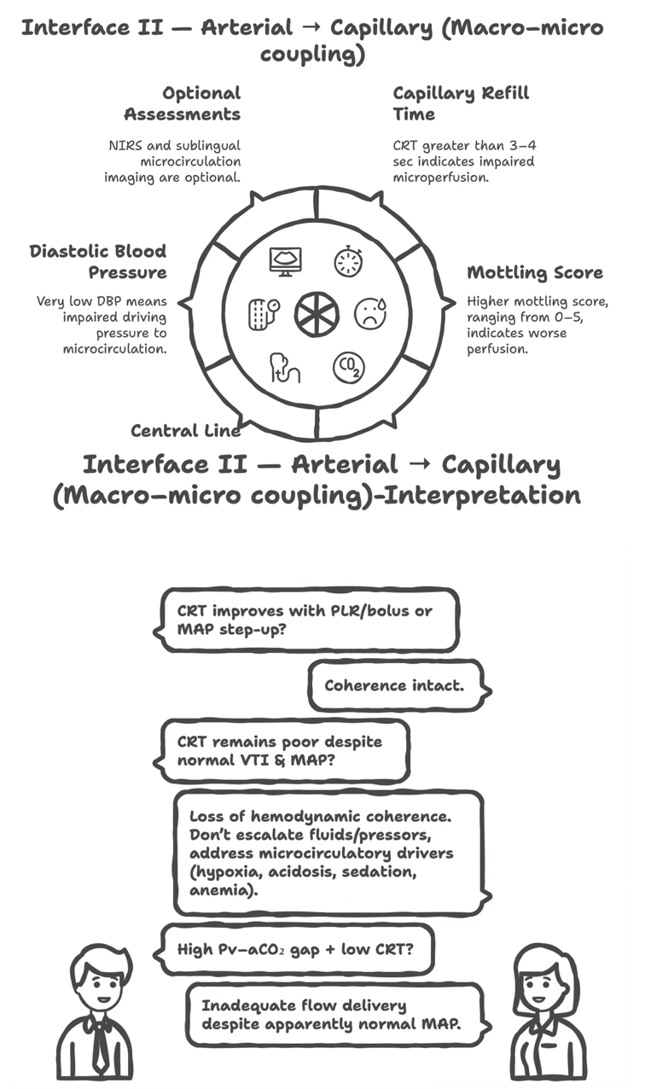

**Interface III: Capillary-Venular (Venous Congestion)**

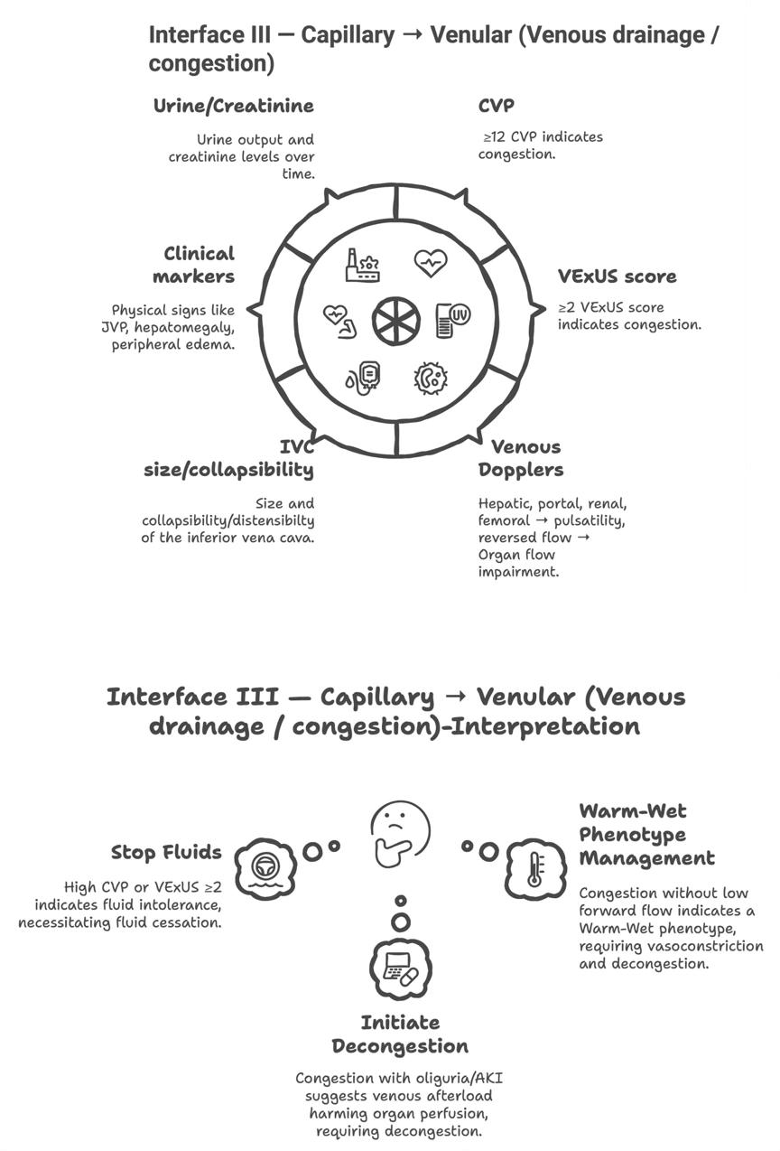

**Interface IV: Right Ventricular-Pulmonary Arterial Coupling (Ees/Ea)**

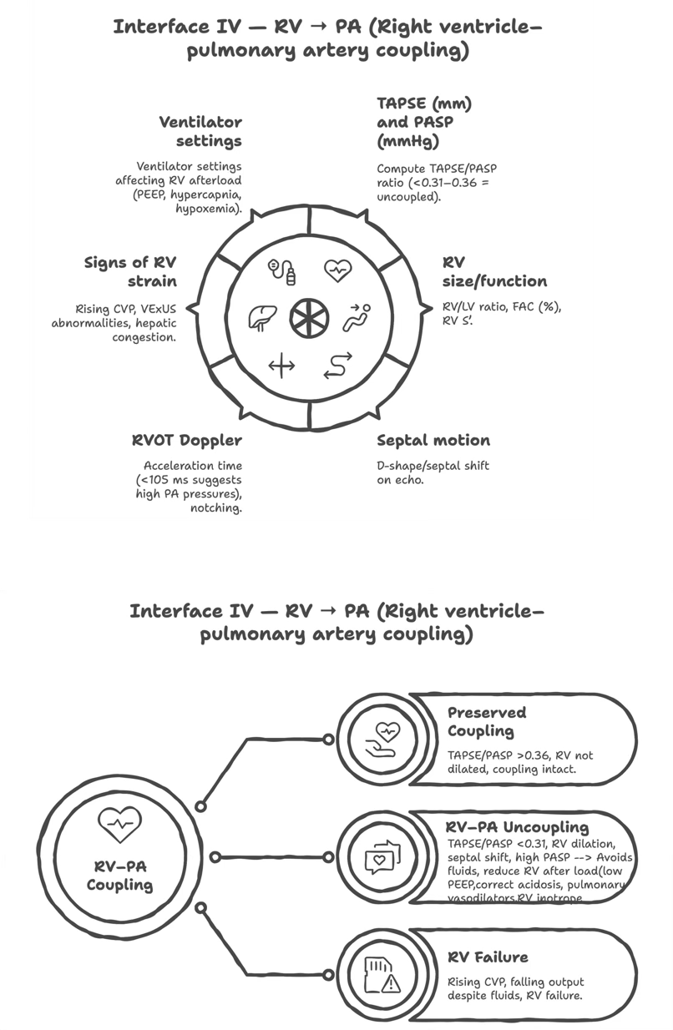

**Step 3: Tracking Progress on the Modified Forrester Diagram**

**Dynamic Reassessment and Therapeutic Adjustment**

Continuously re-evaluate and re-plot the patient on the four-quadrant diagram:

**Goal-Directed Movement**

* **Target**: Move patient toward **Quadrant 1 (Warm & Dry)**
* **Objective**: Achieve perfusion without congestion with reasonable coupling of all interfaces

**Therapeutic Adjustments Based on Interface Findings**

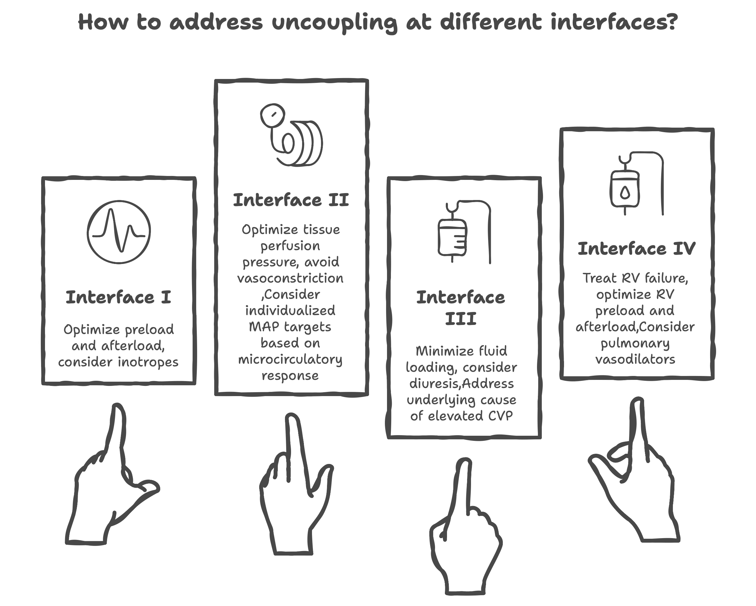

**Continuous Monitoring Principles**

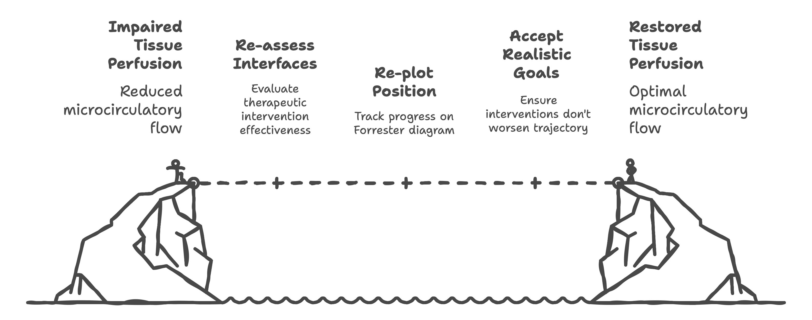

**Key Clinical Insights**

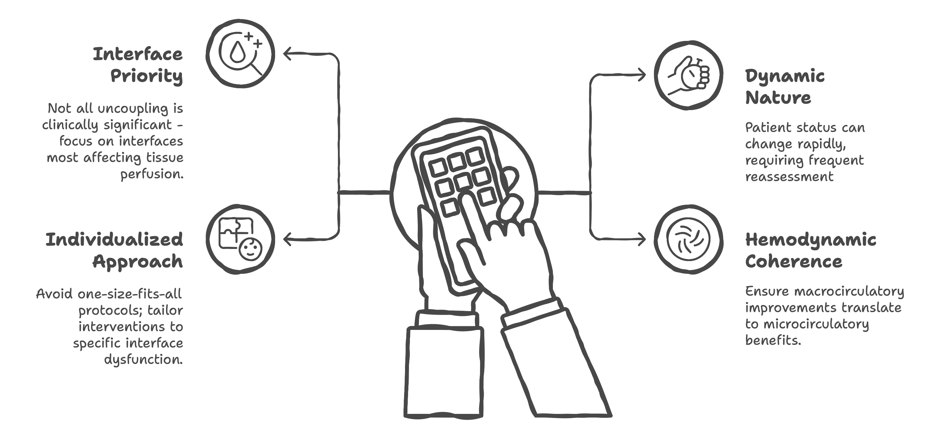

This three-step approach transforms shock resuscitation from protocolized care to **physiologically-guided, precision medicine**, addressing the complex, interconnected nature of cardiovascular dysfunction while avoiding therapeutic interventions that may inadvertently worsen tissue perfusion despite improving macrocirculatory parameters.

**7. Antimicrobial Therapy and Source Control**

**Antimicrobial Therapy**

**Timing and Selection**:  
Antimicrobial therapy represents the first pillar of sepsis treatment. Current guidelines recommend administration within 1 hour of sepsis recognition, as each hour of delay significantly increases mortality. [4,26,27]

**Empiric Therapy Principles**: 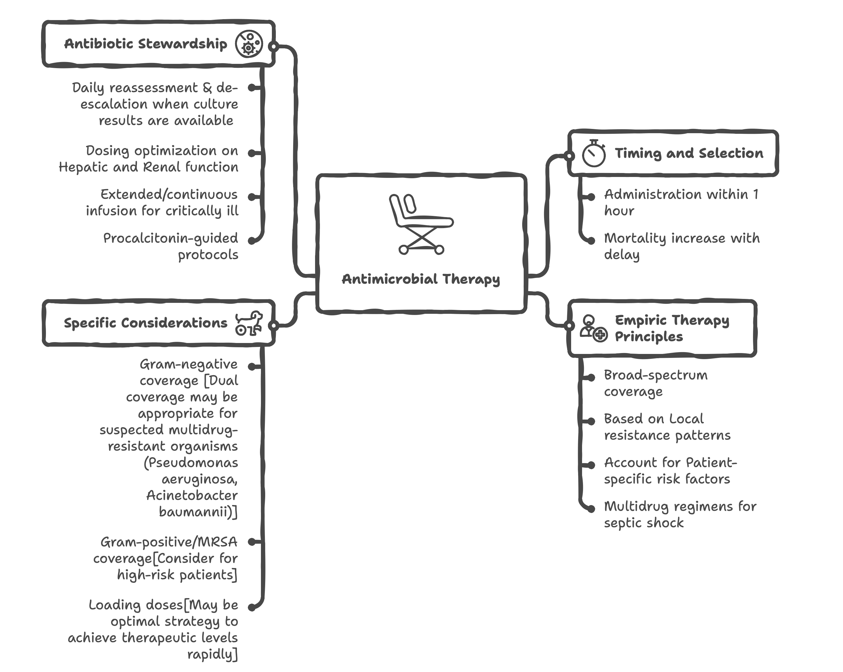

**Source Control**

Source control involves identification and elimination of the anatomical source of infection through:

**Timing**: Should be accomplished as soon as medically feasible, ideally within 6-12 hours of diagnosis. 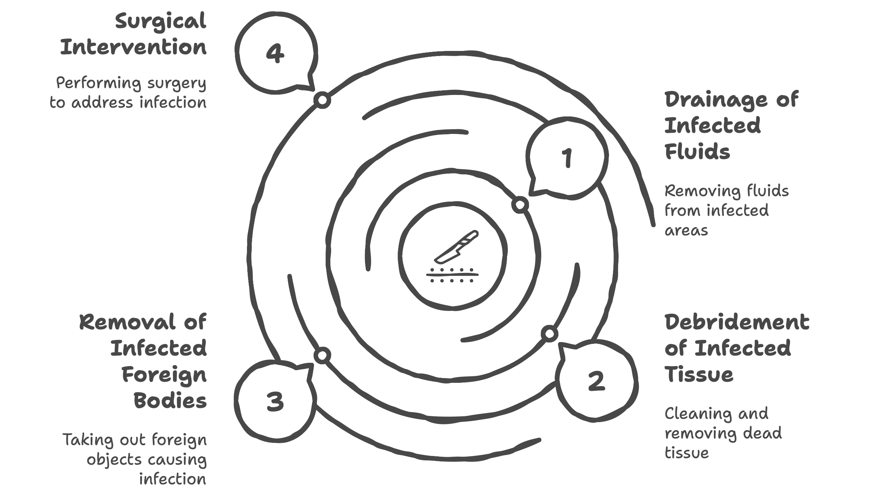

**8. Adjunctive Therapies**

While antimicrobials, fluid resuscitation, and vasopressors remain the cornerstone treatments, several adjunctive therapies may be considered in specific clinical scenarios.

**Corticosteroids**

|  |  |  |  |  |  |  |
| --- | --- | --- | --- | --- | --- | --- |
| (Year) | Type of RCT | Sample Size | Eligibility Criteria | Intervention | Primary Outcome | Conclusion |
| CSG (Bennett et al.)  (1963) | Prospective, randomized, double-blind, placebo-controlled | ~100 patients | Inclusion: Severe sepsis and septic shock with clinical evidence of infection Exclusion: Not specified in detail | Hydrocortisone 100mg oral vs placebo | Outcome: 28-day mortality Result: No significant survival difference between groups | No survival benefit from hydrocortisone in severe sepsis |
| Schumer  (1976) | Prospective + retrospective analysis | 172 patients (prospective) | Inclusion: Adult surgical patients with septic shock Exclusion: Poor prognosis conditions | High-dose methylprednisolone (30mg/kg IV) or dexamethasone (3mg/kg IV) vs placebo | Outcome: Hospital mortality Result: Mortality: methylprednisolone 11.6%, dexamethasone 9.3% vs placebo 38.4% | High-dose steroids significantly reduce mortality in septic shock |
| Sprung et al.  (1984) | Prospective, controlled, double-blind | 59 patients | Inclusion: Septic shock patients with hypotension despite fluid resuscitation Exclusion: Previous steroid use, immunosuppression | High-dose methylprednisolone (30mg/kg q6h × 4 doses) vs placebo | Outcome: Hospital mortality Result: 46% vs 32% mortality (p=NS) | High-dose steroids do not improve survival in septic shock |
| Bone et al.  (1987) | Multicenter, randomized, double-blind, placebo-controlled | 382 patients | Inclusion: Severe sepsis or septic shock with evidence of infection Exclusion: Contraindications to steroids, moribund patients | High-dose methylprednisolone (30mg/kg q6h × 4 doses) vs placebo | Outcome: 14-day mortality Result: No survival benefit; increased secondary infections in steroid group | High-dose methylprednisolone does not improve survival and may be harmful |
| Annane et al.  (2002) | Randomized, double-blind, placebo-controlled | 299 patients | Inclusion: Septic shock with hypotension >1hr despite fluids and vasopressors Exclusion: Contraindications to steroids, recent steroid use | Hydrocortisone 50mg q6h + fludrocortisone 50μg daily × 7 days vs placebo | Outcome: 28-day mortality Result: Non-responders to ACTH test: 53% vs 61% mortality (p=0.02) | Hydrocortisone + fludrocortisone improves survival in ACTH non-responders |
| CORTICUS (Sprung et al.)  (2008) | Multicenter, randomized, double-blind, placebo-controlled | 499 patients | Inclusion: ≥18 yrs, clinical infection, SIRS criteria, shock within 72hrs, hypoperfusion/organ dysfunction Exclusion: Poor prognosis disease, life expectancy <24hrs, immunosuppression, recent steroids | Hydrocortisone 50mg q6h × 5 days, then taper vs placebo | Outcome: 28-day mortality Result: 39.2% vs 36.1% (p=0.51); faster shock reversal with hydrocortisone | No survival benefit from hydrocortisone regardless of ACTH response` |
| HYPRESS (Keh et al.)  (2016) | Multicenter, randomized, double-blind, placebo-controlled | 380 patients | Inclusion: Severe sepsis without shock, SOFA ≥4, within 72hrs of diagnosis Exclusion: Septic shock, contraindications to steroids, recent steroid use | Hydrocortisone 200mg/day continuous infusion × 5 days vs placebo | Outcome: Progression to septic shock within 14 days Result: 32.7% vs 25.7% (p=0.26) | Hydrocortisone does not prevent progression from sepsis to septic shock |
| ADRENAL (Venkatesh et al.)  (2018) | Multicenter, randomized, double-blind, placebo-controlled | 3,800 patients | Inclusion: ≥18 yrs, mechanical ventilation, infection/SIRS, vasopressors ≥4hrs Exclusion: Likely to receive steroids for other indications, etomidate use, likely death <90 days | Hydrocortisone 200mg/day continuous infusion × 7 days vs placebo | Outcome: 90-day mortality Result: 27.9% vs 28.8% (OR 0.95, p=0.50); faster shock reversal | No survival benefit from hydrocortisone in mechanically ventilated septic shock patients |
| APROCCHSS (Annane et al.)  (2018) | Multicenter, randomized, double-blind, placebo-controlled | 1,241 patients | Inclusion: Septic shock, vasopressors ≥0.25μg/kg/min or ≥1mg/hr for ≥6hrs to maintain MAP ≥65mmHg Exclusion: Contraindications to steroids, moribund patients, recent steroid use | Hydrocortisone 50mg q6h + fludrocortisone 50μg daily × 7 days vs placebo | Outcome: 90-day mortality Result: 43.0% vs 49.1% (RR 0.88, p=0.03) | Hydrocortisone + fludrocortisone reduces 90-day mortality in refractory septic shock |
| SHIPSS  (2025)  (Ongoing) | Multicenter, randomized, double-blind, placebo-controlled | 500 patients | Inclusion: Age 1 month to 17 years, fluid and vasoactive-inotropic refractory septic shock Exclusion: Previous systemic corticosteroids, etomidate/ketoconazole use | Hydrocortisone vs placebo for critically ill children with septic shock | Outcome: New/progressive multi-organ dysfunction syndrome (MODS) Secondary: 90-day mortality, health-related quality of life | First large pediatric RCT examining steroids in septic shock |

## **Insights**

High-Dose Era (1960s-1980s): Early enthusiasm based on anti-inflammatory rationale was dampened by studies showing either no benefit or potential harm from high-dose steroids.

Low-Dose Era (2000s-Present): Focus shifted to physiologic "stress doses" based on relative adrenal insufficiency concept. Results remain mixed, with patient selection and combination therapy appearing crucial.

Current Understanding: The most recent large trials suggest potential benefit in the sickest patients (those requiring high-dose vasopressors ≥0.25μg/kg/min for ≥6 hours) when hydrocortisone is combined with fludrocortisone. Conditional recommendation for hydrocortisone 200mg/day in septic shock patients on moderate-to-high dose vasopressors, though controversy persists.

**Blood Product Transfusion**

|  |  |  |  |  |  |  |
| --- | --- | --- | --- | --- | --- | --- |
| Trial Name (Year) | Type of RCT | Sample Size | Eligibility Criteria | Intervention | Primary Outcome | Conclusion |
| TRICC (Hébert et al.) (1999) | Multicenter, randomized, controlled | 838 patients | Inclusion: Adults admitted to ICU with Hgb <9.0 g/dL within 72hrs, expected ICU stay >24hrs Exclusion: Active bleeding, chronic anemia, acute MI, unstable angina, peripheral vascular disease with ischemia | Restrictive: RBC transfusion to maintain Hgb 7.0-9.0 g/dL Liberal: RBC transfusion to maintain Hgb 10.0-12.0 g/dL | Outcome: 30-day mortality Result: Restrictive 18.7% vs Liberal 23.3% (p=0.11); significantly lower mortality in patients <55 yrs and APACHE II <20 | Restrictive transfusion strategy is at least as effective as liberal strategy in critically ill patients; fewer transfusions without increased mortality |
| FOCUS (Carson et al.) (2011) | Multicenter, randomized, controlled | 2,016 patients | Inclusion: Age ≥50 yrs, hip fracture surgery, postop Hgb <10.0 g/dL, cardiovascular disease or risk factors Exclusion: Active bleeding, symptomatic coronary disease, declined transfusion | Liberal: RBC transfusion to maintain Hgb ≥10.0 g/dL Restrictive: RBC transfusion only if Hgb <8.0 g/dL or symptoms of anemia | Outcome: Death or inability to walk independently at 60 days Result: Liberal 35.2% vs Restrictive 34.7% (p=0.90) | No benefit from liberal transfusion strategy in elderly patients with cardiovascular disease after hip fracture surgery |
| TRISS (Holst et al.) (2014) | Multicenter, randomized, controlled | 1,005 patients | Inclusion: Adults with septic shock, Hgb ≤9.0 g/dL within 12hrs of ICU admission or shock recognition Exclusion: Life-threatening bleeding, acute coronary syndrome, life expectancy <24hrs, blood disorders | Lower threshold: RBC transfusion when Hgb ≤7.0 g/dL Higher threshold: RBC transfusion when Hgb ≤9.0 g/dL | Outcome: 90-day mortality Result: Lower threshold 45.0% vs Higher threshold 43.0% (p=0.60; RR 1.04) | No difference in 90-day mortality between lower vs higher hemoglobin thresholds in septic shock; lower threshold reduces transfusion exposure |
| TIT (Murphy et al.) (2015) | Multicenter, randomized, controlled | 2,003 patients | Inclusion: Adults ≥16 yrs, acute upper GI bleeding, Hgb ≤9.0 g/dL Exclusion: Exsanguinating bleeding, acute coronary syndrome, symptomatic peripheral vascular disease | Restrictive: RBC transfusion when Hgb ≤8.0 g/dL Liberal: RBC transfusion when Hgb ≤10.0 g/dL | Outcome: Death within 28 days Result: Restrictive 5.3% vs Liberal 7.7% (p=0.02; HR 0.68) | Restrictive transfusion strategy reduces mortality in patients with acute upper GI bleeding |
| TRICS III (Mazer et al.) (2017) | Multinational, randomized, noninferiority | 5,243 patients | Inclusion: Adults undergoing cardiac surgery with cardiopulmonary bypass, moderate-to-high risk for death or morbidity Exclusion: Anemia (preop Hgb <10.0 g/dL women, <11.0 g/dL men), blood disorders, declined transfusion | Restrictive: RBC transfusion when Hgb <7.5 g/dL (ICU/ward) or <9.5 g/dL (OR) Liberal: RBC transfusion when Hgb <8.5 g/dL (ICU/ward) or <10.5 g/dL (OR) | Outcome: Composite of death, MI, stroke, or new-onset kidney failure requiring dialysis at 28 days Result: Restrictive 11.4% vs Liberal 12.5% (p<0.001 for noninferiority) | Restrictive transfusion strategy is noninferior to liberal strategy in cardiac surgery; significantly reduces transfusion requirements |
| MINT (Carson et al.) (2023) | Multinational, randomized, controlled | 3,504 patients | Inclusion: Age ≥45 yrs, acute MI, Hgb <10.0 g/dL Exclusion: Active bleeding, recent RBC transfusion, blood disorders, declined transfusion | Restrictive: RBC transfusion when Hgb <8.0 g/dL Liberal: RBC transfusion when Hgb <10.0 g/dL | Outcome: Death or recurrent MI at 30 days Result: Restrictive 16.9% vs Liberal 14.5% (p=0.004 for noninferiority; failed) | Liberal transfusion strategy may be superior to restrictive strategy in patients with acute MI and anemia |
| REALITY (Chassé et al.) (2023) | Multicenter, randomized, controlled | 1,568 patients | Inclusion: Adults in ICU with cardiovascular SOFA ≥1, Hgb ≤9.5 g/dL, expected ICU stay >24hrs Exclusion: Active bleeding, recent cardiac surgery, acute coronary syndrome, declined transfusion | Restrictive: RBC transfusion when Hgb <7.0 g/dL Liberal: RBC transfusion when Hgb <8.5 g/dL | Outcome: 180-day mortality Result: Restrictive 27.0% vs Liberal 24.8% (p=0.37) | No significant difference in 180-day mortality between restrictive vs liberal transfusion in ICU patients with cardiovascular organ dysfunction |

## Key Insights

**Paradigm Shift Era (1999-2011):** The landmark TRICC trial fundamentally changed transfusion practice by demonstrating that restrictive transfusion (Hgb 7-9 g/dL) was as safe as liberal transfusion (Hgb 10-12 g/dL) in critically ill patients. Historical Context: Prior to TRICC, hemoglobin targets of 10-12 g/dL were standard practice based on physiologic rationale rather than clinical evidence.

**Population-Specific Evidence (2011-2017):** Subsequent trials confirmed restrictive strategies across diverse populations. Key Finding: FOCUS showed no benefit from liberal transfusion even in high-risk elderly patients with cardiovascular disease, while TIT demonstrated mortality reduction with restrictive strategy in GI bleeding.

**Sepsis-Specific Evidence (2014):** TRISS trial specifically studied septic shock patients and found no difference in 90-day mortality between hemoglobin thresholds of 7 g/dL vs 9 g/dL. This definitively established that septic shock patients do not require higher transfusion thresholds despite theoretical concerns about oxygen delivery in distributive shock. [23]

**Recent Challenges (2023):** MINT trial challenged restrictive strategies in acute MI patients, showing potential benefit from liberal transfusion (failed noninferiority for restrictive approach). However, REALITY confirmed safety of restrictive strategies in ICU patients with cardiovascular dysfunction.

**Current Evidence-Based Practice:** Standard threshold: Hemoglobin <7 g/dL for most critically ill patients, including those with septic shock. Special populations: Consider hemoglobin <8 g/dL threshold in acute coronary syndrome patients.

**Glycemic Control**

|  |  |  |  |  |  |  |
| --- | --- | --- | --- | --- | --- | --- |
| Trial Name (Year) | Type of RCT | Sample Size | Eligibility Criteria | Intervention | Primary Outcome | Conclusion |
| Leuven 1 (Van den Berghe et al.) (2001) | Single-center, randomized, controlled | 1,548 patients | Inclusion: Adults admitted to surgical ICU, expected to require intensive care for ≥24hrs Exclusion: Expected death within 12hrs, Do-Not-Resuscitate orders | Intensive: IV insulin to maintain glucose 80-110 mg/dL (4.4-6.1 mmol/L) Conventional: IV insulin only if glucose >215 mg/dL, target 180-200 mg/dL | Outcome: ICU mortality Result: Intensive 4.6% vs Conventional 8.0% (p<0.04; 34% relative reduction) | Intensive insulin therapy reduces mortality in surgical ICU patients; most benefit in patients requiring ICU >5 days |
| Leuven 2 (Van den Berghe et al.) (2006) | Single-center, randomized, controlled | 1,200 patients | Inclusion: Adults admitted to medical ICU, expected to require intensive care for ≥3 days Exclusion: Previous enrollment, expected death within 24hrs, diabetic ketoacidosis | Intensive: IV insulin to maintain glucose 80-110 mg/dL (4.4-6.1 mmol/L) Conventional: IV insulin if glucose >215 mg/dL, target 180-200 mg/dL | Outcome: Hospital mortality Result: Intensive 40.0% vs Conventional 37.3% (p=0.33) | No mortality benefit from intensive insulin therapy in medical ICU patients; reduced morbidity in patients staying ≥3 days |
| VISEP (Brunkhorst et al.) (2008) | Multicenter, randomized, 2×2 factorial design | 537 patients | Inclusion: Severe sepsis or septic shock <24hrs, infection source controlled or controllable Exclusion: Age <18 yrs, pregnancy, severe heart failure, immunosuppression | Intensive: IV insulin to maintain glucose 80-110 mg/dL (4.4-6.1 mmol/L) Conventional: IV insulin if glucose >200 mg/dL, target <180 mg/dL | Outcome: 28-day mortality Result: Intensive 24.7% vs Conventional 26.0% (p=0.74); increased severe hypoglycemia (12.1% vs 2.1%) | No mortality benefit from intensive insulin therapy in severe sepsis; significantly increased hypoglycemia risk; trial stopped early |
| GLUCONTROL (Preiser et al.) (2009) | Multicenter, randomized, controlled | 1,101 patients | Inclusion: Adults expected to stay in ICU ≥3 days Exclusion: Diabetic ketoacidosis/hyperosmolar coma, hepatic failure, moribund state | Intensive: IV insulin to maintain glucose 80-110 mg/dL (4.4-6.1 mmol/L) Conventional: IV insulin to maintain glucose 140-180 mg/dL (7.8-10.0 mmol/L) | Outcome: ICU mortality Result: Intensive 15.3% vs Conventional 17.2% (p=0.39); severe hypoglycemia 8.7% vs 0.5% | No mortality benefit from intensive insulin therapy; significantly increased hypoglycemia; trial stopped early for safety |
| NICE-SUGAR (Finfer et al.) (2009) | Multinational, multicenter, randomized, controlled | 6,104 patients | Inclusion: Adults admitted to ICU, expected to require treatment ≥3 days Exclusion: Expected death <24hrs, previous enrollment, physician preference for specific glucose target | Intensive: IV insulin to maintain glucose 81-108 mg/dL (4.5-6.0 mmol/L) Conventional: IV insulin to maintain glucose ≤180 mg/dL (≤10.0 mmol/L) | Outcome: 90-day mortality Result: Intensive 27.5% vs Conventional 24.9% (p=0.02; OR 1.14); severe hypoglycemia 6.8% vs 0.5% | Intensive glucose control increases 90-day mortality in critically ill adults; conventional targets are safer |
| HI-5 (Krinsley et al.) (2017) | Multicenter, randomized, controlled | 2,394 patients | Inclusion: Adults in ICU with hyperglycemia (≥2 glucose values 150-180 mg/dL within 24hrs) Exclusion: DKA, expected ICU stay <72hrs, previous enrollment, pregnancy | Moderate: IV insulin to maintain glucose 100-140 mg/dL (5.6-7.8 mmol/L) Liberal: IV insulin to maintain glucose 140-180 mg/dL (7.8-10.0 mmol/L) | Outcome: 90-day mortality Result: Moderate 15.5% vs Liberal 17.3% (p=0.10); hypoglycemia <70 mg/dL: 3.4% vs 1.0% | No significant mortality difference between moderate vs liberal glucose control; modest increase in hypoglycemia with tighter control |
| CONTROLING (Cousins et al.) (2021) | Multicenter, randomized, double-blind | 2,516 patients | Inclusion: Adults in ICU expected to stay ≥24hrs with HbA1c available Exclusion: DKA, pregnancy, previous enrollment, expected death <48hrs | Individualized: Target glucose based on pre-admission HbA1c-derived "usual glucose" Conventional: Target glucose 6-10 mmol/L (108-180 mg/dL) | Outcome: ICU-free days at day 90 Result: Individualized 76 days vs Conventional 76 days (p=0.69) | Individualized glucose control based on HbA1c does not improve outcomes vs conventional control |
| TGC-Fast (Mesotten et al.) (2024) | Multicenter, randomized, controlled | 2,516 patients | Inclusion: Critically ill adults expected to stay ≥72hrs, no early parenteral nutrition Exclusion: DKA, expected death <72hrs, contraindication to enteral nutrition | Tight: IV insulin to maintain glucose 80-110 mg/dL (4.4-6.1 mmol/L) Liberal: IV insulin to maintain glucose 150-180 mg/dL (8.3-10.0 mmol/L) | Outcome: 90-day mortality Result: Tight 11.5% vs Liberal 13.0% (p=0.29); severe hypoglycemia 2.9% vs 0.1% | Tight glucose control without early parenteral nutrition shows no mortality benefit; increased hypoglycemia risk persists |

## **Insights**

**Early Era (2001-2006):** The landmark Leuven 1 study in surgical ICU patients showed dramatic mortality reduction with intensive insulin therapy targeting 80-110 mg/dL, leading to widespread adoption. Surgical vs Medical Populations: Leuven 2 in medical ICU patients showed no mortality benefit, suggesting population-specific effects.

**Safety Concerns Era (2008-2009):** Multiple large trials (VISEP, GLUCONTROL, NICE-SUGAR) demonstrated increased mortality and severe hypoglycemia with tight glucose control. Critical Finding: NICE-SUGAR, the largest trial with >6,000 patients, showed 14% increased mortality with intensive control, definitively shifting practice.

**Current Evidence-Based Practice (2010s-Present):** Standard Targets: Current guidelines recommend initiating insulin therapy when glucose >180 mg/dL (10.0 mmol/L), targeting 140-180 mg/dL (7.8-10.0 mmol/L). Hypoglycemia Prevention: Severe hypoglycemia (<40 mg/dL) independently increases mortality risk up to 5-fold. [4,5]

**Precision Medicine Attempts:** Recent trials (CONTROLING) attempted individualized approaches based on pre-admission glycemic status (HbA1c) but showed no benefit over conventional control.

**Sepsis-Specific Considerations**: While hyperglycemia in sepsis reflects stress response and insulin resistance, no evidence supports different glucose targets in septic vs non-septic critically ill patients. Standard ICU glucose management (140-180 mg/dL target) applies to septic shock patients.

**Renal Replacement Therapy Strategies**

|  |  |  |  |  |  |  |
| --- | --- | --- | --- | --- | --- | --- |
| Trial Name (Year) | Type of RCT | Sample Size | Eligibility Criteria | Intervention | Primary Outcome | Conclusion |
| ATN Study (Palevsky et al.) (2008) | Multicenter, randomized, controlled | 1,124 patients | Inclusion: Critically ill adults ≥18 yrs, AKI consistent with ATN requiring RRT, failure of ≥1 non-renal organ (SOFA ≥2) or sepsis  Exclusion: >1 session HD/SLED or >24hrs CRRT pre-randomization, elevated baseline creatinine >177μmol/L (men) or >133μmol/L (women) | Intensive: IHD 6x/week, CVVHDF 35ml/kg/hr, SLED 6x/week Conventional: IHD 3x/week, CVVHDF 20ml/kg/hr, SLED 3x/week | Outcome: 60-day mortality Result: Intensive 53.6% vs Conventional 51.5% (p=0.47) | Intensive RRT does not improve mortality vs conventional therapy; 63% of patients had sepsis |
| RENAL Study (Bellomo et al.) (2009) | Multicenter, randomized, controlled | 1,508 patients | Inclusion: Critically ill adults with AKI requiring CRRT, expected ICU stay ≥3 days Exclusion: Chronic dialysis, previous RRT, expected death <48hrs, preexisting advanced kidney disease | Higher-intensity: CVVHDF 40ml/kg/hr post-dilution Lower-intensity: CVVHDF 25ml/kg/hr post-dilution | Outcome: 90-day mortality Result: Higher-intensity 44.7% vs Lower-intensity 44.7% (p=0.99) | Higher-intensity CRRT does not improve mortality vs standard dose; increased hypophosphatemia risk |
| IVOIRE Study (Joannes-Boyau et al.) (2013) | Multicenter, randomized, controlled | 137 patients | Inclusion: Septic shock with AKI (RIFLE-I, F, or L), vasopressors ≥24hrs, expected survival ≥24hrs Exclusion: Age <18 or >80 yrs, chronic RRT, moribund, previous HVHF | High-volume: CVVH 70ml/kg/hr Standard-volume: CVVH 35ml/kg/hr | Outcome: 28-day mortality Result: High-volume 36.8% vs Standard 31.3% (p=0.79) | HVHF at 70ml/kg/hr does not reduce mortality vs standard volume in septic shock with AKI |
| ELAIN (Zarbock et al.) (2016) | Single-center, randomized, controlled | 231 patients | Inclusion: Critically ill patients, AKI KDIGO stage 2 with NGAL >150ng/ml Exclusion: Pre-existing advanced CKD, RRT within 6 months, chronic immunosuppression, contrast-induced AKI | Early: RRT within 8hrs of KDIGO stage 2 Delayed: RRT within 12hrs of KDIGO stage 3 or absolute indication | Outcome: 90-day mortality Result: Early 39.3% vs Delayed 54.7% (p=0.03; HR 0.66) | Early RRT initiation reduces 90-day mortality in critically ill patients with AKI; 93.5% surgical patients |
| AKIKI (Gaudry et al.) (2016) | Multicenter, randomized, controlled | 620 patients | Inclusion: AKI KDIGO stage 3, mechanical ventilation and/or vasopressors, compatible with ATN Exclusion: Obstructive nephropathy, AIN, rapidly progressive GN, life-threatening complications | Early: RRT immediately after randomization Delayed: RRT only if life-threatening complications, BUN >40mmol/L, or oliguria >72hrs | Outcome: 60-day mortality Result: Early 48.5% vs Delayed 49.7% (p=0.79) | Delayed RRT strategy is safe; ~49% of delayed group avoided RRT; 66% septic shock |
| IDEAL-ICU (Barbar et al.) (2018) | Multicenter, randomized, controlled | 488 patients | Inclusion: Septic shock with severe AKI (RIFLE-F stage), within 12hrs of documentation Exclusion: Life-threatening AKI complications, chronic RRT, expected survival <48hrs | Early: RRT within 12hrs of RIFLE-F documentation Delayed: RRT after 48hrs if no renal recovery or absolute indication | Outcome: 90-day mortality Result: Early 58.0% vs Delayed 54.0% (p=0.38) | No difference in 90-day mortality between early vs delayed RRT in septic shock; trial stopped for futility |
| STARRT-AKI (Wald et al.) (2020) | Multinational, randomized, controlled | 3,019 patients | Inclusion: Critically ill patients with severe AKI, no urgent RRT indications Exclusion: RRT indication mandated, previous RRT, advanced CKD, expected death <7 days | Accelerated: RRT within 12hrs of eligibility Standard: RRT discouraged unless conventional indications develop or AKI persists >72hrs | Outcome: 90-day mortality Result: Accelerated 43.9% vs Standard 43.7% (p=0.92) | Accelerated RRT initiation does not reduce mortality vs standard strategy; 62% sepsis/septic shock |
| AKIKI-2 (Gaudry et al.) (2021) | Multicenter, randomized, controlled | 278 patients | Inclusion: AKI stage 3 with oliguria >72hrs or BUN >40mmol/L, no severe complications Exclusion: Severe hyperkalemia, severe acidosis, acute pulmonary edema with hypoxemia | Delayed: RRT using AKIKI criteria (BUN >40mmol/L, oliguria >72hrs, or complications) More-delayed: RRT only for mandatory indications or BUN >50mmol/L | Outcome: RRT-free days at day 28 Result: Delayed 12 days vs More-delayed 10 days (p=0.93) | More-delayed RRT initiation does not provide additional benefit and may be harmful; higher mortality in more-delayed group |

## **Insights**

**Dosing/Intensity Era (2000s-2010s):** Early studies suggested potential benefits from high-volume hemofiltration in sepsis, but large multicenter trials (ATN, RENAL) definitively showed no mortality benefit from intensive RRT.   
**Standard Dosing:** Current evidence supports effluent flow rates of 20-25ml/kg/hr (accounting for 10-15% downtime, prescribe 25-30ml/kg/hr). High-volume hemofiltration (>50ml/kg/hr) shows no benefit and increases complications.

**Timing Era (2010s-2020s):** The optimal timing of RRT initiation remains debated.   
Patient Selection Critical: ELAIN (surgical patients) showed benefit for early RRT, while AKIKI/IDEAL-ICU/STARRT-AKI (predominantly medical/septic patients) showed no benefit. Early RRT may benefit surgical patients with high physiologic stress, while delayed strategies are safe in medical patients and can reduce RRT exposure.

**Current Understanding (2020s):** Personalized Approach: No "one-size-fits-all" strategy exists. Consider patient population (surgical vs medical), severity of illness, fluid status, and potential for recovery.   
Delayed Strategy Benefits: 40-50% of patients in delayed groups avoided RRT entirely without increased mortality.   
Quality Metrics: Focus on delivered (not prescribed) dose, minimize circuit downtime, and optimize drug dosing during RRT.

**Sepsis-Specific Considerations:** Septic patients may have different pathophysiology than other AKI causes, but large trials show no specific benefit from early or intensive RRT strategies. Standard approaches remain appropriate.

**9. Monitoring and Complications**

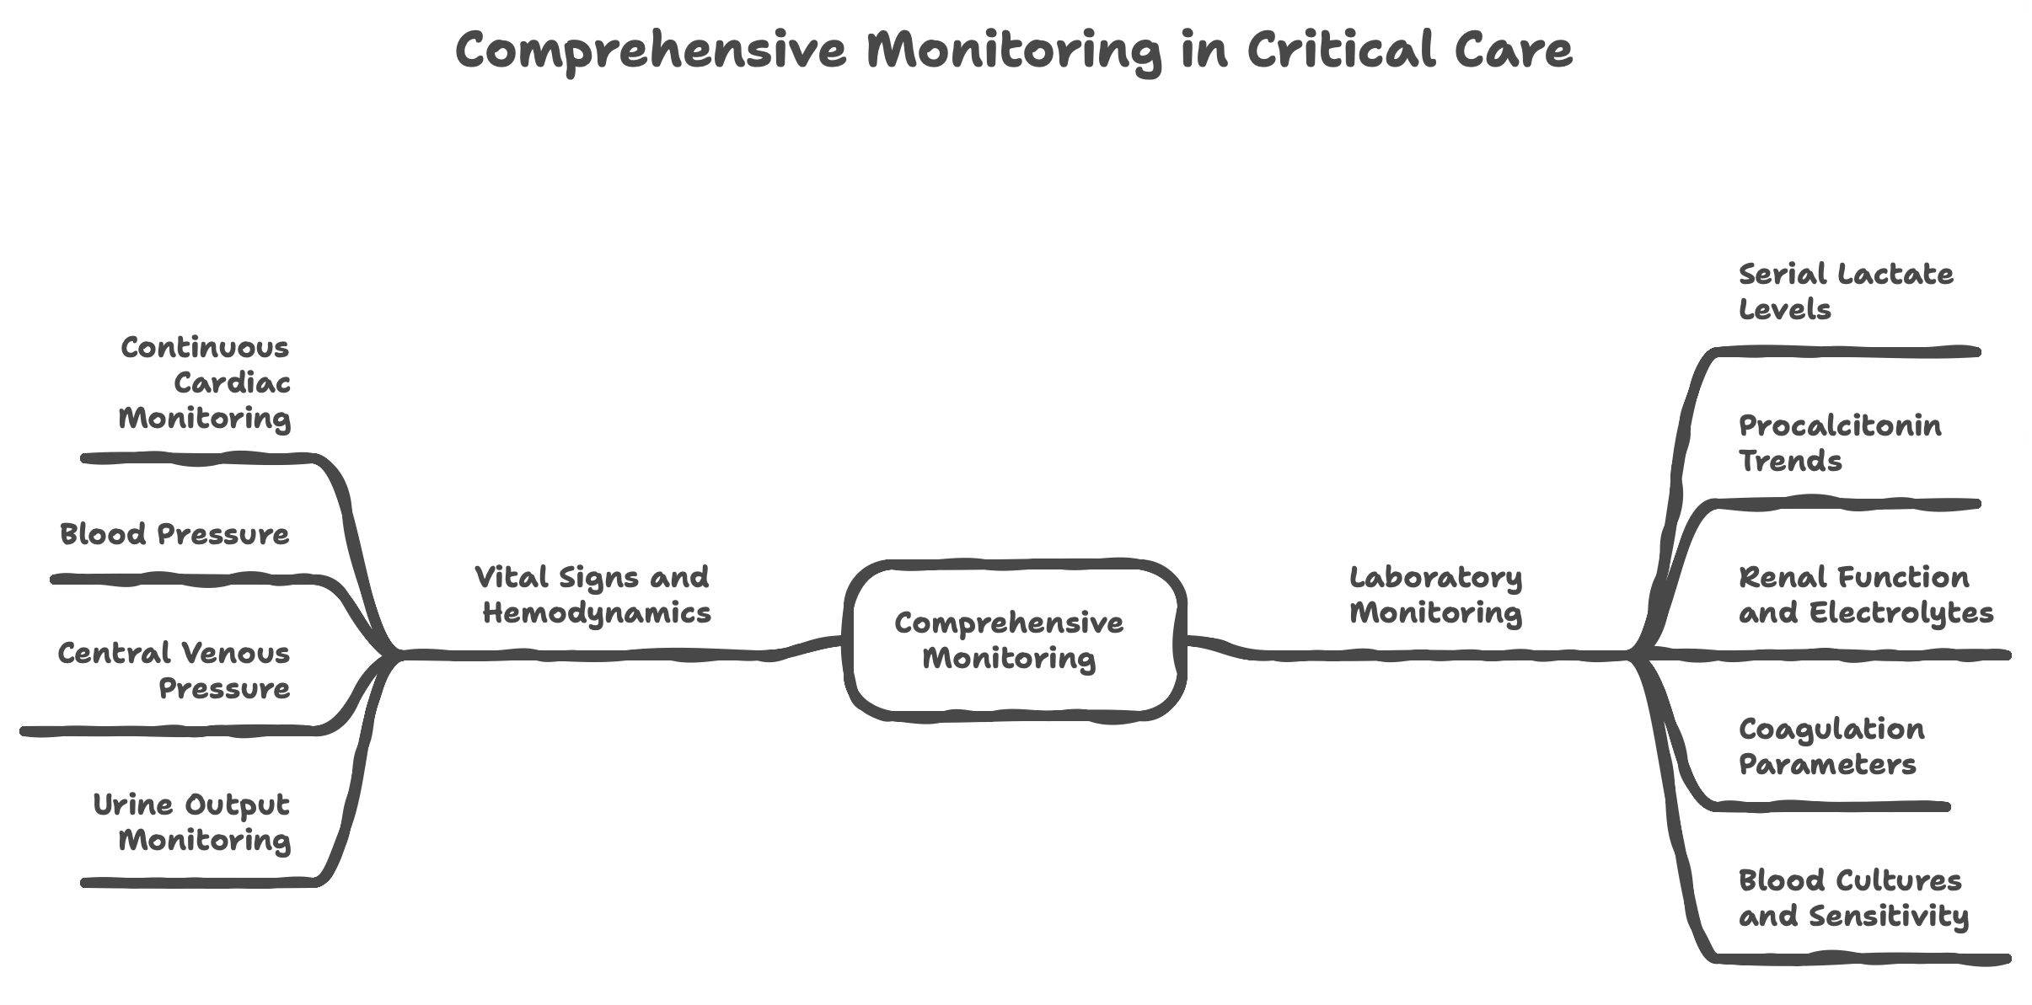

**Common Complications**

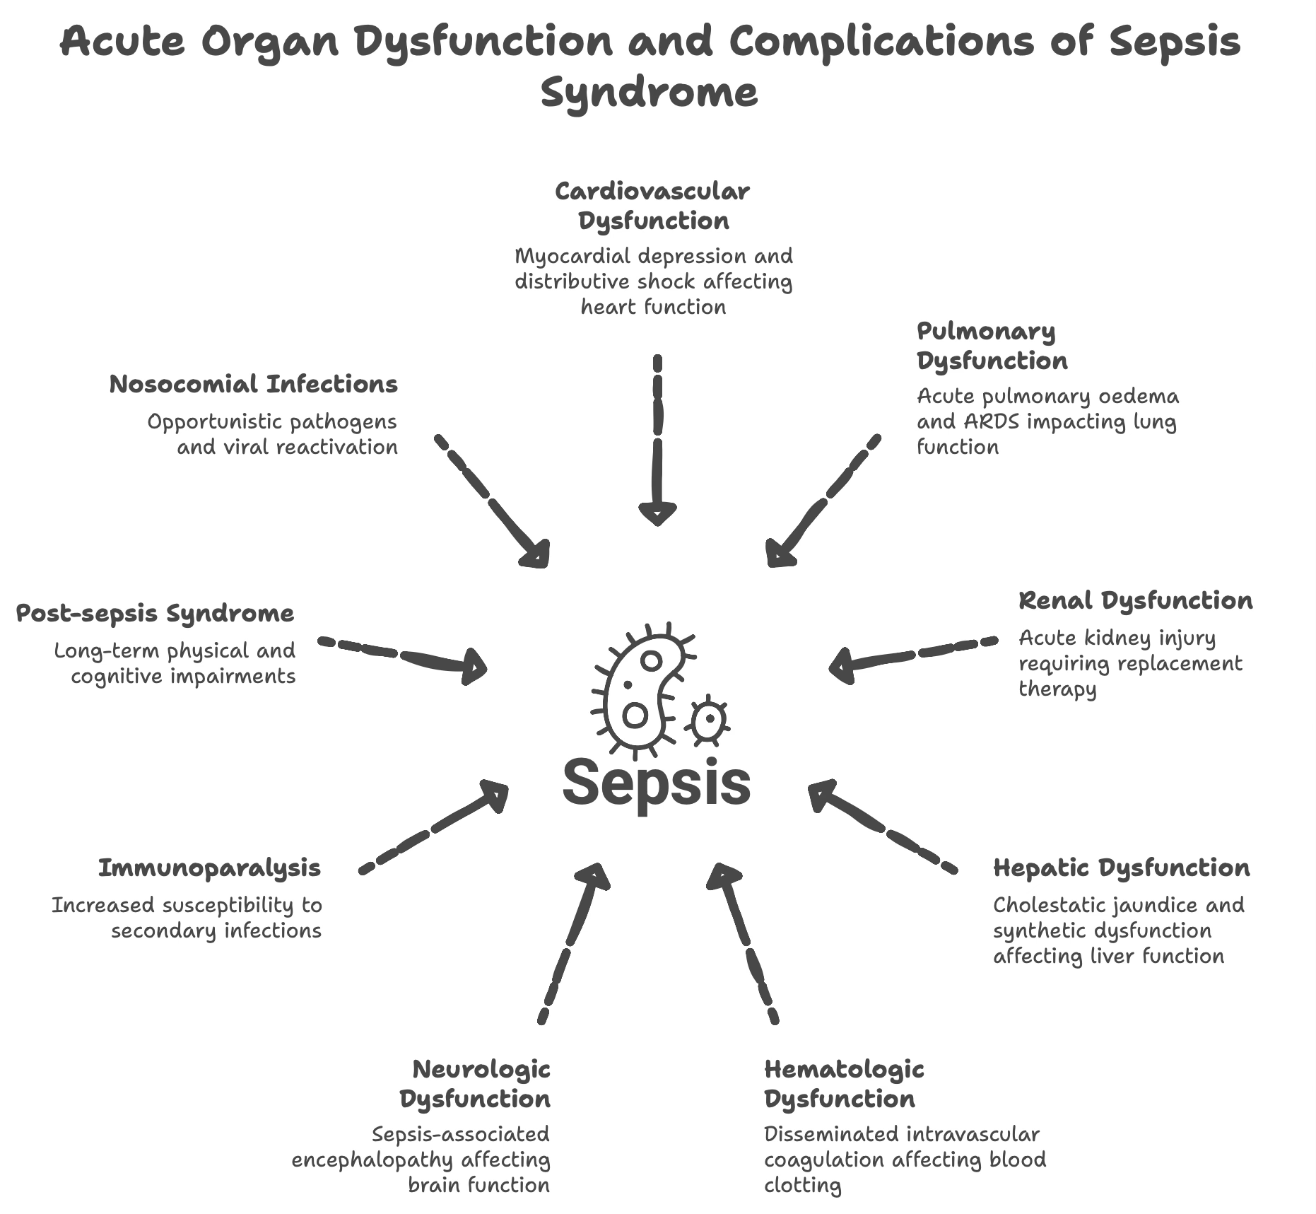

**Risk Scores and Prognostication**

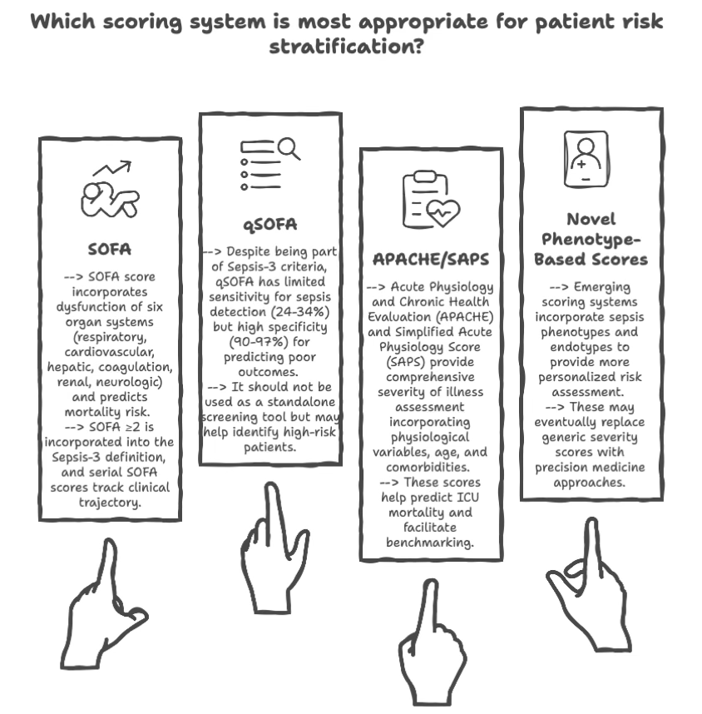

**Prognostic Indicators**

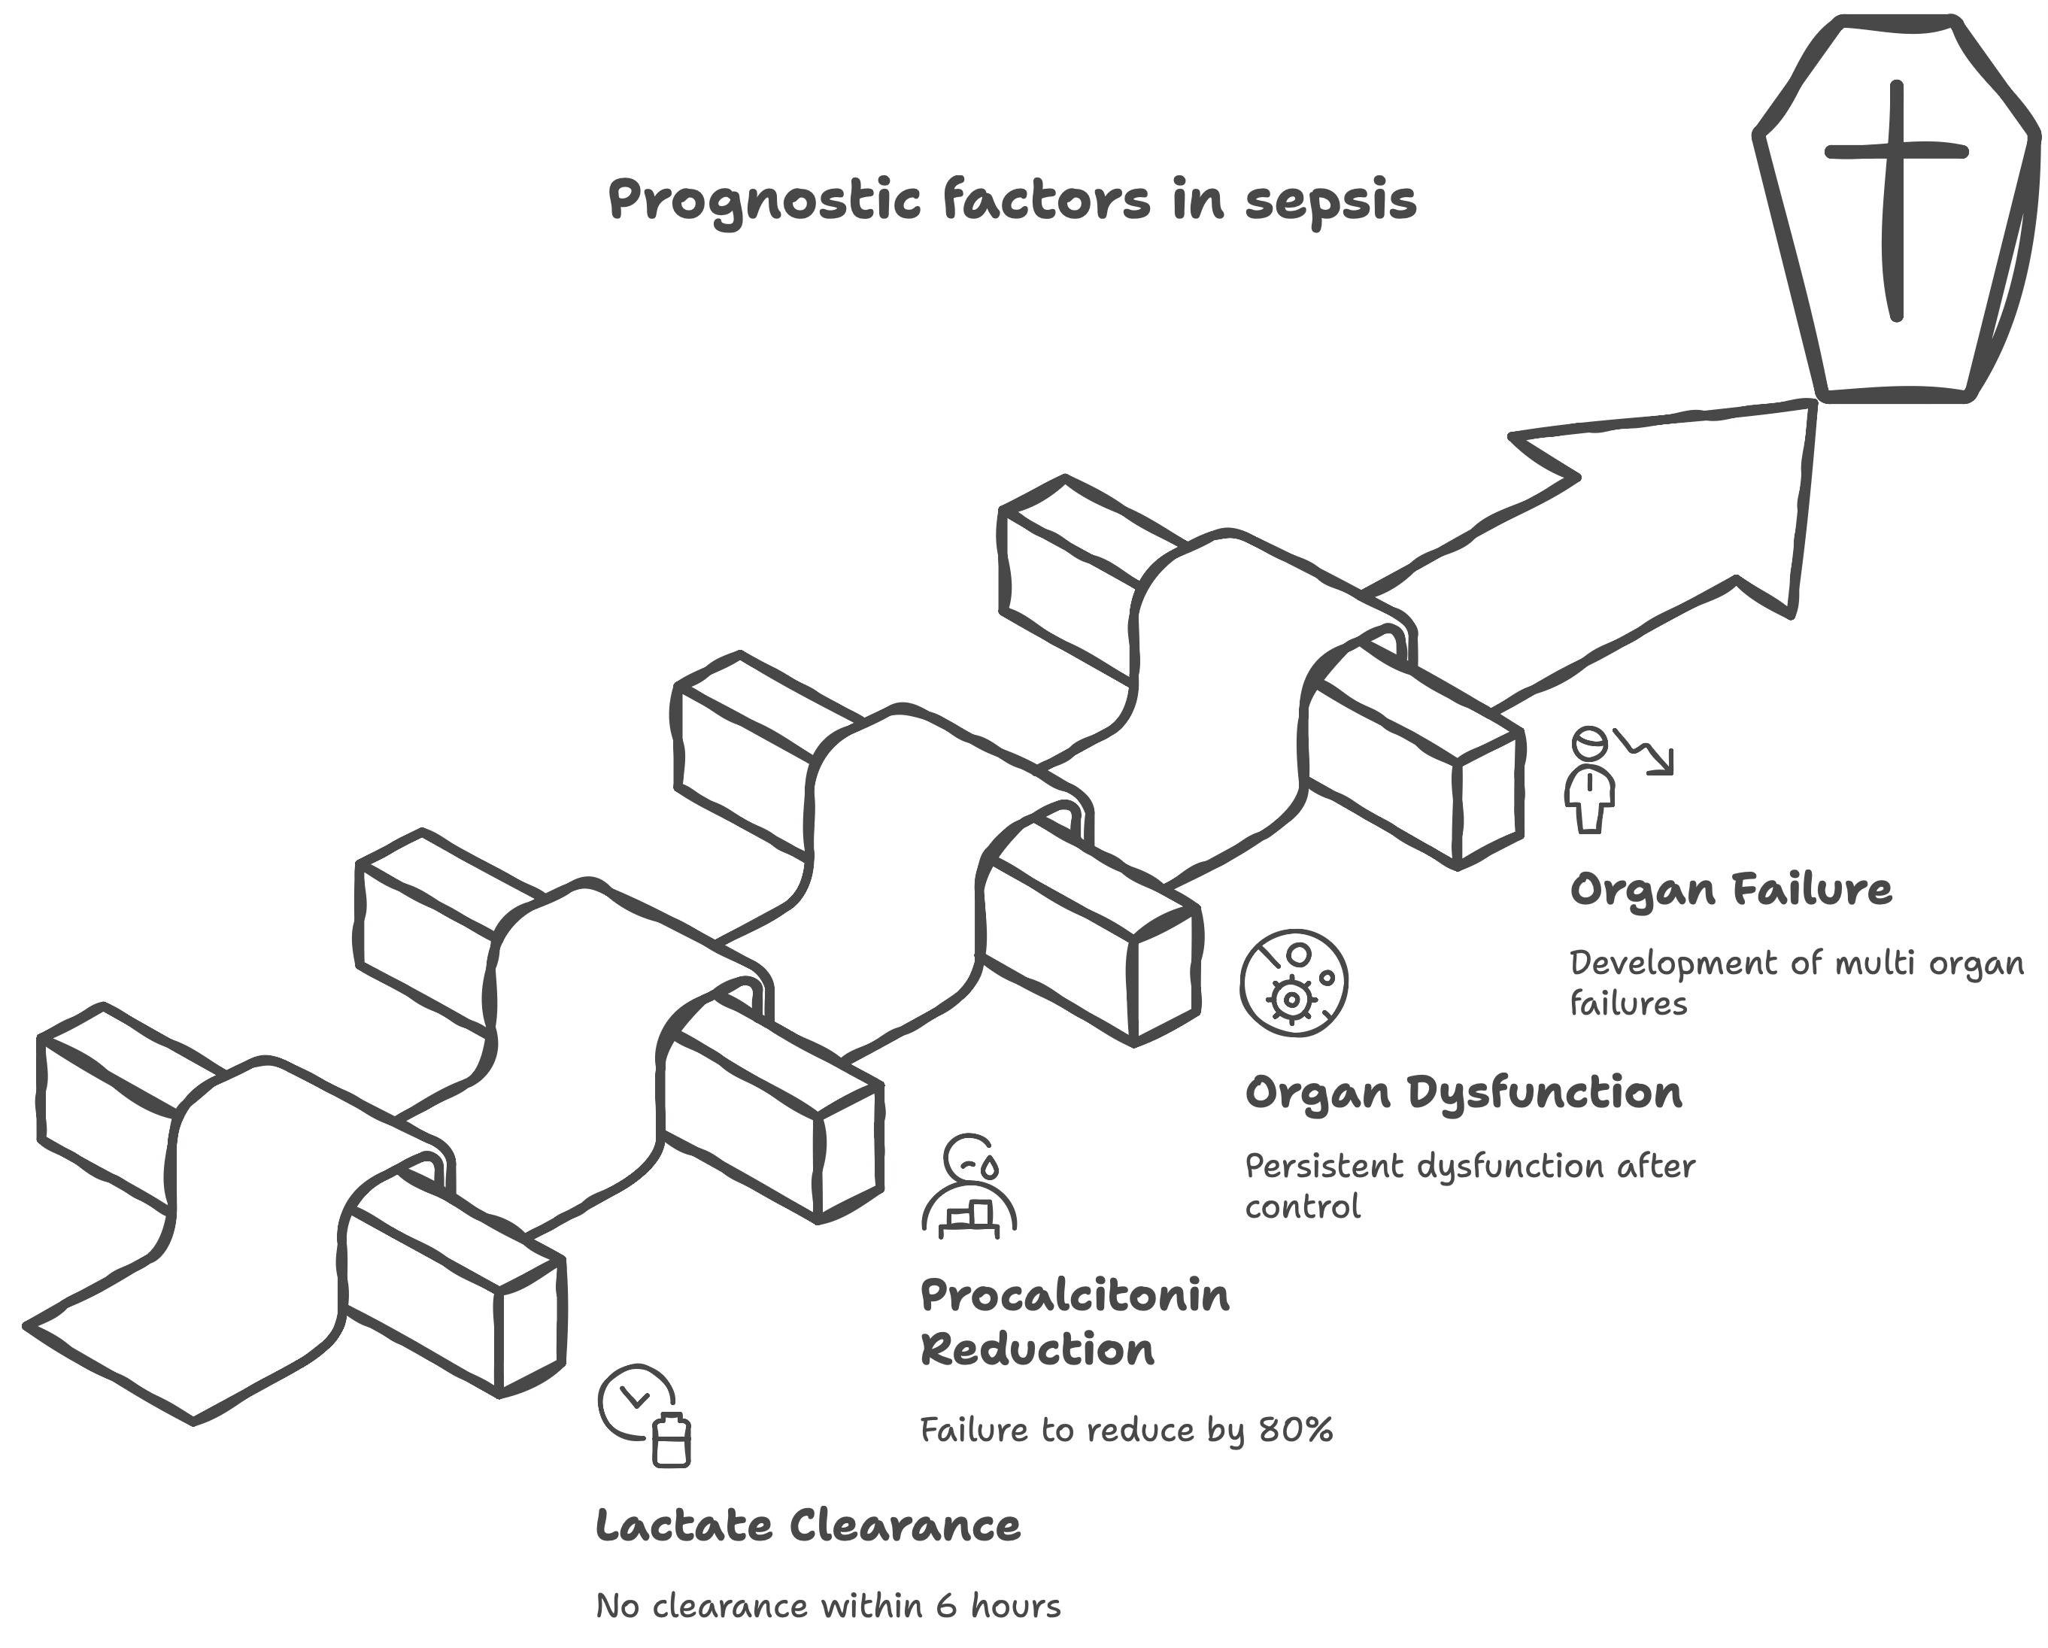

**11. Special Scenarios**

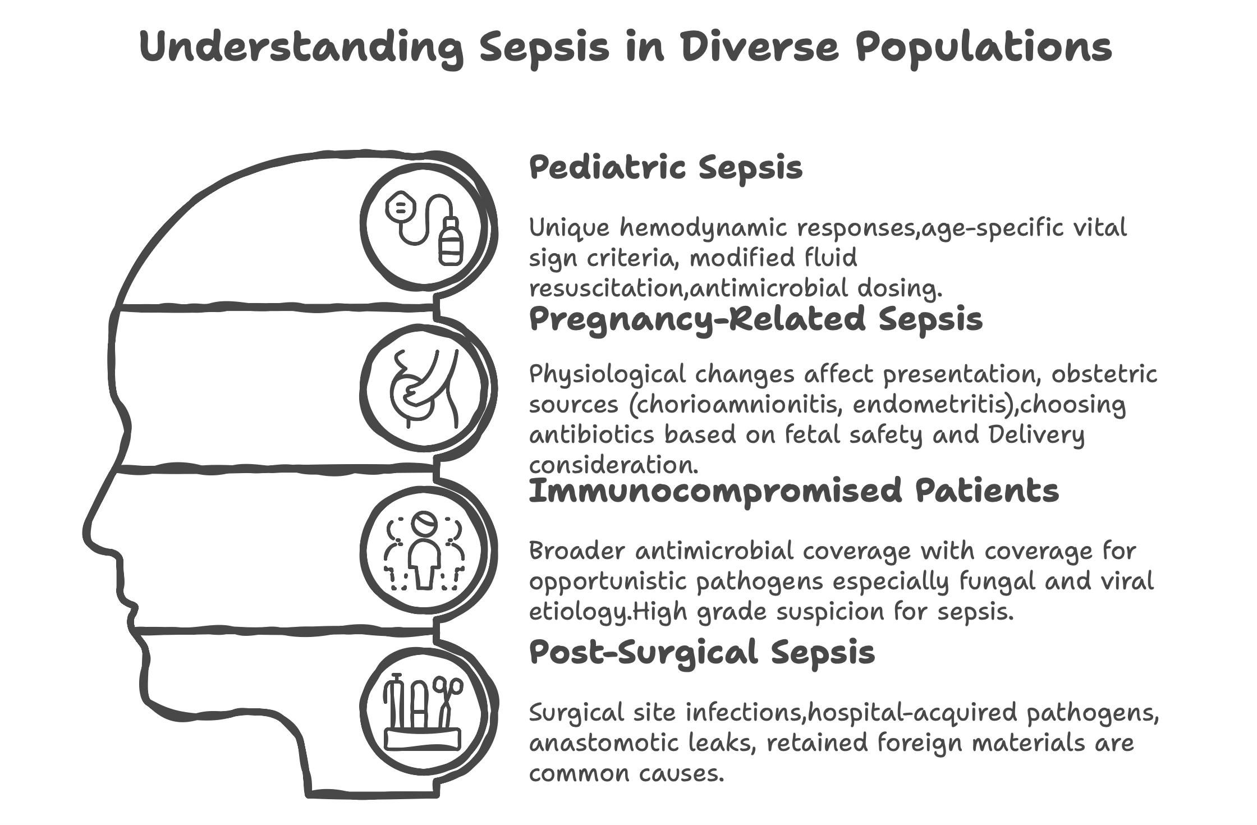

**12. Conclusion**

Sepsis remains a leading cause of morbidity and mortality worldwide, requiring immediate recognition and aggressive management. The Sepsis-3 definition has shifted focus to organ dysfunction as the key diagnostic criterion, emphasizing the life-threatening nature of the condition from its onset. [1]

**Critical Success Factors**:

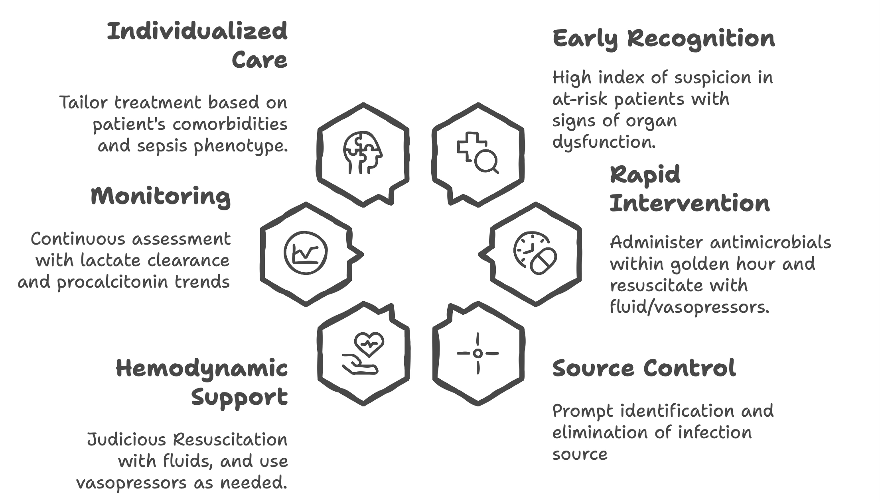

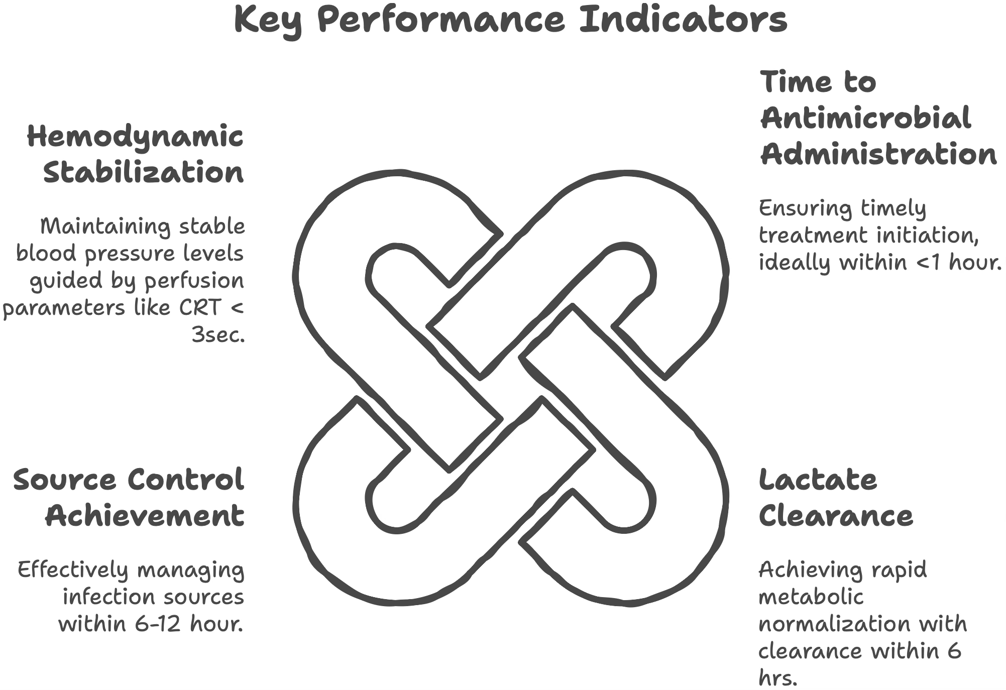

The management of sepsis requires a multidisciplinary team approach with strong emphasis on adherence to evidence-based protocols while maintaining flexibility for individual patient needs. Continuous quality improvement and protocol refinement based on emerging evidence remain essential for optimizing patient outcomes.

**Future Directions** include development of precision medicine approaches, improved biomarkers for early detection, and novel therapeutic targets addressing the dysregulated immune response characteristic of sepsis. The Sepsis-3 definition framework anticipates future updates as our understanding of this complex syndrome continues to evolve. [1]

**References**

1. Singer M, Deutschman CS, Seymour CW, Shankar-Hari M, Annane D, Bauer M, et al. The Third International Consensus Definitions for Sepsis and Septic Shock (Sepsis-3). JAMA. 2016;315(8):801-10. [1]
2. Shankar-Hari M, Phillips GS, Levy ML, Seymour CW, Liu VX, Deutschman CS, et al. Developing a New Definition and Assessing New Clinical Criteria for Septic Shock: For the Third International Consensus Definitions for Sepsis and Septic Shock (Sepsis-3). JAMA. 2016;315(8):775-87. [1]
3. Seymour CW, Liu VX, Iwashyna TJ, Brunkhorst FM, Rea TD, Scherag A, et al. Assessment of Clinical Criteria for Sepsis: For the Third International Consensus Definitions for Sepsis and Septic Shock (Sepsis-3). JAMA. 2016;315(8):762-74. [1]
4. Evans L, Rhodes A, Alhazzani W, Antonelli M, Coopersmith CM, French C, et al. Surviving Sepsis Campaign: International Guidelines for Management of Sepsis and Septic Shock 2021. Intensive Care Med. 2021;47(11):1181-247. [4,5]
5. Evans L, Rhodes A, Alhazzani W, Antonelli M, Coopersmith CM, French C, et al. Executive Summary: Surviving Sepsis Campaign: International Guidelines for the Management of Sepsis and Septic Shock 2021. Crit Care Med. 2021;49(11):1974-82. [4,5]
6. Asfar P, Meziani F, Hamel JF, Grelon F, Megarbane B, Anguel N, et al. High versus Low Blood-Pressure Target in Patients with Septic Shock. N Engl J Med. 2014;370(17):1583-93.
7. Lamontagne F, Richards-Belle A, Thomas K, Harrison DA, Sadique MZ, Grieve RD, et al. Effect of Reduced Exposure to Vasopressors on 90-Day Mortality in Older Critically Ill Patients With Vasodilatory Hypotension: A Randomized Clinical Trial. JAMA. 2020;323(10):938-49.
8. Mouncey PR, Richards-Belle A, Thomas K, Harrison DA, Sadique MZ, Grieve RD, et al. Reduced Exposure to Vasopressors Through Permissive Hypotension to Reduce Mortality in Critically Ill People Aged 65 and Over: The 65 RCT. Health Technol Assess. 2021;25(14):1-90.
9. Semler MW, Self WH, Wanderer JP, Ehrenfeld JM, Wang L, Byrne DW, et al. Balanced Crystalloids versus Saline in Critically Ill Adults. N Engl J Med. 2018;378(9):829-39. [9,10]
10. Brown RM, Wang L, Coston TD, Krishnan NI, Casey JD, Wanderer JP, et al. Balanced Crystalloids versus Saline in Sepsis. A Secondary Analysis of the SMART Clinical Trial. Am J Respir Crit Care Med. 2019;200(12):1487-95. [9,10]
11. Bone RC, Balk RA, Cerra FB, Dellinger RP, Fein AM, Knaus WA, et al. Definitions for Sepsis and Organ Failure and Guidelines for the Use of Innovative Therapies in Sepsis. The ACCP/SCCM Consensus Conference Committee. American College of Chest Physicians/Society of Critical Care Medicine. Chest. 1992;101(6):1644-55. [11]
12. Levy MM, Fink MP, Marshall JC, Abraham E, Angus D, Cook D, et al. 2001 SCCM/ESICM/ACCP/ATS/SIS International Sepsis Definitions Conference. Crit Care Med. 2003;31(4):1250-6. [12]
13. Vincent JL, Moreno R, Takala J, Willatts S, De Mendonça A, Bruining H, et al. The SOFA (Sepsis-related Organ Failure Assessment) Score to Describe Organ Dysfunction/Failure. On behalf of the Working Group on Sepsis-Related Problems of the European Society of Intensive Care Medicine. Intensive Care Med. 1996;22(7):707-10. [13]
14. Smith GB, Prytherch DR, Meredith P, Schmidt PE, Featherstone PI. The Ability of the National Early Warning Score (NEWS) to Discriminate Patients at Risk of Early Cardiac Arrest, Unanticipated Intensive Care Unit Admission, and Death. Resuscitation. 2013;84(4):465-70. [14]
15. Rola P, Miralles-Aguiar F, Argaiz E, Beaubien-Souligny W, Haycock K, Karimov T, et al. Clinical Applications of the Venous Excess Ultrasound (VExUS) Score: Conceptual Review and Case Series. Ultrasound J. 2021;13(1):32. [15]
16. Prescott HC, Ostermann M. What is New and Different in the 2021 Surviving Sepsis Campaign Guidelines. Internist (Berl). 2023;64(6):561-8. [4,5]
17. Seymour CW, Kennedy JN, Wang S, Chang CH, Elliott CF, Xu Z, et al. Derivation, Validation, and Potential Treatment Implications of Novel Clinical Phenotypes for Sepsis. JAMA. 2019;321(20):2003-17.
18. Rivers E, Nguyen B, Havstad S, Ressler J, Muzzin A, Knoblich B, et al. Early Goal-Directed Therapy in the Treatment of Severe Sepsis and Septic Shock. N Engl J Med. 2001;345(19):1368-77.
19. Dellinger RP, Levy MM, Rhodes A, Annane D, Gerlach H, Opal SM, et al. Surviving Sepsis Campaign: International Guidelines for Management of Severe Sepsis and Septic Shock: 2012. Crit Care Med. 2013;41(2):580-637. [4,5]
20. Rhodes A, Evans LE, Alhazzani W, Levy MM, Antonelli M, Ferrer R, et al. Surviving Sepsis Campaign: International Guidelines for Management of Sepsis and Septic Shock: 2016. Intensive Care Med. 2017;43(3):304-77. [4,5]
21. Annane D, Renault A, Brun-Buisson C, Megarbane B, Quenot JP, Siami S, et al. Hydrocortisone plus Fludrocortisone for Adults with Septic Shock. N Engl J Med. 2018;378(9):809-18.
22. Venkatesh B, Finfer S, Cohen J, Rajbhandari D, Arabi Y, Bellomo R, et al. Adjunctive Glucocorticoid Therapy in Patients with Septic Shock. N Engl J Med. 2018;378(9):797-808.
23. Holst LB, Haase N, Wetterslev J, Wernerman J, Guttormsen AB, Karlsson S, et al. Lower versus Higher Hemoglobin Threshold for Transfusion in Septic Shock. N Engl J Med. 2014;371(15):1381-91.
24. Zampieri FG, Machado FR, Biondi RS, Freitas FGR, Veiga VC, Figueiredo RC, et al. Effect of Intravenous Fluid Treatment With a Balanced Solution vs 0.9% Saline Solution on Mortality in Critically Ill Patients: The BaSICS Randomized Clinical Trial. JAMA. 2021;326(9):1-12. [24]
25. Kellum JA, Lameire N, Aspelin P, Barsoum RS, Burdmann EA, Goldstein SL, et al. Kidney Disease: Improving Global Outcomes (KDIGO) Acute Kidney Injury Work Group. KDIGO Clinical Practice Guideline for Acute Kidney Injury. Kidney Int Suppl. 2012;2(1):1-138. [25]
26. Gaieski DF, Mikkelsen ME, Band RA, Pines JM, Massone R, Furia FF, et al. Impact of Time to Antibiotics on Survival in Patients with Severe Sepsis or Septic Shock in Whom Early Goal-Directed Therapy Was Initiated in the Emergency Department. Crit Care Med. 2010;38(4):1045-53.
27. Kumar A, Roberts D, Wood KE, Light B, Parrillo JE, Sharma S, et al. Duration of Hypotension Before Initiation of Effective Antimicrobial Therapy is the Critical Determinant of Survival in Human Septic Shock. Crit Care Med. 2006;34(6):1589-96.
28. Sprung CL, Annane D, Keh D, Moreno R, Singer M, Freivogel K, et al. Hydrocortisone Therapy for Patients with Septic Shock. N Engl J Med. 2008;358(2):111-24.
29. Gordon AC, Mason AJ, Thirunavukkarasu N, Perkins GD, Cecconi M, Cepkova M, et al. Effect of Early Vasopressin vs Norepinephrine on Kidney Failure in Patients With Septic Shock: The VANISH Randomized Clinical Trial. JAMA. 2016;316(5):509-18. [29]
30. Heyland DK, Johnson AP, Reynolds SC, Muscedere J. Procalcitonin for Reduced Antibiotic Exposure in the Critical Care Setting: A Systematic Review and an Economic Evaluation. Crit Care Med. 2011;39(7):1792-9. [30]
31. Gattinoni L, Tognoni G, Pesenti A, Taccone P, Mascheroni D, Labarta V, et al. Effect of Prone Positioning on the Survival of Patients with Acute Respiratory Failure. N Engl J Med. 2001;345(8):568-73. [31]
32. ARDS Network. Ventilation with Lower Tidal Volumes as Compared with Traditional Tidal Volumes for Acute Lung Injury and the Acute Respiratory Distress Syndrome. N Engl J Med. 2000;342(18):1301-8. [32]
33. Angus DC, van der Poll T. Severe Sepsis and Septic Shock. N Engl J Med. 2013;369(9):840-51.
34. Payen D, de Pont AC, Sakr Y, Spies C, Reinhart K, Vincent JL. A Positive Fluid Balance is Associated with a Worse Outcome in Patients with Acute Renal Failure. Crit Care. 2008;12(3):R74. [34]
35. Finfer S, Bellomo R, Boyce N, French J, Myburgh J, Norton R, et al. A Comparison of Albumin and Saline for Fluid Resuscitation in the Intensive Care Unit. N Engl J Med. 2004;350(22):2247-56.